**Course Description**

Ultimately, data analysis is about understanding relationships among variables. Exploring data with multiple variables requires new, more complex tools, but enables a richer set of comparisons. In this course, you will learn how to describe relationships between two numerical quantities. You will characterize these relationships graphically, in the form of summary statistics, and through simple linear regression models.

***Visualizing two variables***In this chapter, you will learn techniques for exploring bivariate relationships.



We are going to delve deep into the relationship between two variables. We will learn techniques for characterizing and quantifying the relationship between two numeric variables.

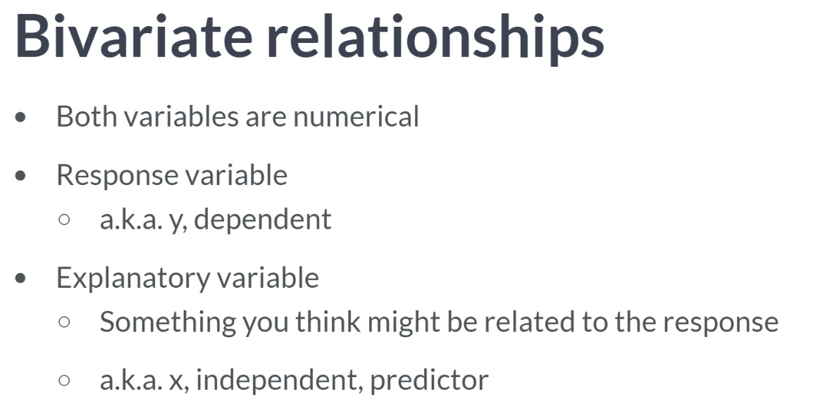  
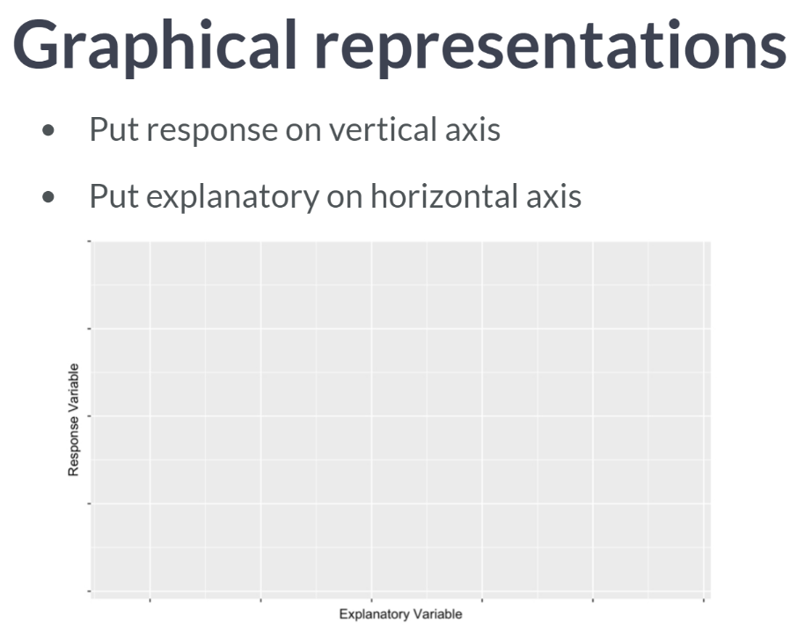

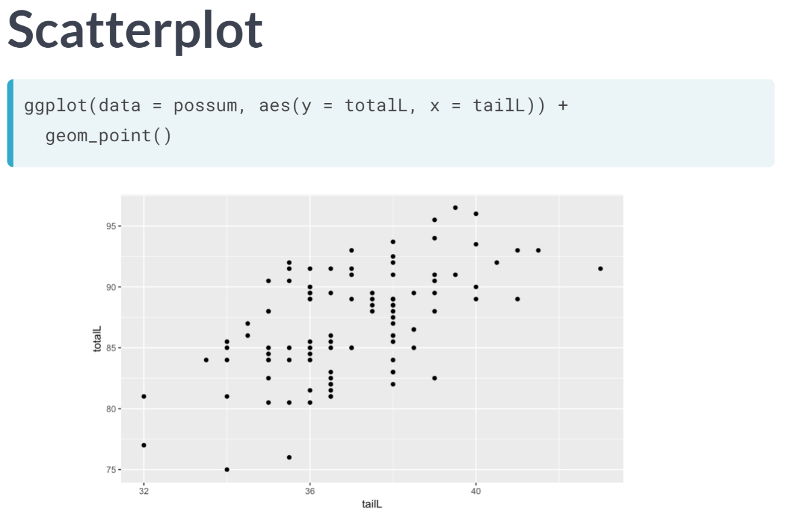

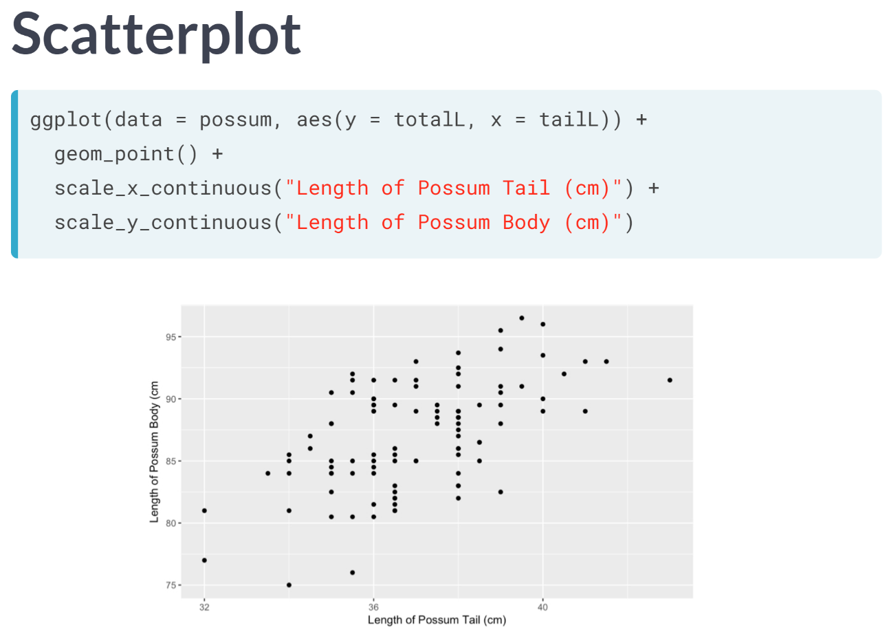  
For clarity, it's important to give our axes human readable labels. We can do this with the *scale_x_continuous* and *scale_y_continuous* functions.

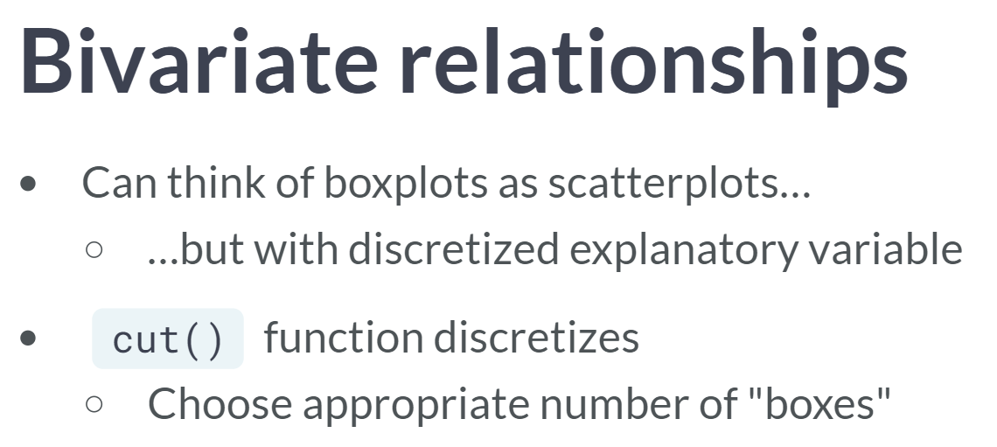  
Since we already know how a box plot can illustrate the relationship between a numerical response variable and a categorical explanatory variable, it may be helpful to think of a scatter plot as a generalization of side-by-side box plots. We can connect these ideas by discretizing our explanatory variable.

This can be achieved in R using the ***cut()*** function, which takes a numeric vector and chops it into discrete chunks. The *breaks* argument specifies the number of chunks.

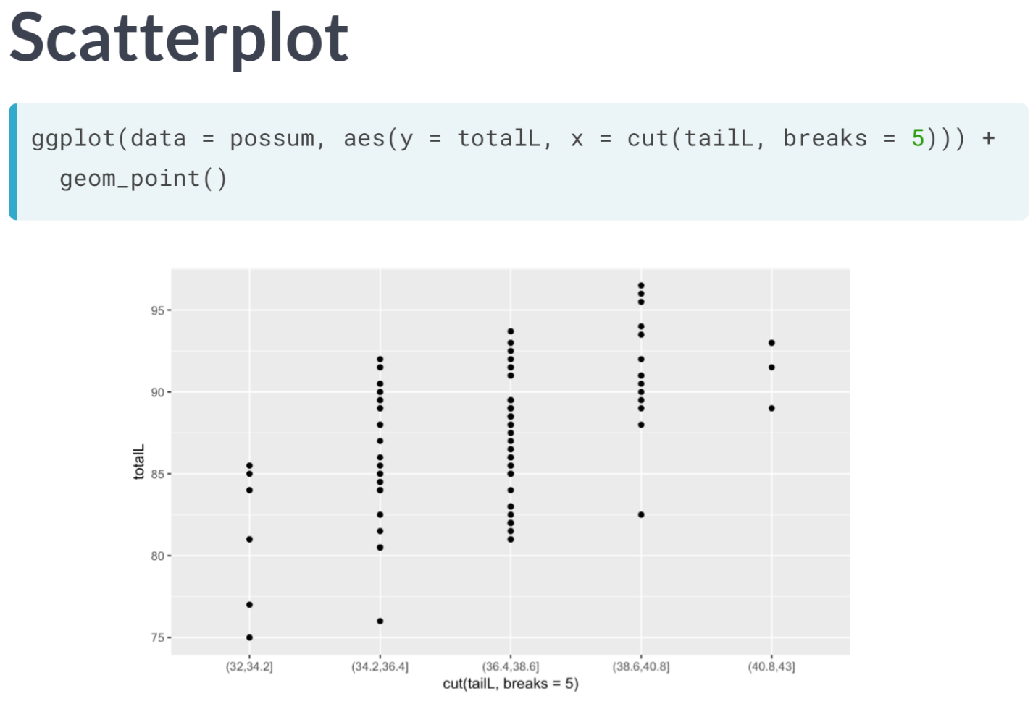Here, we used five breaks to separate the possums into five groups based on their tail length.

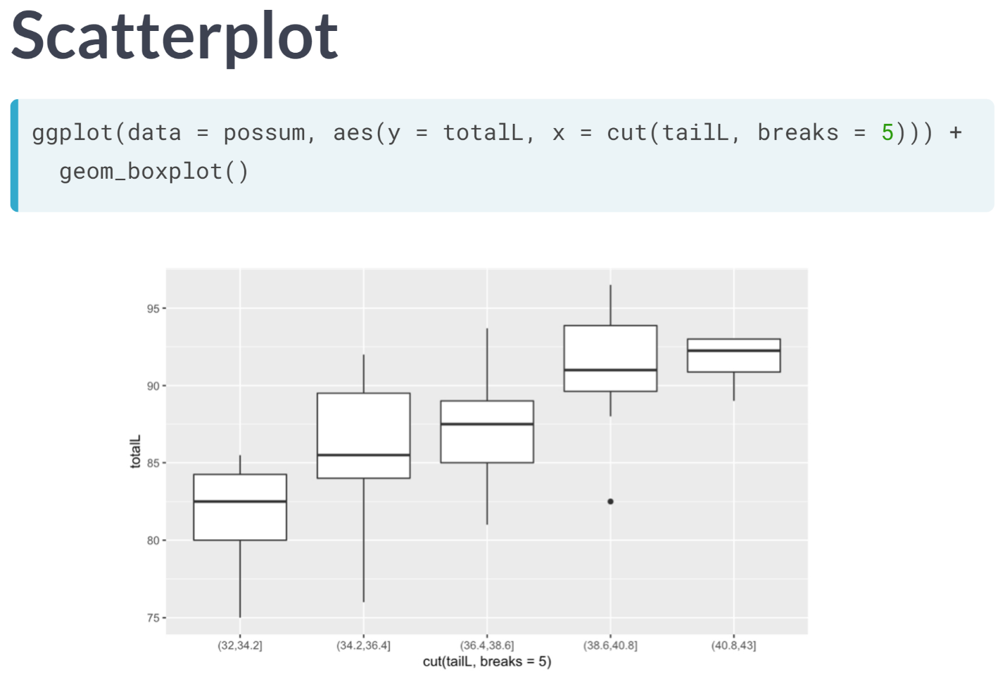

Finally, we change to ***geom_boxplot()*** to make the boxes. Note how the median body length increases as the tail length increases across the five groups.

# Scatterplots

Scatterplots are the most common and effective tools for visualizing the relationship between two numeric variables.

The ncbirths dataset is a random sample of 1,000 cases taken from a larger dataset collected in 2004. Each case describes the birth of a single child born in North Carolina, along with various characteristics of the child (e.g. birth weight, length of gestation, etc.), the child's mother (e.g. age, weight gained during pregnancy, smoking habits, etc.) and the child's father (e.g. age). You can view the help file for these data by running ?ncbirths in the console.

  
  
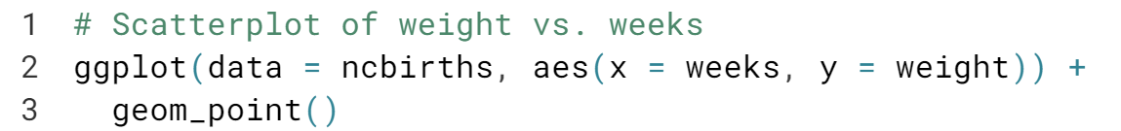  
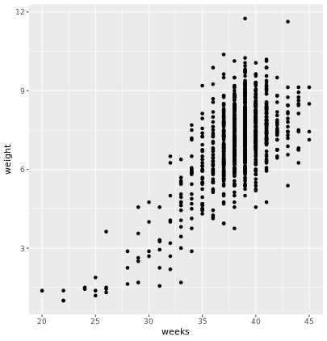

# Boxplots as discretized/conditioned scatterplots

If it is helpful, you can think of boxplots as scatterplots for which the variable on the x-axis has been discretized.

The cut() function takes two arguments: the continuous variable you want to discretize and the number of breaks that you want to make in that continuous variable in order to discretize it.

  
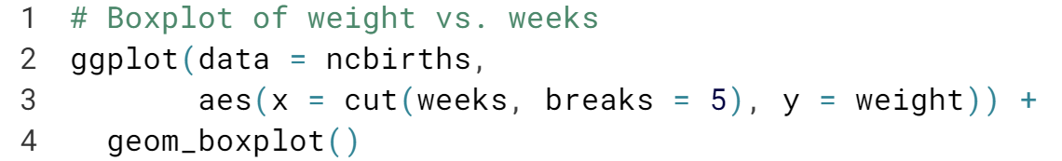  
  
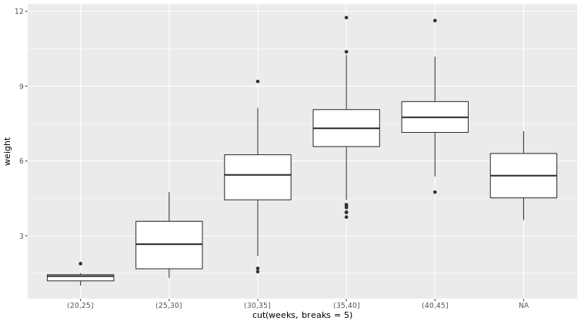  
Great! Note how the relationship no longer seems linear.



When we look at scatter plots, we look for four things: form, direction, strength, and outliers.

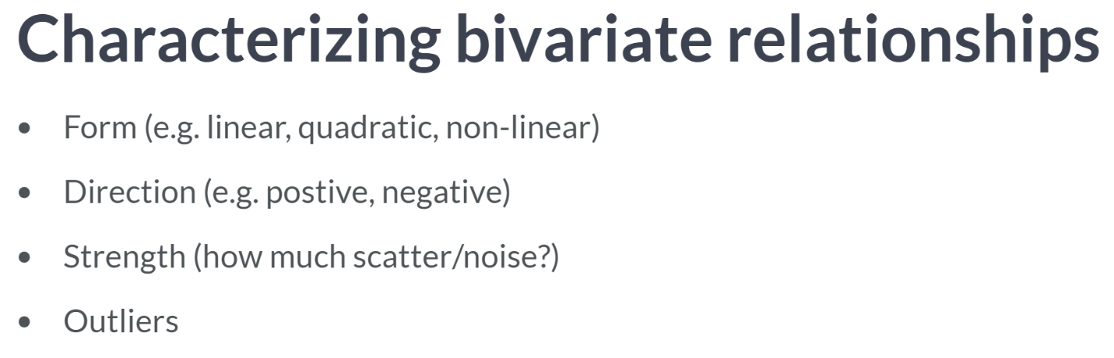Form is the overall shape made by the points. Since we are learning about linear regression, our primary concern is whether the form is linear or nonlinear.

Direction is either positive or negative. Here, the question is whether the two variables tend to move in the same direction, that is, when one goes up, the other tends to go up, or in the opposite direction.

The strength of the relationship is governed by how much scatter is present. Do the points seem to be clustered together in a way that suggests a close relationship? Or are they very loosely organized?

Finally, any points that don't fit the overall pattern, or simply lie far away, are important to investigate. These outliers may be erroneous measurements, or they can be exceptions that help clarify the general trend. Either way, outliers can be revealing, and we'll learn more about it in the later course.

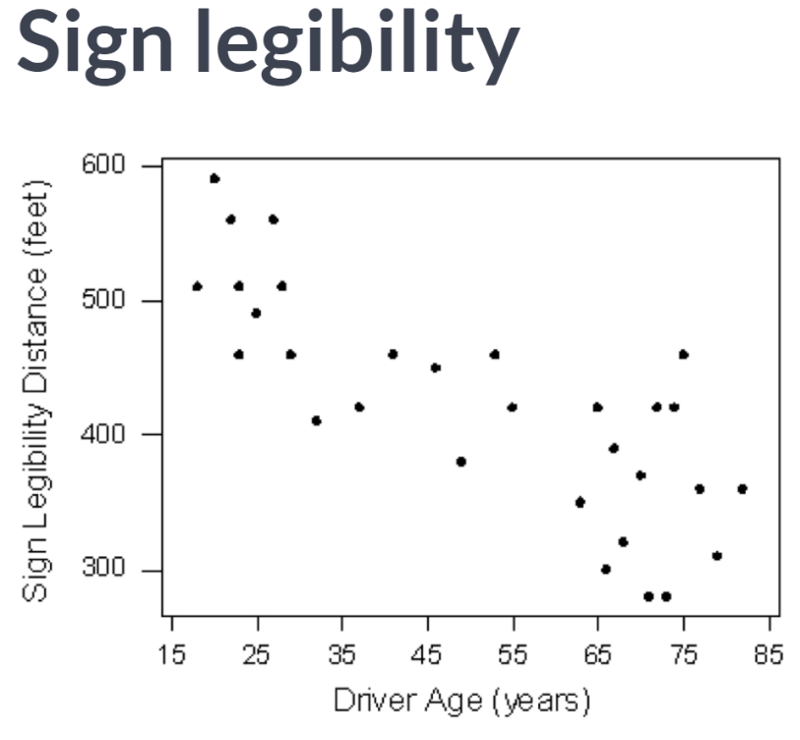  
Here we see a negative, linear relationship between sign legibility and driver age. This plot is in many ways a perfect candidate for fitting a regression model, since the form and direction are clear, but there is some variability in the observations.

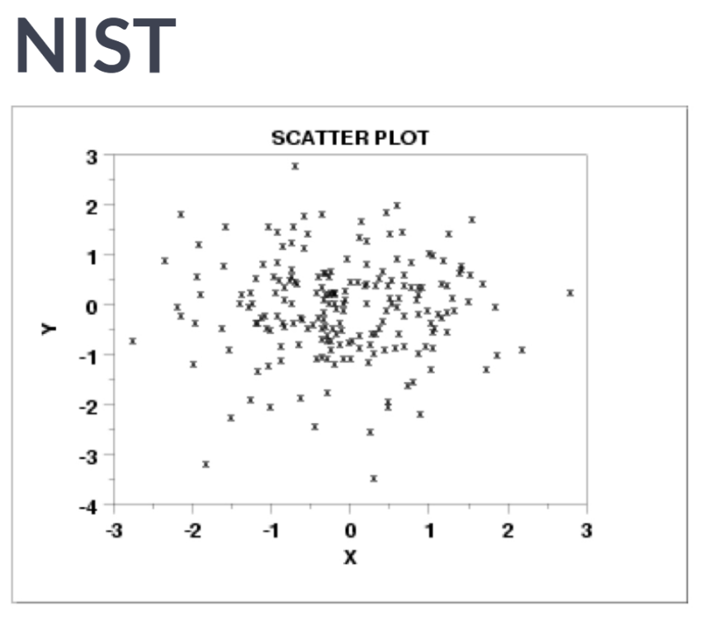  
Conversely, in this next scatter plot, we see little evidence of any relationship at all. The direction is neither positive nor negative, nor is there any clearly identifiable form.

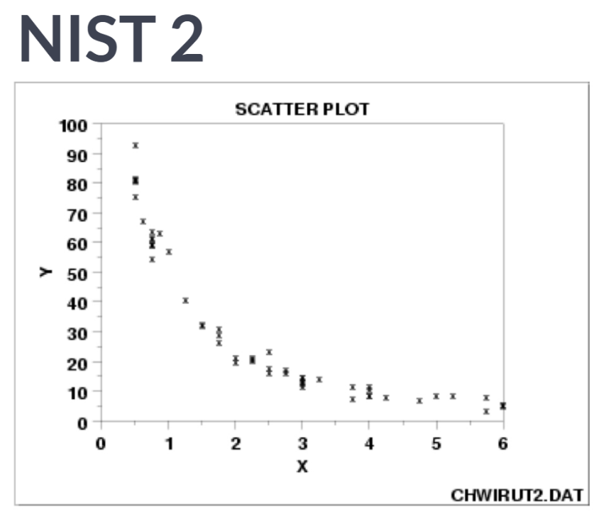  
From the same source, we now see a clear nonlinear, negative relationship. This appears to be a very strong relationship, since if you know the value of x, you can do a pretty good job of predicting the value of y.

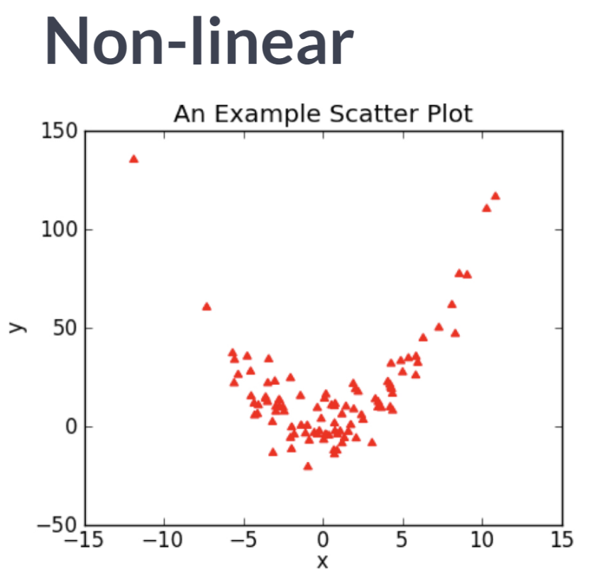  
In this example scatter plot, we see another clear, nonlinear relationship. In this case, the direction is negative for negative values of x, but positive for positive values of x. The points are clustered fairly close together, so the relationship is fairly strong. The point in the upper-left-hand corner might be considered an outlier, since it is far from the other points, but it doesn't represent a break from the overall pattern of the points.

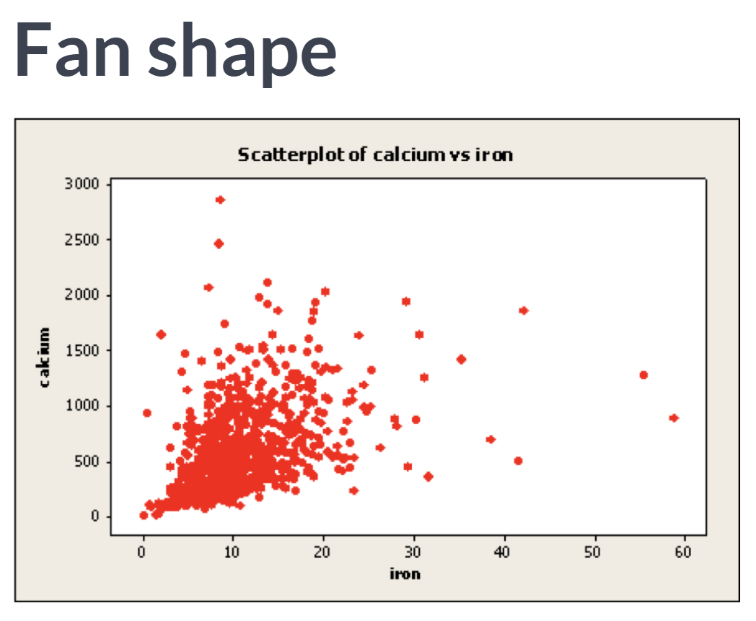  
In this scatter plot, we see what is known as a "fan shape." The direction is certainly positive, but the spread of the points increases dramatically as we get further from the origin.

If we wanted to fit a linear model to these data, we would be best served by performing a logarithmic transformation on both variables.

My guess is that taking the log of both calcium and iron would result in a very nice-looking scatter plot with a clear linear form.

# Creating scatterplots

Creating scatterplots is simple and they are so useful that it is worthwhile to expose yourself to many examples. Over time, you will gain familiarity with the types of patterns that you see. You will begin to recognize how scatterplots can reveal the nature of the relationship between two variables.

In this exercise, and throughout this chapter, we will be using several datasets listed below. These data are available through the openintro package. Briefly:

* The mammals dataset contains information about 39 different species of mammals, including their body weight, brain weight, gestation time, and a few other variables.
* The mlbBat10 dataset contains batting statistics for 1,199 Major League Baseball players during the 2010 season.
* The bdims dataset contains body girth and skeletal diameter measurements for 507 physically active individuals.
* The smoking dataset contains information on the smoking habits of 1,691 citizens of the United Kingdom.

  
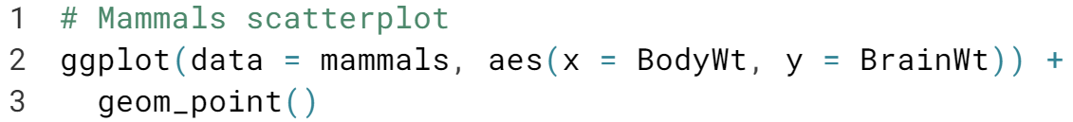  
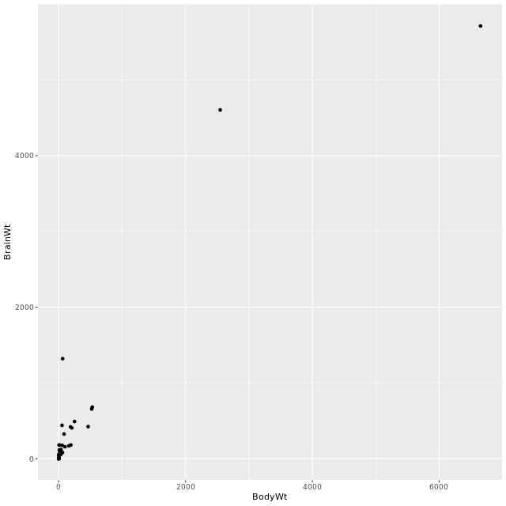

  
  
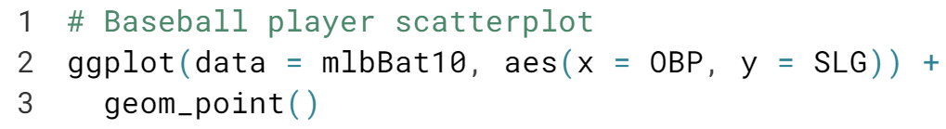  
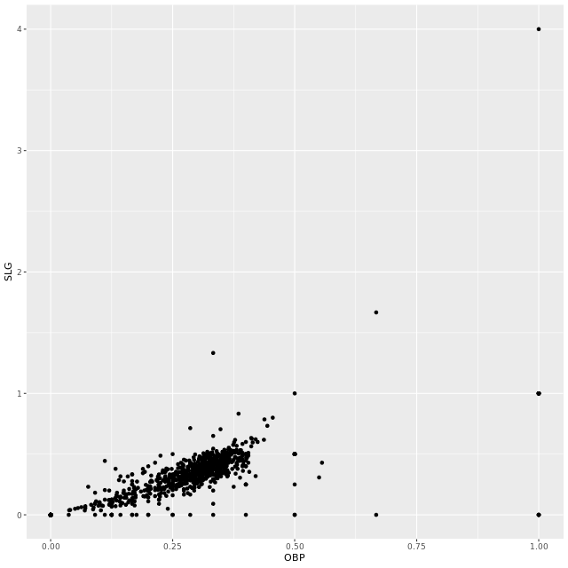

  
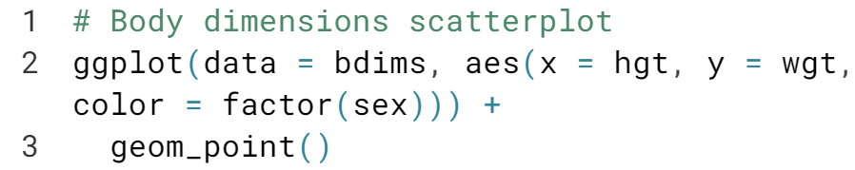  
  
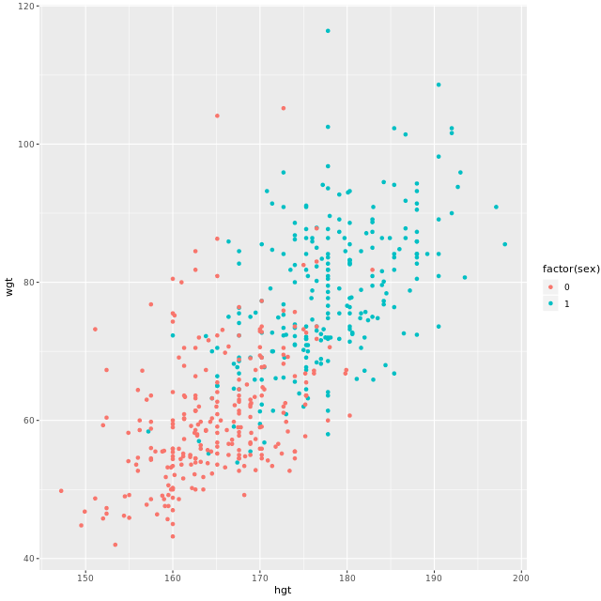

  
  
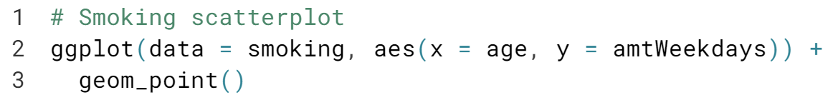  
  
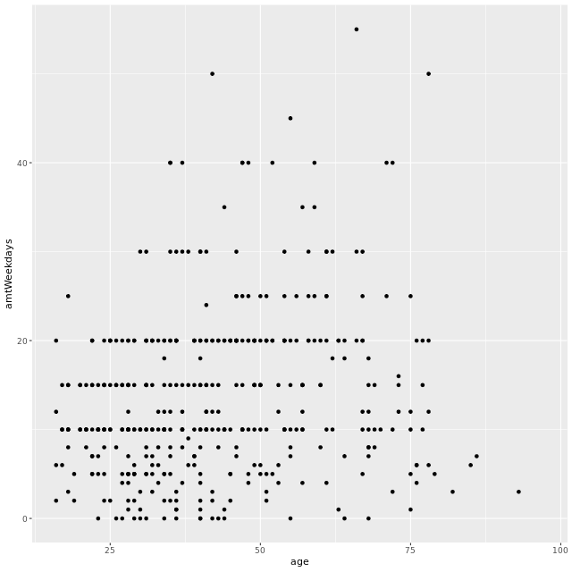

# Characterizing scatterplots

This scatterplot shows the relationship between the poverty rates and high school graduation rates of counties in the United States.

Describe the form, direction, and strength of this relationship.

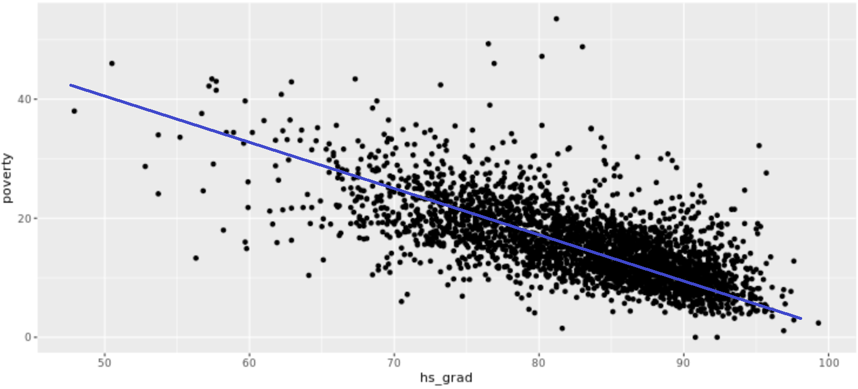

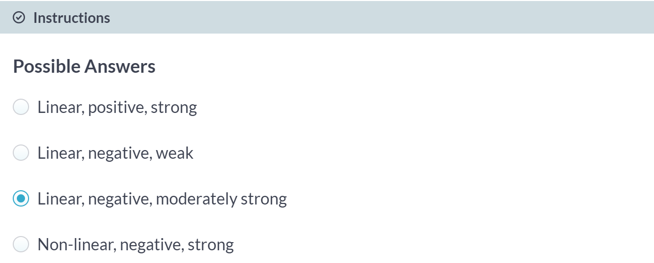

# Transformations

The relationship between two variables may not be linear. In these cases we can sometimes see strange and even inscrutable patterns in a scatterplot of the data. Sometimes there really is no meaningful relationship between the two variables. Other times, a careful transformation of one or both of the variables can reveal a clear relationship.

Recall the bizarre pattern that you saw in the scatterplot between brain weight and body weight among mammals in a previous exercise. Can we use transformations to clarify this relationship?

ggplot2 provides several different mechanisms for viewing transformed relationships. The coord_trans() function transforms the coordinates of the plot. Alternatively, the scale_x_log10() and scale_y_log10() functions perform a base-10 log transformation of each axis. Note the differences in the appearance of the axes.

The mammals dataset is available in your workspace.

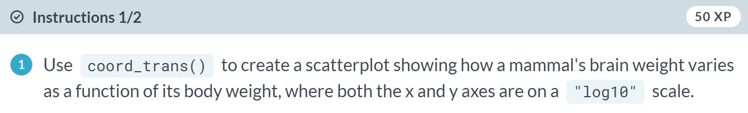  
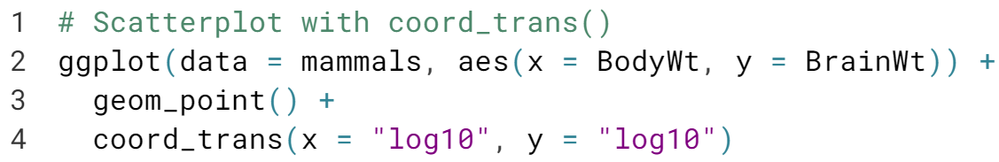  
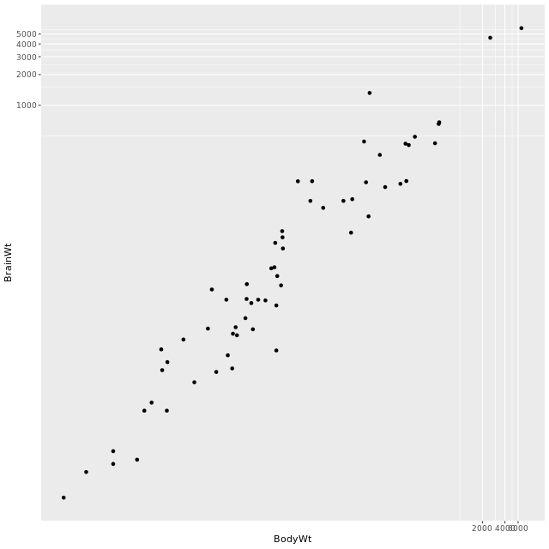

  
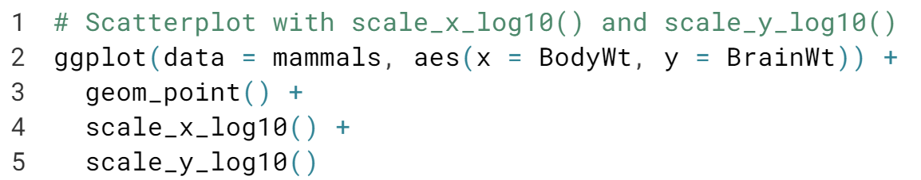  
  
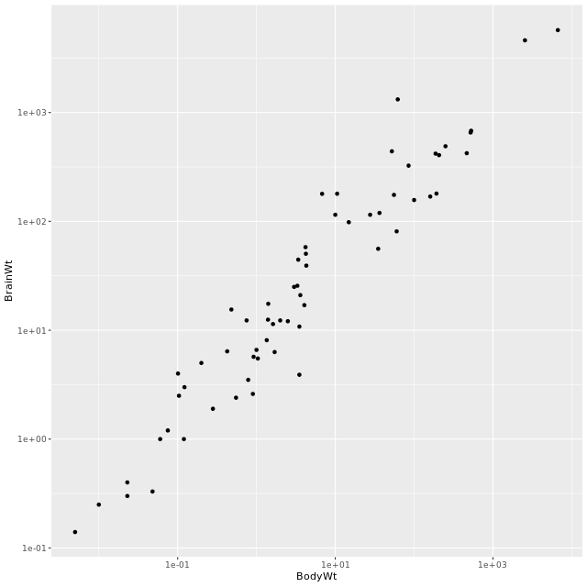



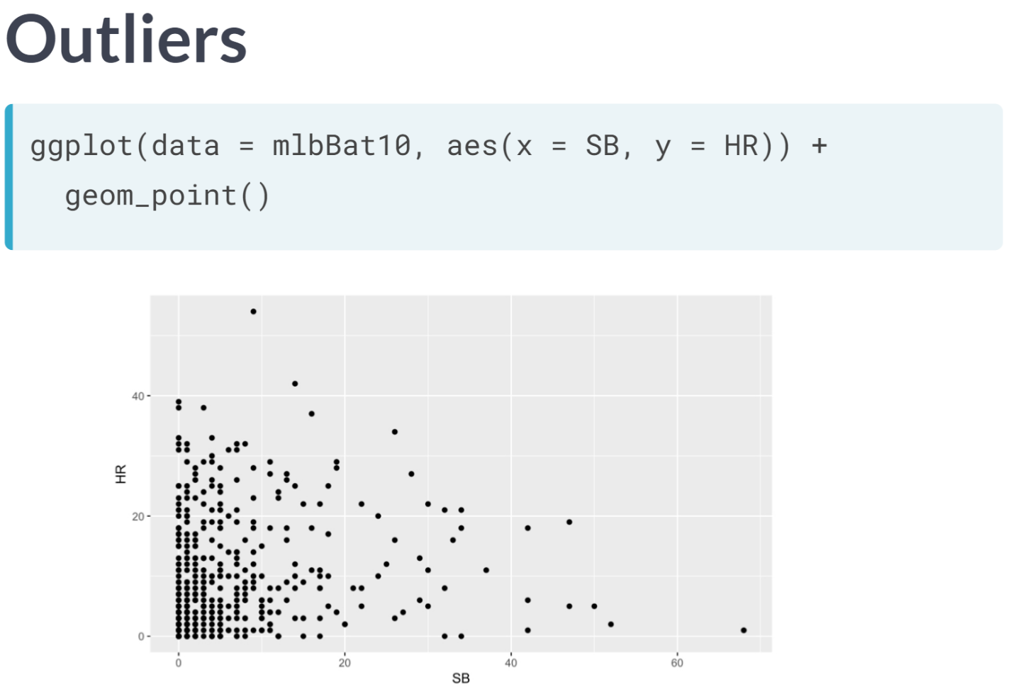

In this scatter plot, we consider the relationship between the number of home runs hit by MLB players in 2010 and the number of bases they stole. Home runs are a measure of batting power, while stolen bases are a measure of footspeed.

It's not surprising that we see a negative relationship here, since power and speed are generally considered complementary skills. Since both variables here are integer-valued, several of the observation have the same coordinates, and thus the corresponding points are plotted on the top of one another. This can mispresent the data.

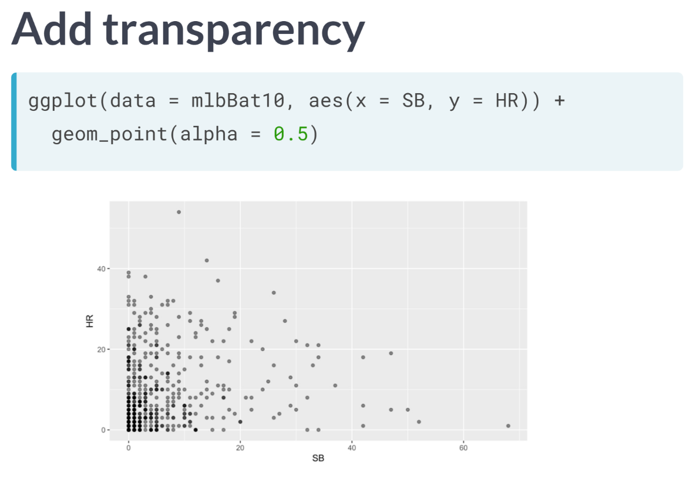  
To combat this, we can add an alpha transparency to the points, making them more translucent. Now we can see that the overplotting occurs where the darker dots are.

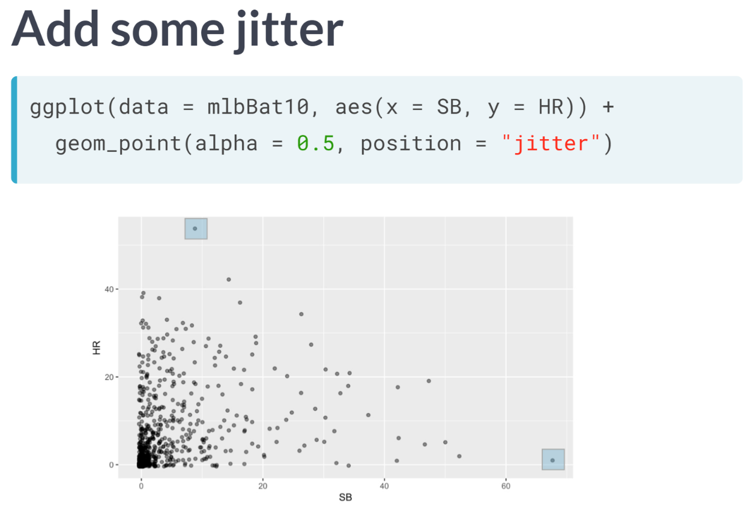  
Another approach is adding some jitter to the plot. This is just a small amount of random noise in either the x or y direction. This relieves the constraint of having both coordinates be integers and thus allows us to see all of the data. In this plot, there are two points that stand out as potential outliers. The one in the lower-right hand corner and the one at the very top.

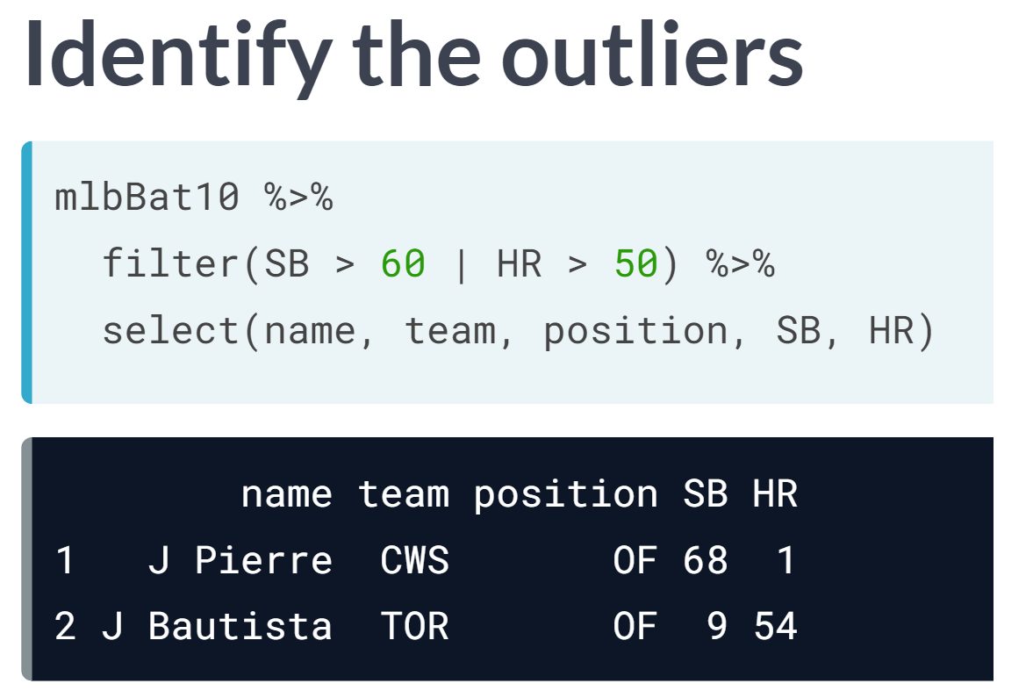  
To identify the outliers, we can use the filter function that helps us to identify those players with at least 60 stolen bases or at least 50 home runs.

As it turns out, the player in the lower-right hand corner is Juan Pierre, who is one of the speediest and least powerful hitters in recent memory; whereas a player at the top, Jose Bautista, is one of the game's most revered sluggers.

# Identifying outliers

In Chapter 5, we will discuss how outliers can affect the results of a linear regression model and how we can deal with them. For now, it is enough to simply identify them and note how the relationship between two variables may change as a result of removing outliers.

Recall that in the baseball example earlier in the chapter, most of the points were clustered in the lower left corner of the plot, making it difficult to see the general pattern of the majority of the data. This difficulty was caused by a few outlying players whose on-base percentages (OBPs) were exceptionally high. These values are present in our dataset only because these players had very few batting opportunities.

Both OBP and SLG are known as rate statistics since they measure the frequency of certain events (as opposed to their count). In order to compare these rates sensibly, it makes sense to include only players with a reasonable number of opportunities, so that these observed rates have the chance to approach their long-run frequencies.

In Major League Baseball, batters qualify for the batting title only if they have 3.1 plate appearances per game. This translates into roughly 502 plate appearances in a 162-game season. The mlbBat10 dataset does not include plate appearances as a variable, but we can use at-bats (AB) -- which constitute a subset of plate appearances -- as a proxy.  
  
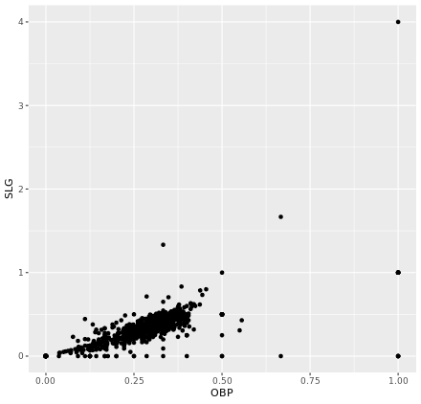  
(Exercise on the next page)

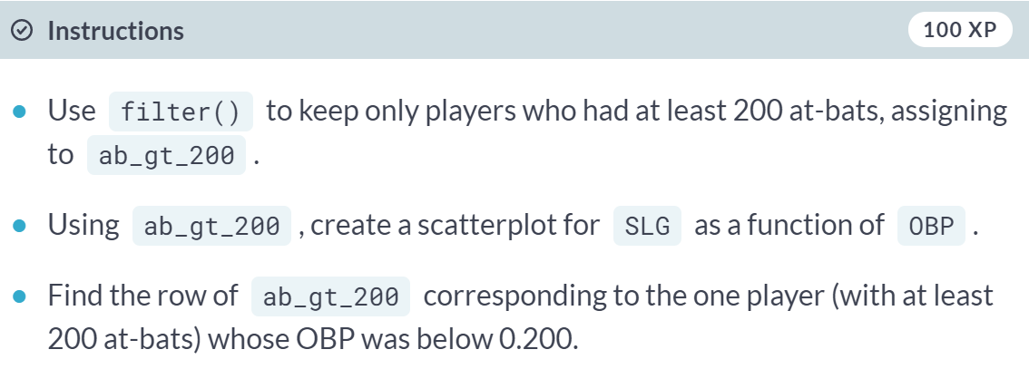  
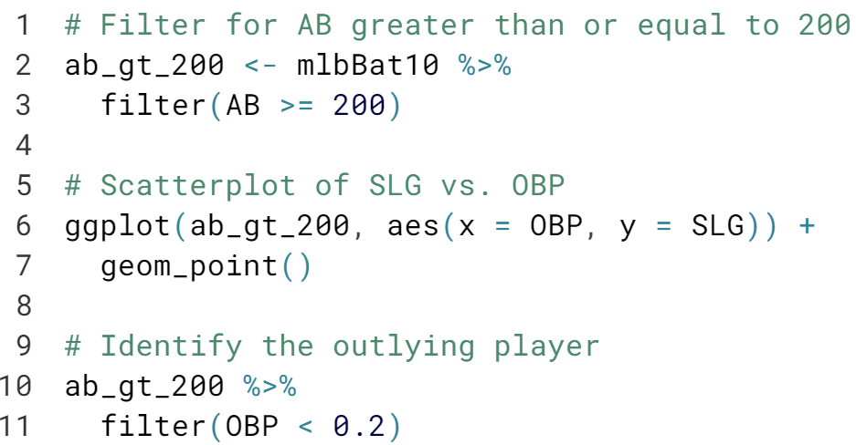  
  
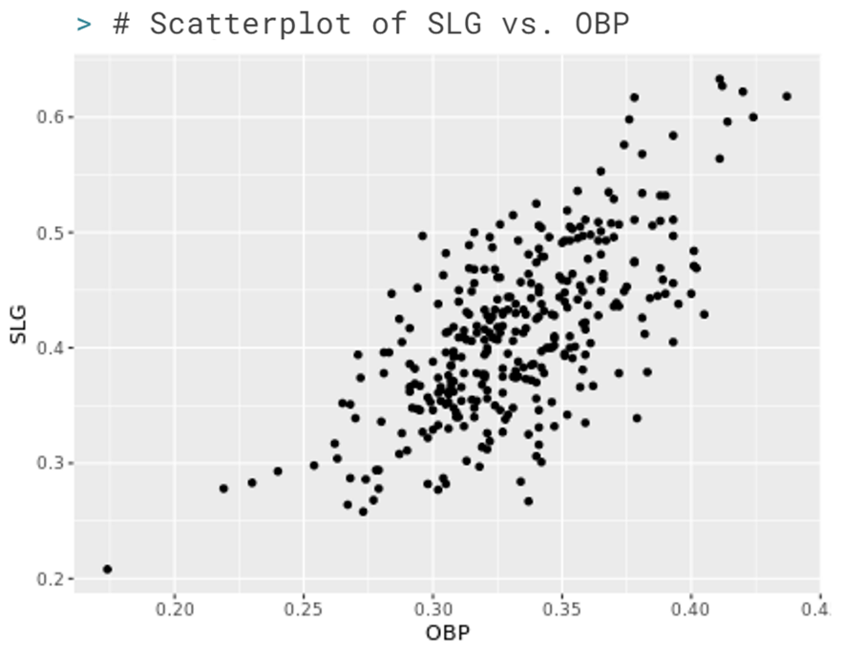  
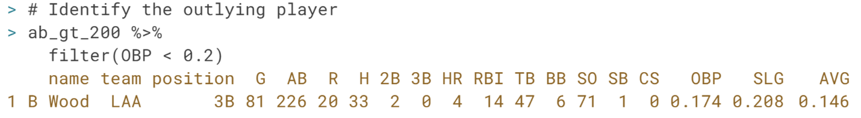

***Correlation***This chapter introduces correlation as a means of quantifying bivariate relationships.



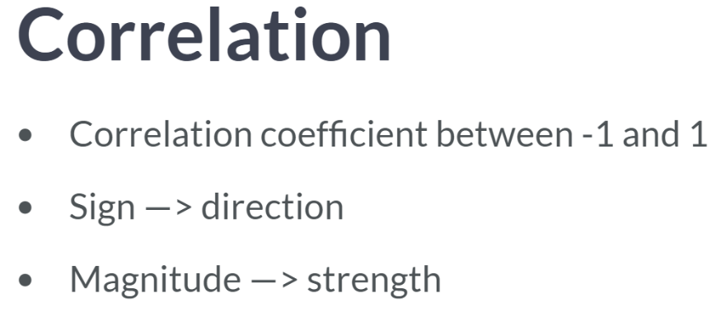  
Correlation coefficients indicates the strength of a linear relationship. The sign corresponds to the direction positive or negative. The magnitude corresponds to the strength.

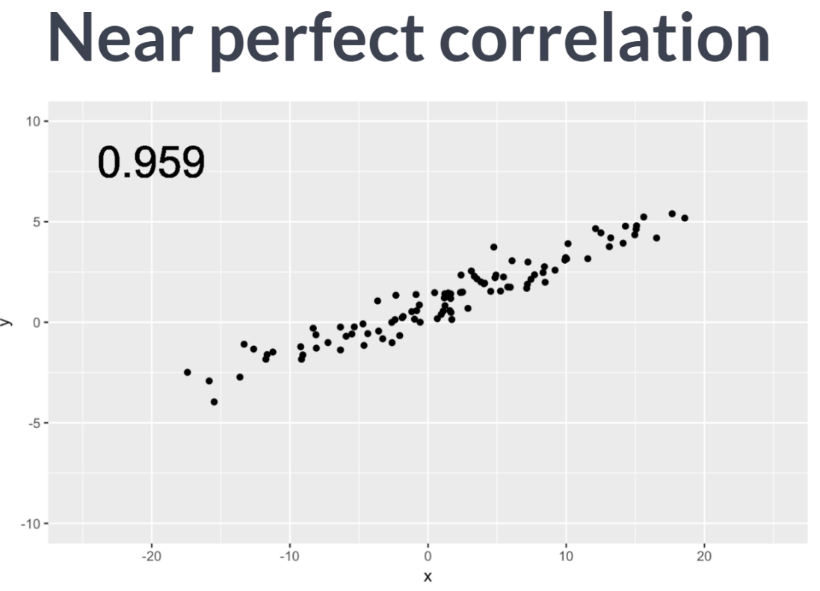  
A correlation coefficient of close to 1 indicates near-perfect positive correlation, as we see in this plot. For scatter plots in which the points more spread out, the value of the correlation coefficient is lower.

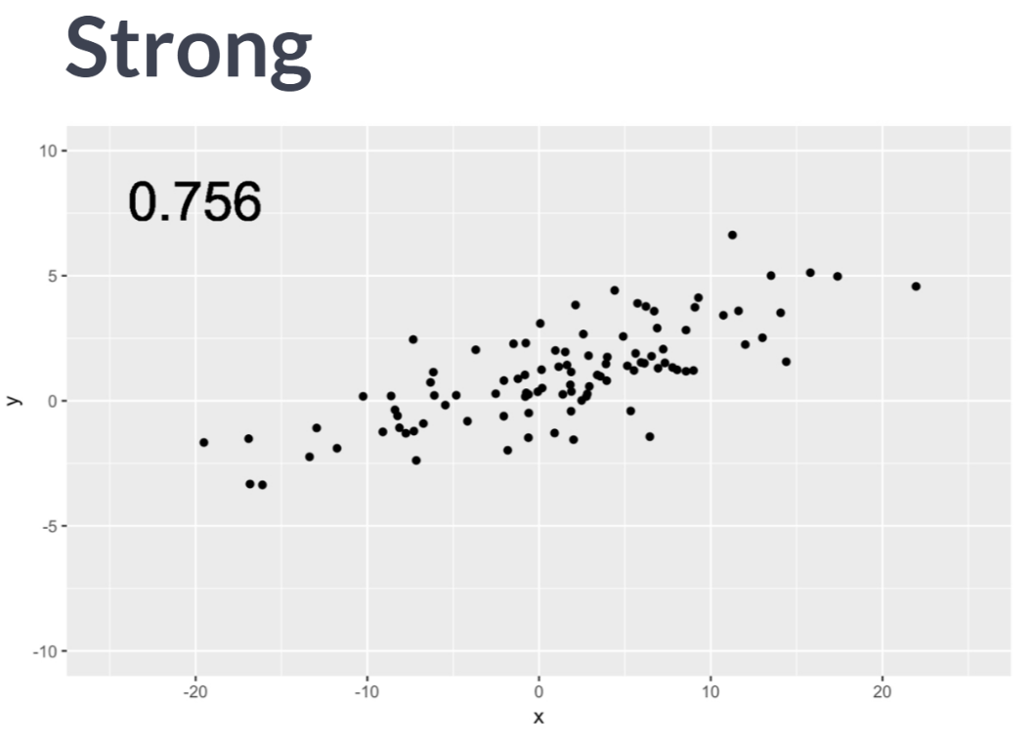  
Here we see a scatter plot with correlation that we might call "strong".

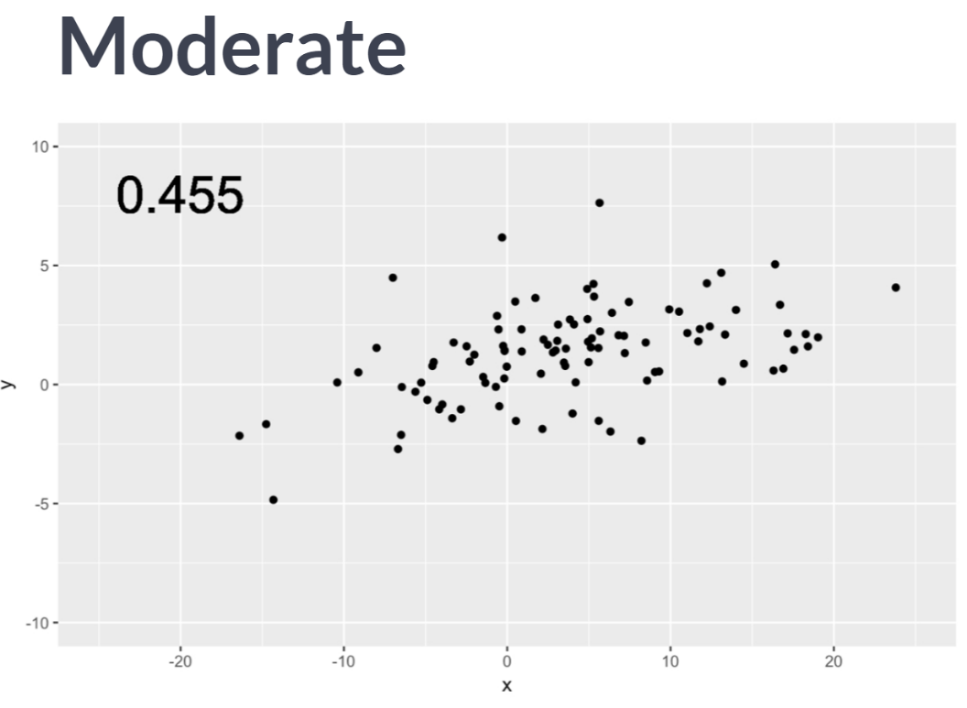  
Values of the correlation coefficient that are closer to .5 might be considered "moderate".

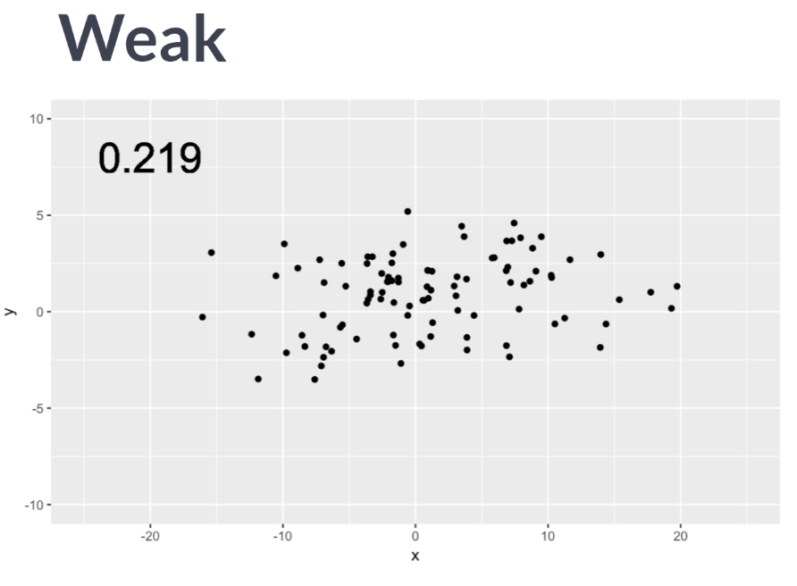  
Values of the coefficient closer to 0.2 might be considered "weak".  
  
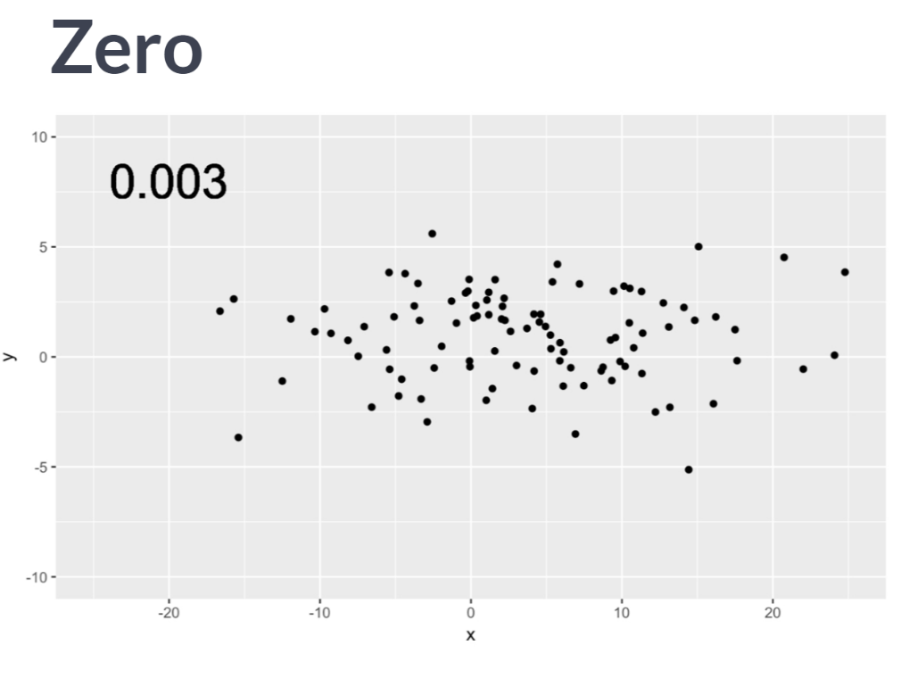  
If there really is no linear relationship between the two variables, then the correlation coefficient will be close to zero. Note how knowing one of the x values gives us almost no information about what the corresponding value of y will be.

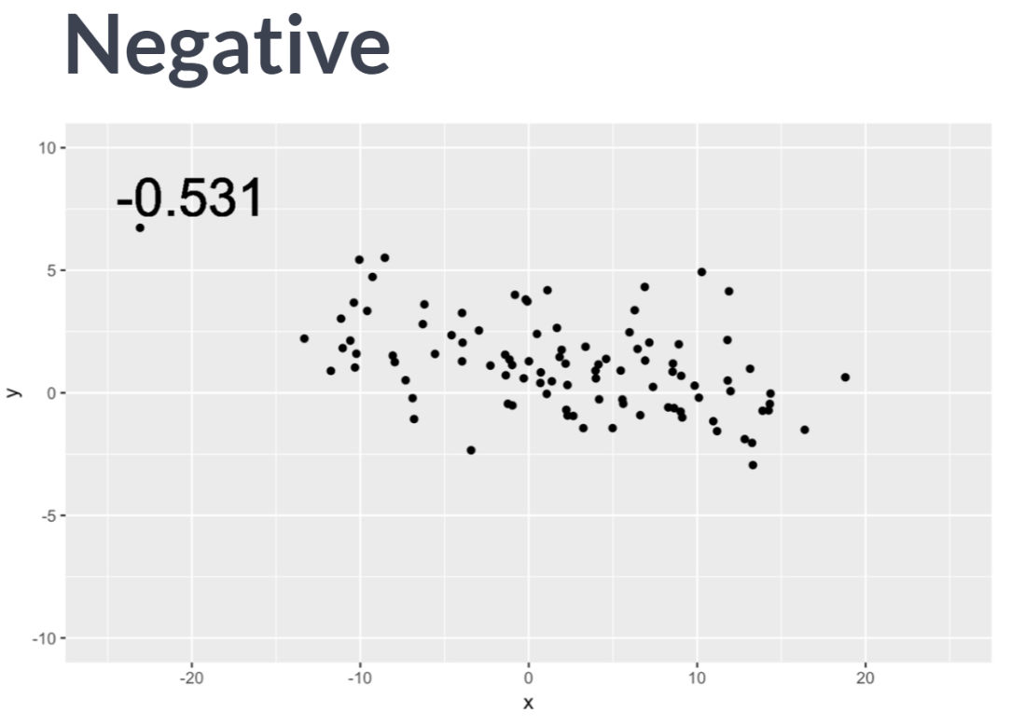  
Of course, when the direction of the relationship is negative, the value of the correlation coefficient is as well. It is crucial to remember that the correlation coefficient only captures the strength of the **linear** relationship between two variables. It is quite common to observe variables that are strongly related, but in a nonlinear way. Blindly computing and reporting the correlation between such variables is not likely to yield meaningful results.

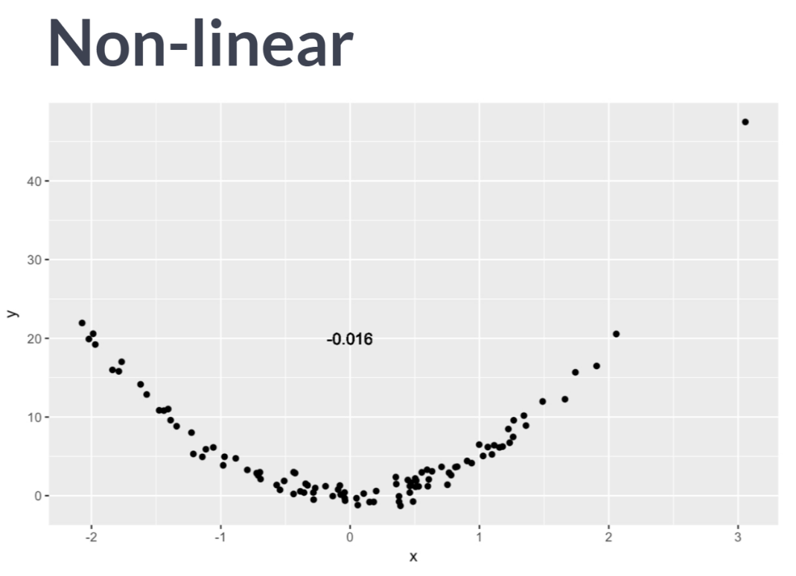  
This scatter plot shows a clear, quadratic relationship. To simply interpret the low correlation coefficient as evidence that x and y are unrelated would be plainly incorrect. Here, x and y are closely related just not in a linear fashion.

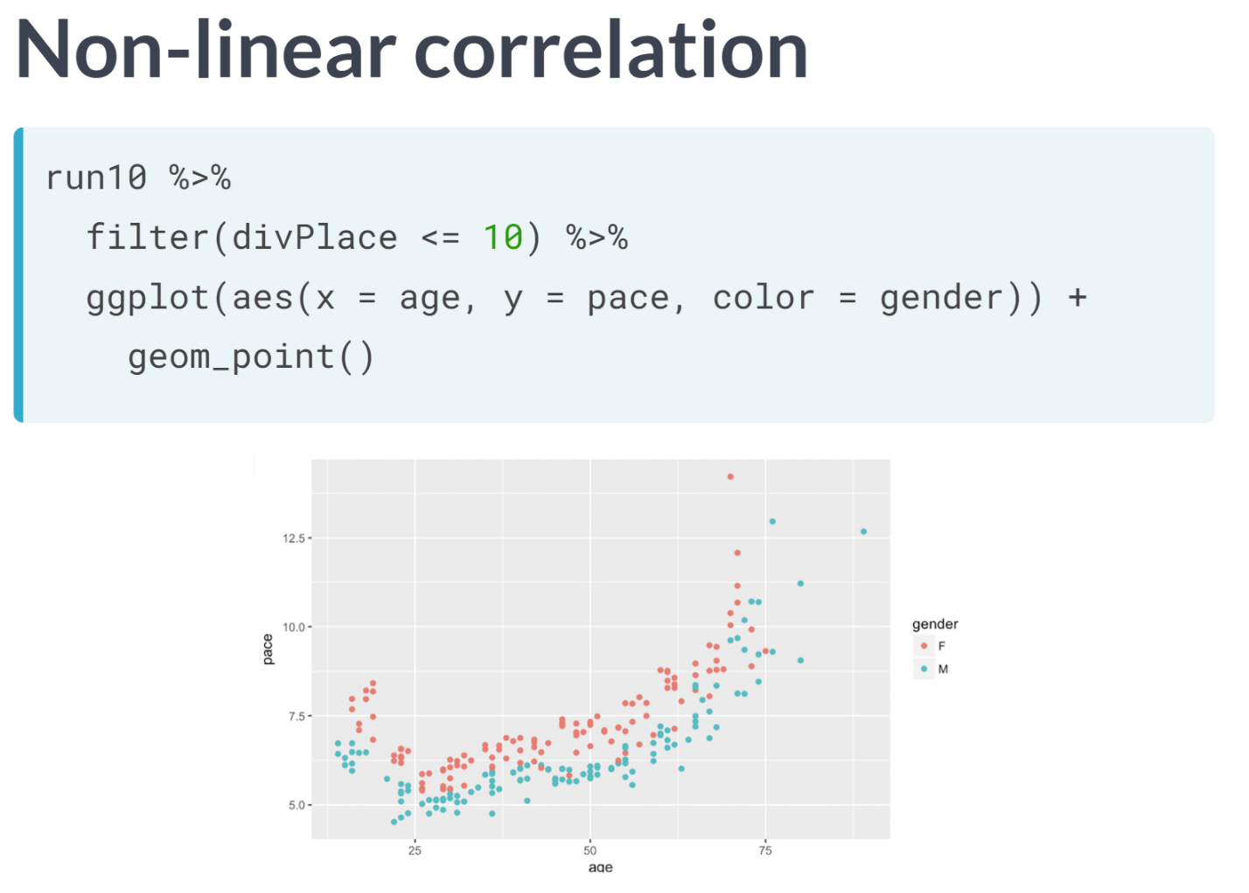  
Here's an example of real data from a 10-mile run. The pace of the top ten finishers in each age group are plotted against their age. Note how the relationship between the pace and age is nonlinear: 25 years old tend to actually be faster than 20-year old, but as people age beyond their thirties, they tend to get slower. This pattern is present for both men and women.

The value of the correlation coefficient here is about .68, but we have some intuitive sense that pace and age are more closely related than the figure indicates.

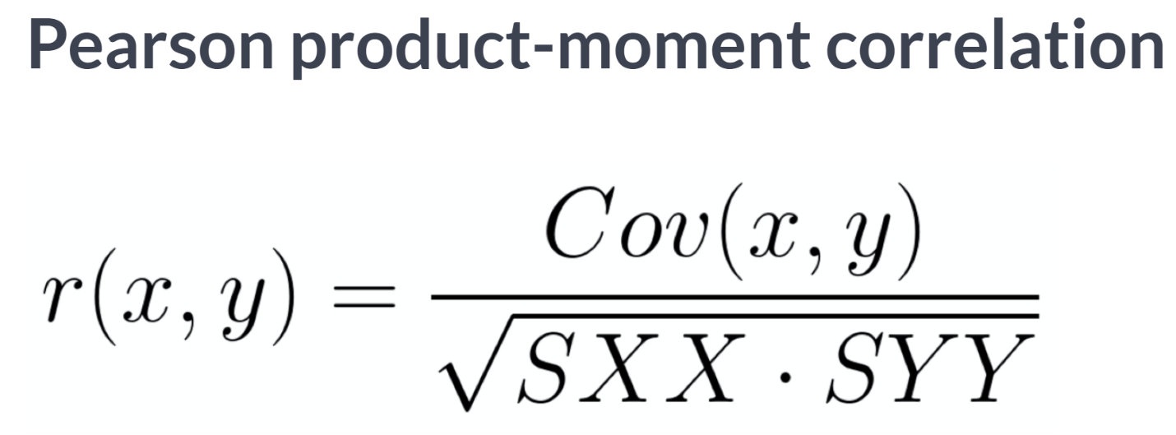  
There are several different ways that correlation can be defined in statistics, but by far the most common is the Pearson Product Moment correlation.

Correlation is most often denoted with the letter *r* and it is a function of two variables, most commonly *x* and *y*. The definition in terms of covariance, which haven't defined, and the sums of the squares is shown here.

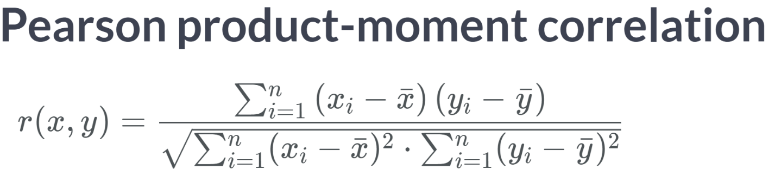

This is an alternative definition using only x's and y's, and their means: $\overline{x}$ and $\overline{y}$.

In the denominator, we see the sums of the squared deviations in both *x* and *y*. In the numerator, we see a sum of terms involving both x and y. In fat, each term in the sum of is the area of the rectangle with corners at each data point, $x_{\dot{l}}$ and $y_{i}$, and the means, $\overline{x}$ and $\overline{y}$.

So, in some sense, we are measuring the deviation from the mean in both x and y. We don't need to memorize this formula as R will do this for us.

# Understanding correlation scale

In a scientific paper, three correlations are reported with the following values:

1. -0.395
2. 1.827
3. 0.738

Choose the correct interpretation of these findings.

  
Right! Correlation coefficients cannot be greater than 1 or smaller than -1.

# Understanding correlation sign

In a scientific paper, three correlations are reported with the following values:

* 0.582
* 0.134
* -0.795

Which of these values represents the strongest correlation?

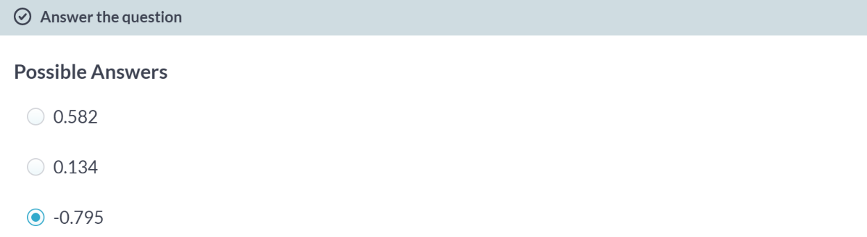  
Right! Absolute value of the -0.795 is the biggest among three choices.

# Computing correlation

The cor(x, y) function will compute the Pearson product-moment correlation between variables, x and y. Since this quantity is symmetric with respect to x and y, it doesn't matter in which order you put the variables.

At the same time, the cor() function is very conservative when it encounters missing data (e.g. NAs). The use argument allows you to override the default behavior of returning NA whenever any of the values encountered is NA.

Setting the use argument to "pairwise.complete.obs" allows cor() to compute the correlation coefficient for those observations where the values of x and y are both not missing.

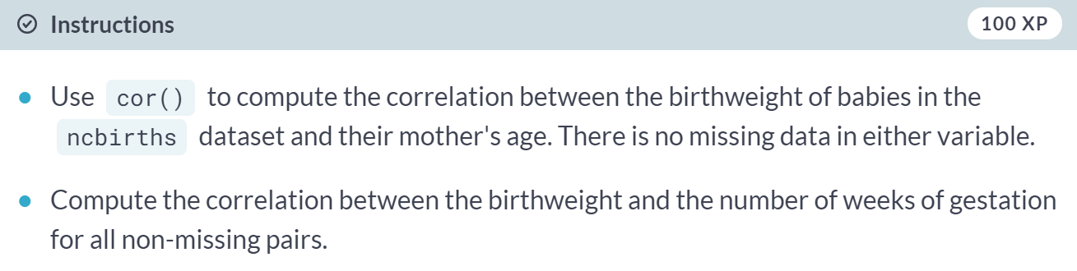  
  
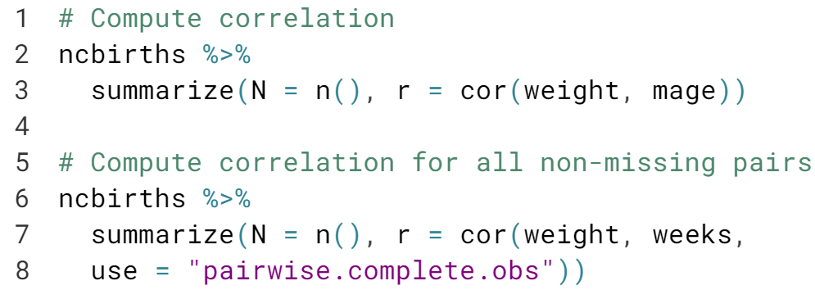

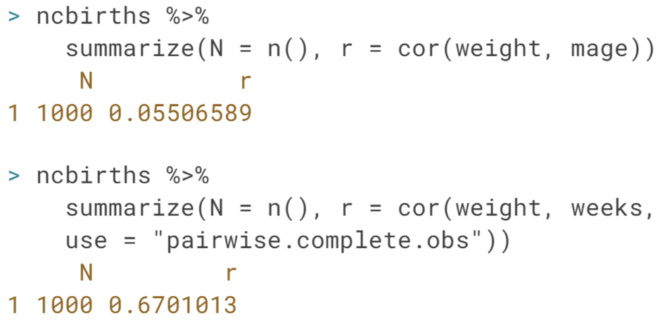



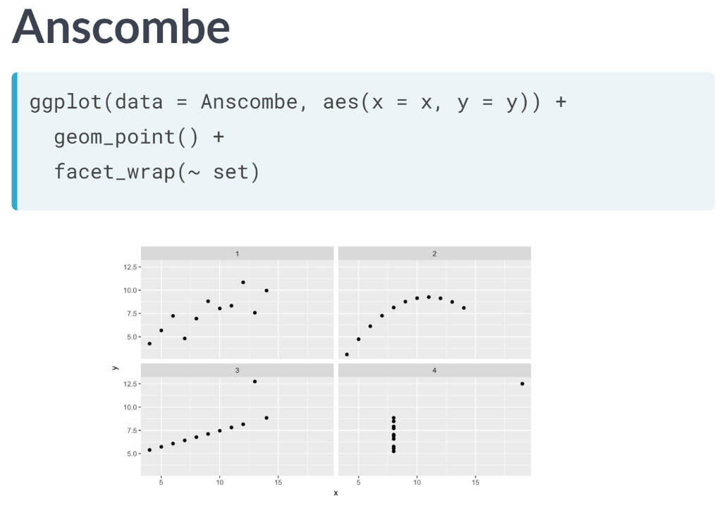  
Here we see four datasets, each having a very different graphical presentation. However, these datasets have the same number of points, the same mean and standard deviation in both x and y, the same correlation, and the same regression line. How is it possible that four datasets with such obvious visual differences could have so many identical important properties?

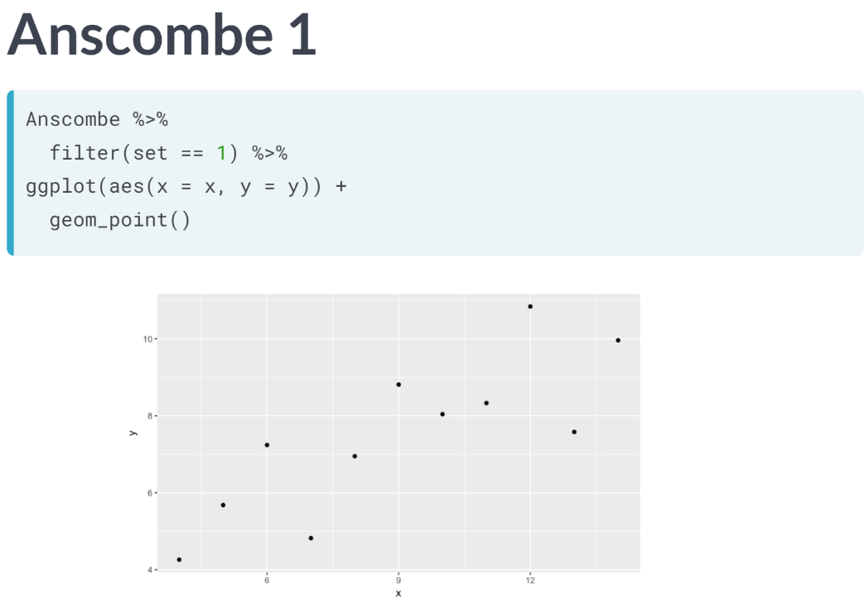  
The first dataset looks the most like "real data". Here we see a positive, linear, moderately strong relationship. As you gain experience working with real data, you will see lots of scatter plots that look similar to this one. Here, the correlation coefficient of .82 is giving us an accurate measurement of the strength of the linear relationship between x and y.

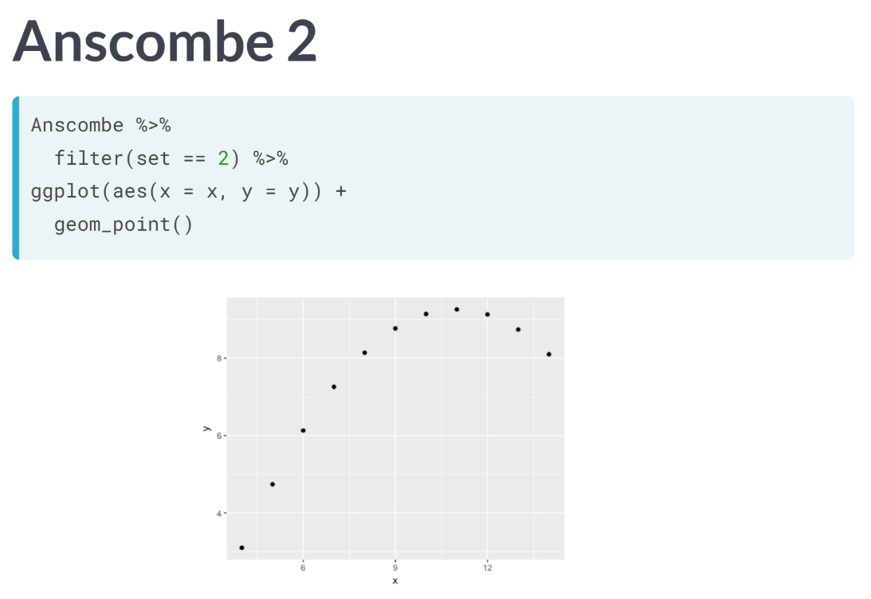  
However, in this set we see something quite different. The relationship here is clearly nonlinear. But note also that while the value of the correlation coefficient is .82, in an intuitive sense, is perfect. That is, knowing the value of x tells us the value of y exactly, having no statistical noise. It's just that the relationship is not linear.

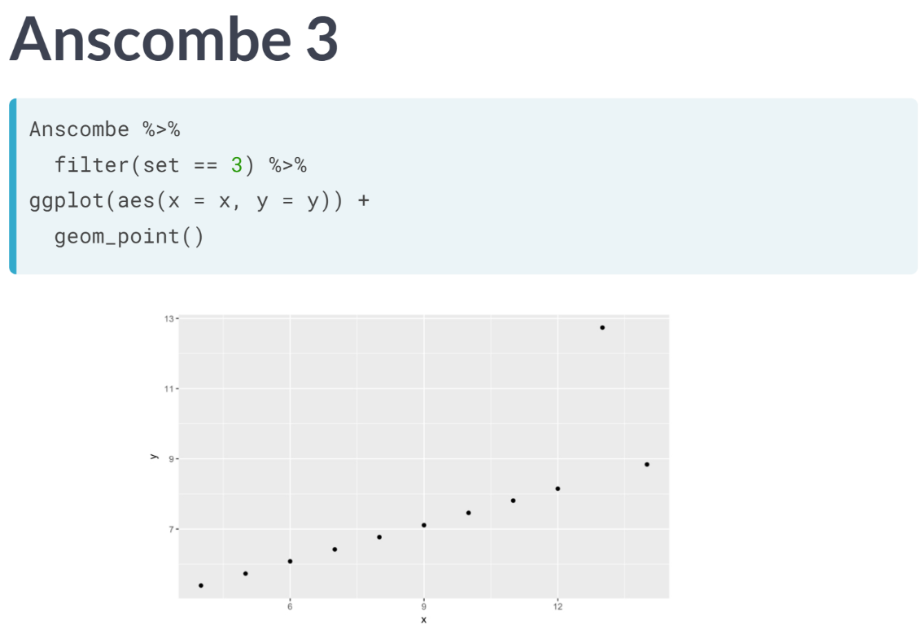  
In the third dataset, we have an outlier. Here again, our eyes tell us that with the exception of the outlier, the correlation between x and y is perfect, and in this case, it is linear. However, the presence of the outlier has lowered the value of the correlation coefficient and, as we will learn soon, the slope of the regression line.

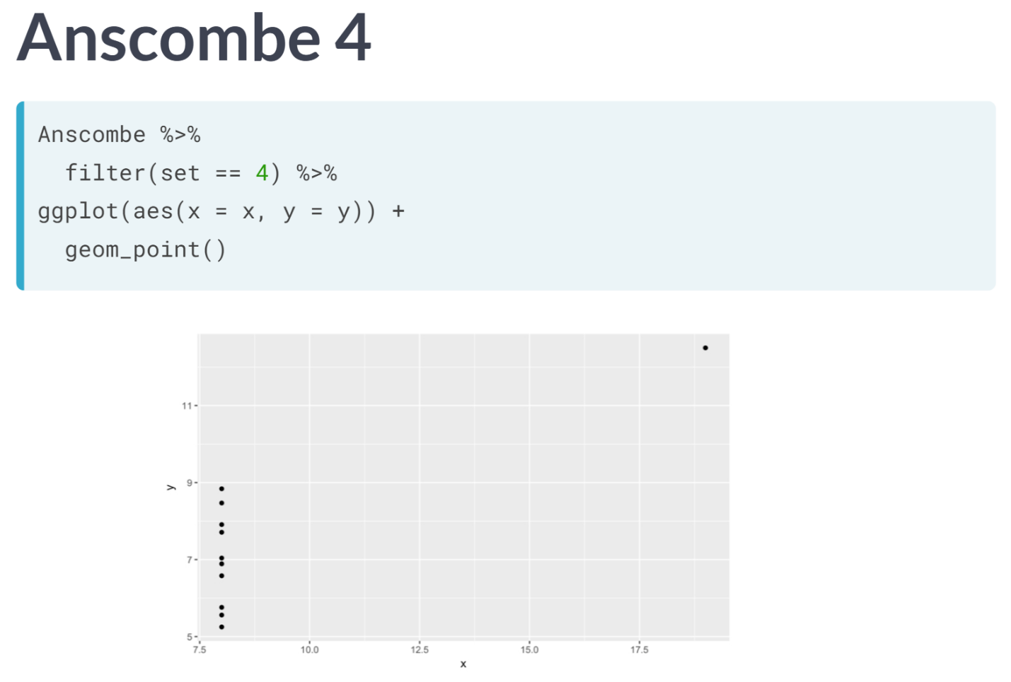  
Finally, in the fourth dataset, we see a pathological example with almost the opposite problem. In the previous plot, we saw that the presence of a single outlier had lowered the correlation from 1 to 0.82.

In this plot, the presence of a single outlier raises the correlation from undefined to 0.82. Note that here, with the exception of the outlier, knowing x doesn't tell us anything about y.

It is only the outlier that gives us the appearance of a correlation, but that correlation is specious.

The Anscombe datasets are fabricated, but they help to illustrate some properties of correlation. Above all else, these examples help to underscore the importance of visually inspecting our data.

# Exploring Anscombe

In 1973, Francis Anscombe famously created four datasets with remarkably similar numerical properties, but obviously different graphic relationships. The Anscombe dataset contains the x and y coordinates for these four datasets, along with a grouping variable, set, that distinguishes the quartet. It may be helpful to remind yourself of the graphic relationship by viewing the four scatterplots:

ggplot(data = Anscombe, aes(x = x, y = y)) +

geom_point() +

facet_wrap(~ set)

(Graphs after running the code above)  
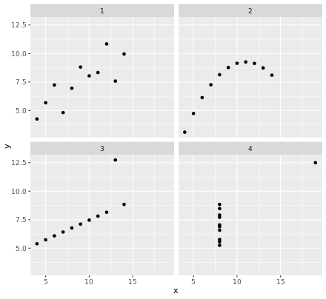

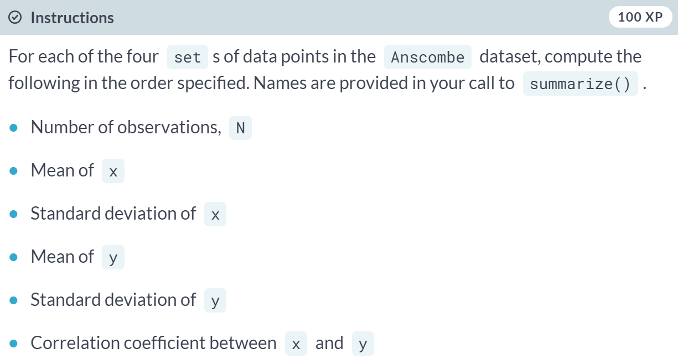  
  
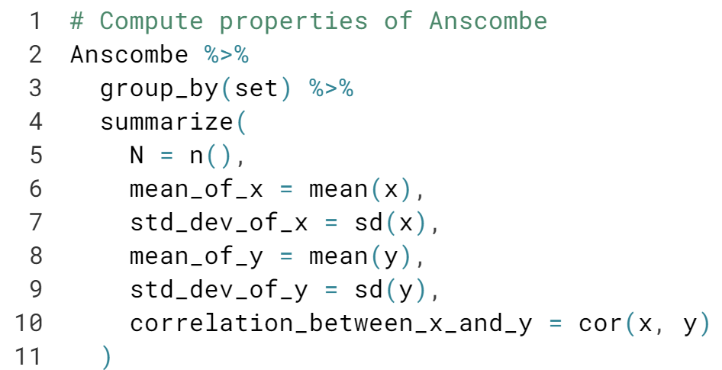  
  
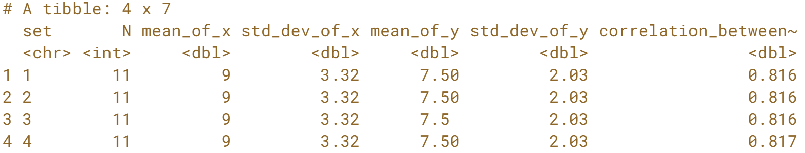  
Great work! Note that all of the measures are identical (ignoring rounding error) across the four different sets.

# Perception of correlation

Recall the scatterplot between the poverty rate of counties in the United States and the high school graduation rate in those counties from the previous chapter. Which of the following values is the correct correlation between poverty rate and high school graduation rate?

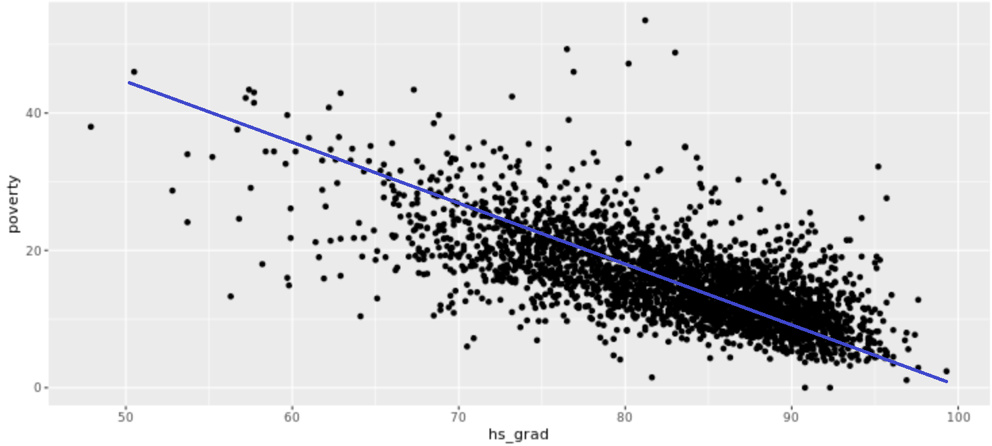

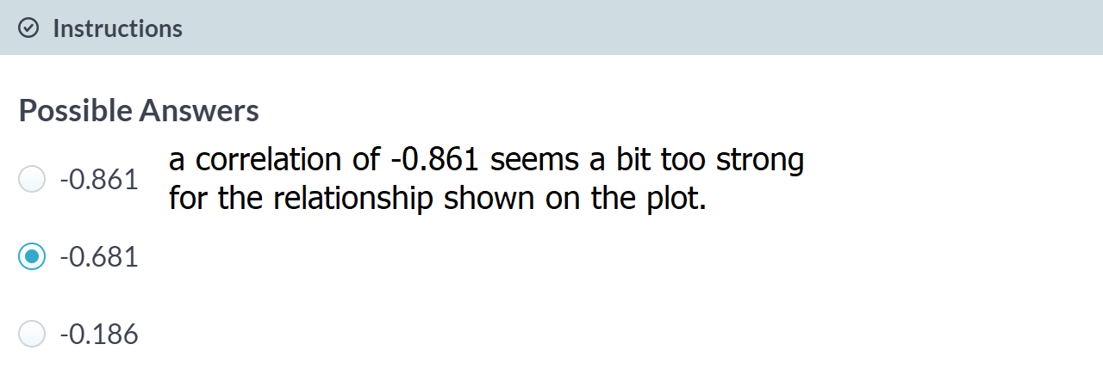

# Perception of correlation (2)

Estimating the value of the correlation coefficient between two quantities from their scatterplot can be tricky. [**Statisticians have shown that**](https://statistics.stanford.edu/sites/default/files/EFS%20NSF%20206.pdf) people's perception of the strength of these relationships can be influenced by design choices like the x and y scales.

Nevertheless, with some practice your perception of correlation will improve. Toggle through the four scatterplots in the plotting window, each of which we’ve seen in a previous exercise. Jot down your best estimate of the value of the correlation coefficient between each pair of variables. Then, compare these values to the actual values you compute in this exercise.

If you're having trouble recalling variable names, it may help to preview a dataset in the console with str() or glimpse().

  
  
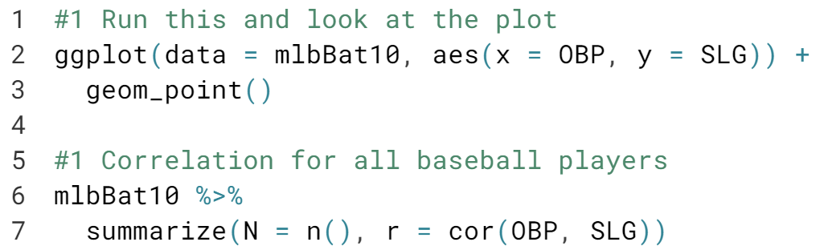  
  
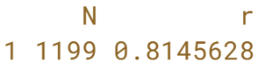  
  
  
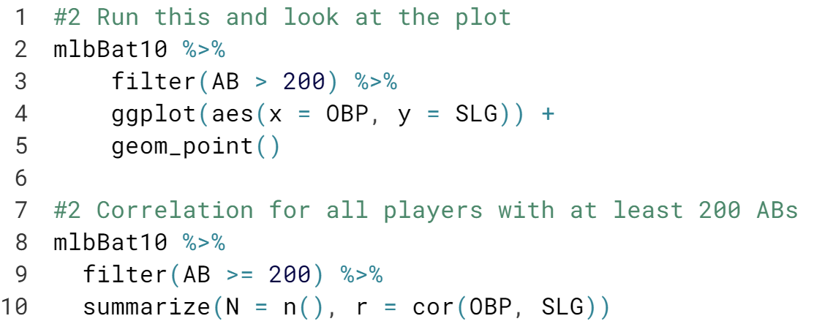

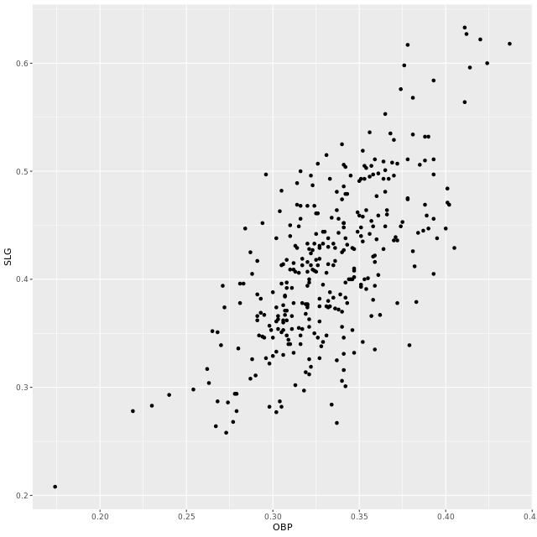  
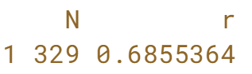

  
  
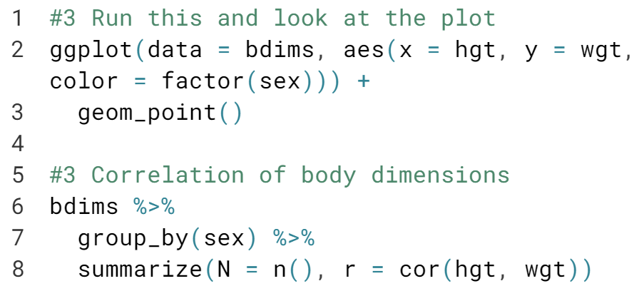

  
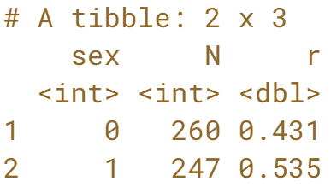

  
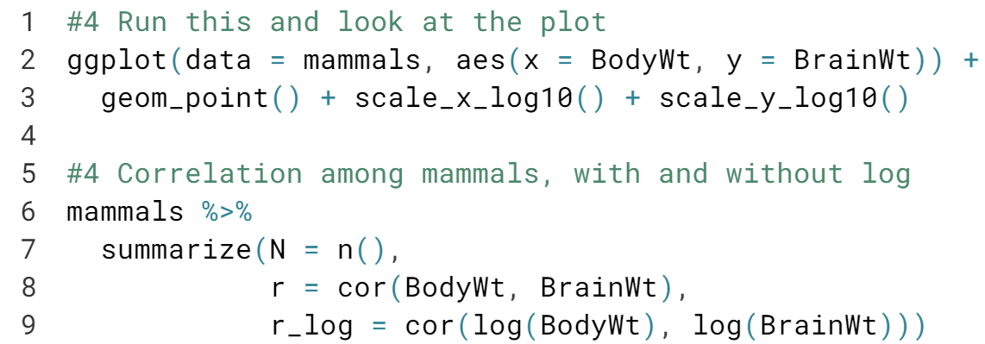

  
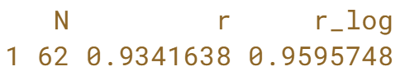



The word "correlation" can be misused.

  
For example, consider the following article about the connection between exercise and drinking beer. After discussing some relatable scenarios, the lead-in raises the question of causation:  
"But whether exercise encourages people to drink and, likewise, whether drinking encourages people to exercise has been in dispute.

But causation is not really the goal here. Notice how in the next two paragraphs, verbs linking exercise and beer drinking include "influence", "affect", and "tend to". The "interplay between" the two activities is also mentioned.

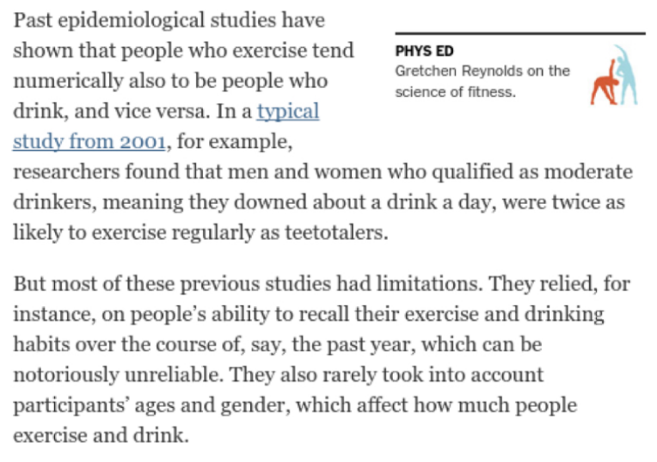  
In the end, this article is worded fairly carefully. Although many different possible connections between exercising and drinking are explored, the author has taken steps not to imply that the research demonstrates that exercising causes one to drink nor that drinking causes one to exercise.

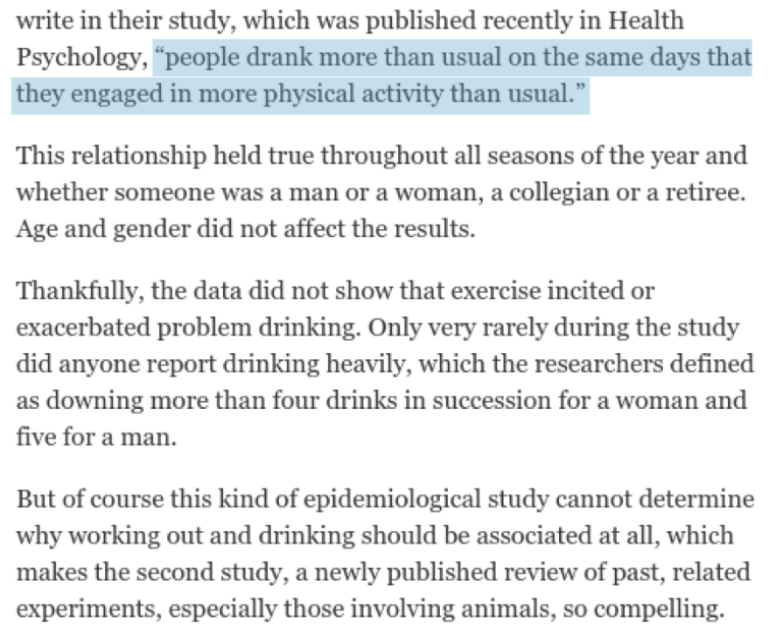  
The best interpretation is quoted from actual study, "people drank more than usual on the same days that they engaged in more physical activity than usual." Note how this statement makes it clear that an association was observed but doesn't try to imply causality.

In observation studies, which are especially common in nutritional science, health, and epidemiology, one must be careful not to erroneously suggest that correlation implies causation.

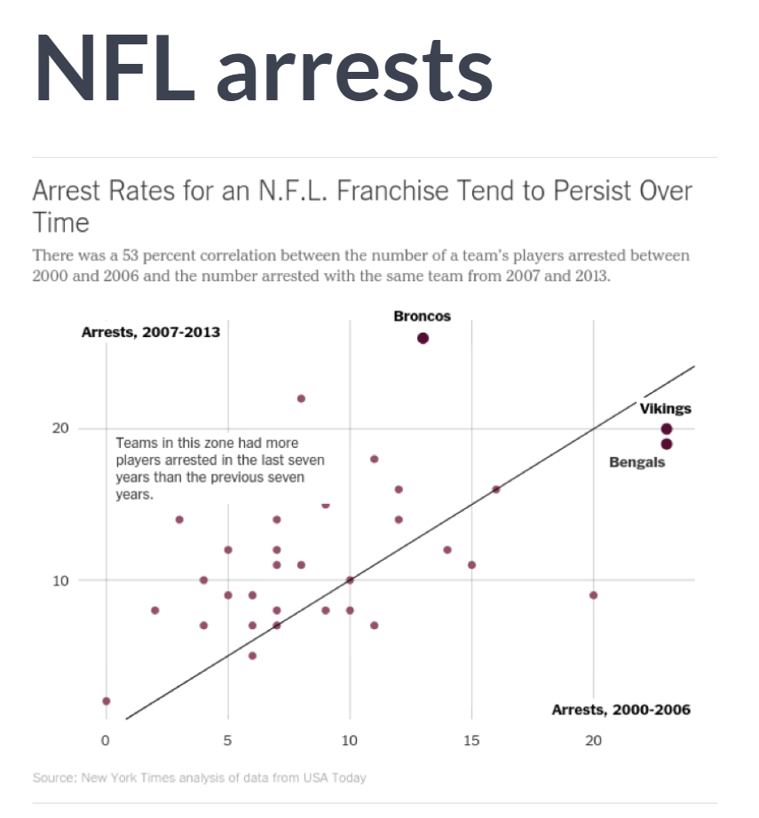  
Here's another interesting use of correlation from NYTimes. The article examines the arrest records of NFL payers and ,among other things, considers whether certain franchises tend to have more, or fewer players arrested consistently over time.

This use of correlation is often called **serial correlation** or **autocorrelation**, which checks to see whether a single numeric variable is highly correlated with past measurements of itself.

From the plot and the reported 0.53 correlation, we see some evidence that the number of players arrested from each team during the seven-year period from 2000 to 2006 was positively associated with the numbers of players arrested by that same team during the subsequent seven year period from 2007 to 2013.

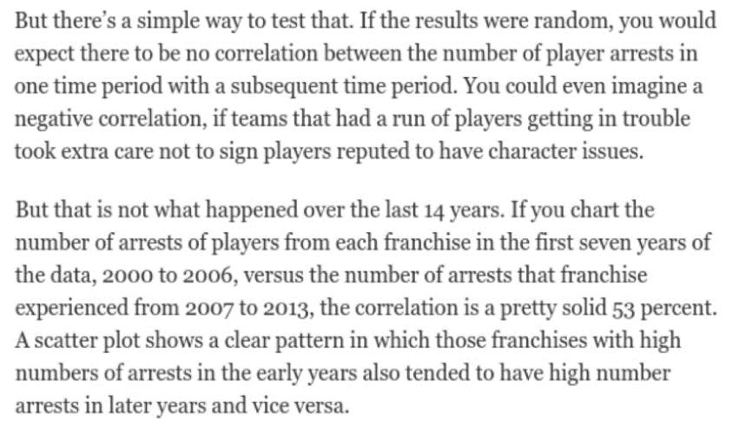

The author interprets both the plot and reported a "pretty solid" correlation as evidence of a team-specific effect. Without offering explanations or implying cause-and-effect, the author effectively communicates that player arrests in the NFL do not appear to be randomly distributed across teams, but rather that certain teams may have player acquisition philosophies that result in them having consistently higher numbers of players arrested.

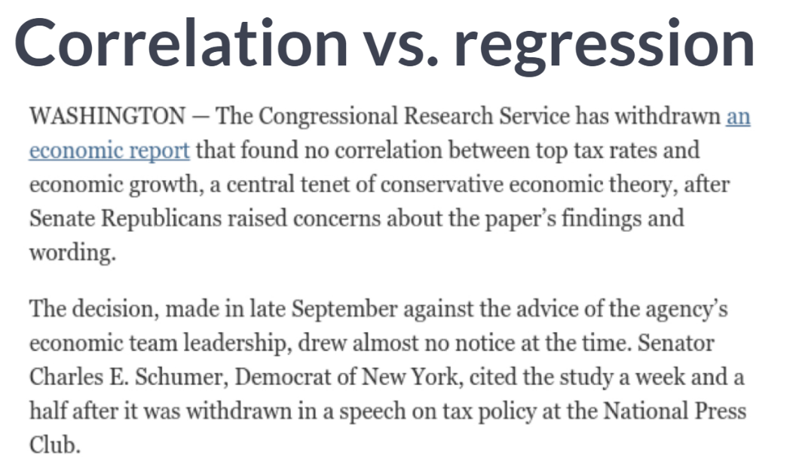  
Sometimes journalists can leave statistical concepts lost in translation. The first sentence of this article reports that no correlations was found between economic growth and lower tax rates at the top of the income bracket.

This is a politically sensitive finding and indeed much of the article discusses attempts by senate republicans to bury these findings, which run counter to their ideological position on macroeconomic issues.

Of greater interest to us is that the word "Correlation" here isn't being used in its precise statistical sense. The link to the actual report reveals that the findings are based on multiple regression model, not a simple correlation.

For the records, multiple regression is when more than one explanatory variable can be considered. This is impossible to do with correlation, which is a simple, bivariate statistic.

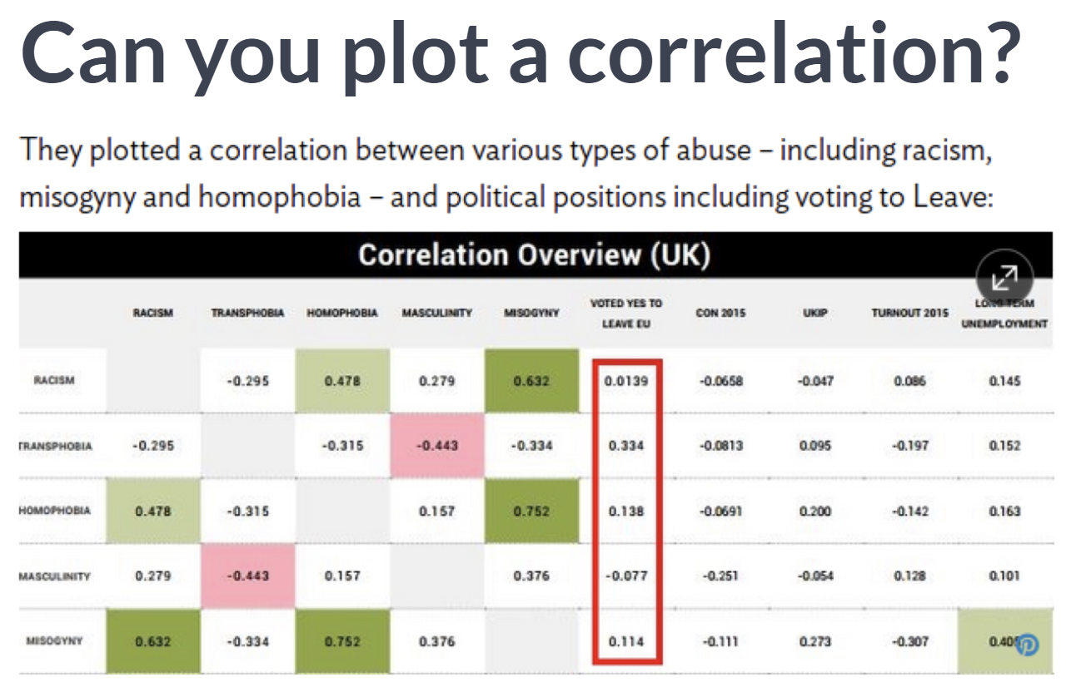

Finally, it is not uncommon to encounter references to a "plot" of a correlation. This doesn’t quite make sense. Of course, a scatter plot may be a graphical presentation of two variables and the strength of the linear relationship shown can be neatly summarized by a correlation.

In this case, the article refers to a table of correlations between several variables often called a correlation matrix as a "plot" of a correlation. The conclusion that there is no correlation between voting for Brexit and racism is supported by these small correlation values.

What other evidence would you want to see in order to have confidence in these findings? The next few exercises will test our ability to interpret correlation like a pro.

# Interpreting correlation in context

Recall that you previously determined the value of the correlation coefficient between the poverty rate of counties in the United States and the high school graduation rate in those counties was -0.681. Choose the correct interpretation of this value.

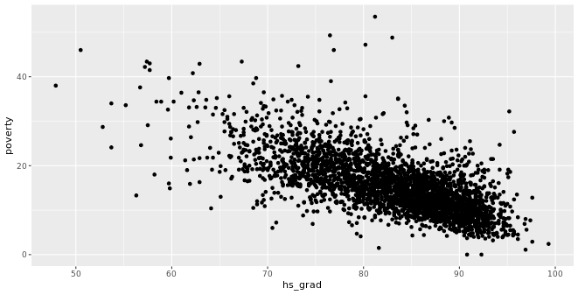  
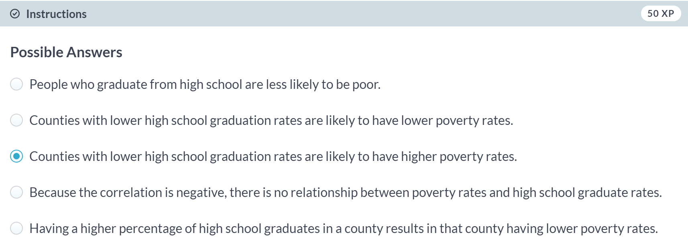  
Option A is incorrect because it contains ecological fallacy.

Option B is incorrect because the sign is flipped.

Option D is incorrect because negative correlation is still a correlation.

Option E is incorrect because correlation doesn’t imply causation.

# Correlation and causation

In the San Francisco Bay Area from 1960-1967, the correlation between the birthweight of 1,236 babies and the length of their gestational period was 0.408. Which of the following conclusions **is not** a valid statistical interpretation of these results?

  
Right! Option C is incorrect because correlation does not imply causation!



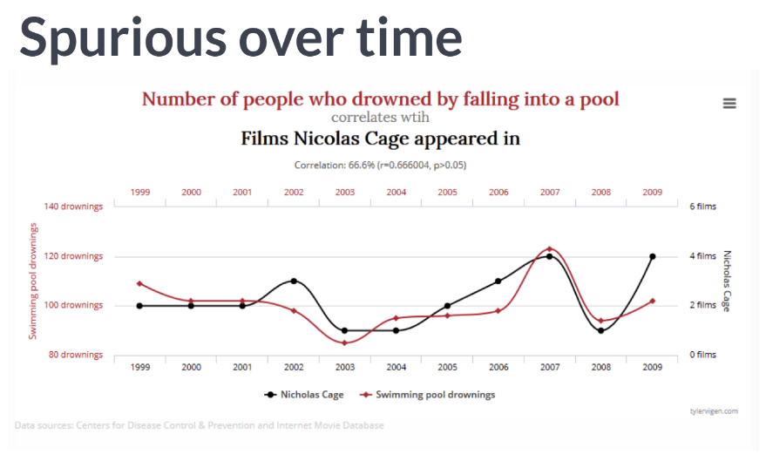  
Above all else, we must always remember that correlation does not imply causation. This is because two variables appear to move together doesn't mean that changes in one area are causing changes in the other.

There are many potential confounders that can cloud our ability to determine cause-and-effect. Remarkable but nonsensical correlations are called, *"spurious".* In fact, there is an entire blog devoted to them.

Here's how the number of films Nicholas Cage has appeared in correlates with the number of people who drowned by falling into a pool. Are these two variables related by any substantive means? Of course not.

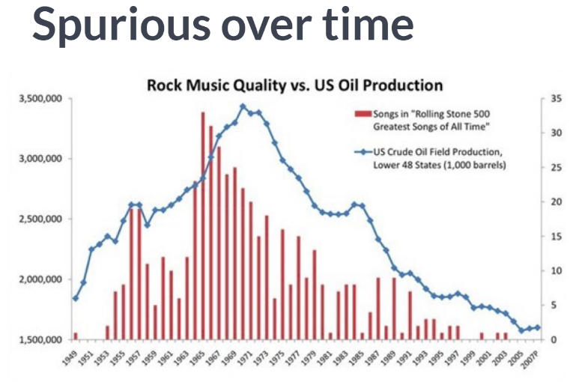  
Here's another example that traces US Oil production to the quality of rock music. I suppose one may need to burn the midnight oil to make a truly endearing rock classic.

In each of these cases, the correlation was illustrated as two variables that seem to move together over time. In fact, time is an obvious confounder for many of these spurious correlations.

Any time you see two variables linked over time, you should be skeptical of the roles that time can play as a confounder.

  
This webcomic from XKCD illustrates how space can also be present in spurious correlations. Colored maps, called choropleths, can be visually arresting ways of conveying information, but they can also reveal spurious correlations.

Many things occur more often in places where there are more people, so failure to control for the confounding influence of populations can lead to spurious correlations.

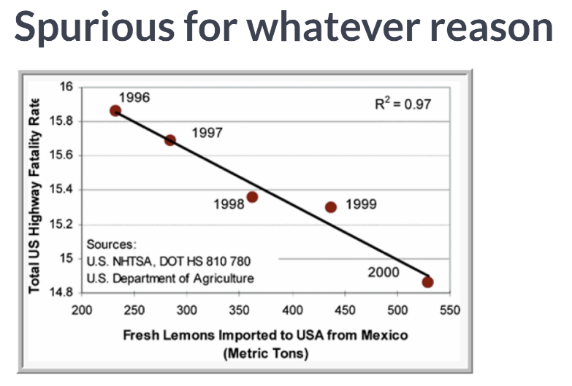  
In other cases, it may not be so obvious what confounding variables are driving the spurious correlations. This plot shows that as the number of lemons imported in the United States from Mexico has increased over time, the number of US highway fatalities has decreased.

The relationship appears to be strong, but of course, there is no plausible causative mechanism that could explain the relationship. This is most likely simply due to the chance. The scrupulous statistician must always be on the lookout for such spurious correlations.

# Spurious correlation in random data

Statisticians must always be skeptical of potentially spurious correlations. Human beings are very good at seeing patterns in data, sometimes when the patterns themselves are actually just random noise. To illustrate how easy it can be to fall into this trap, we will look for patterns in truly random data.

The noise dataset contains 20 sets of x and y variables drawn at random from a standard normal distribution. Each set, denoted as z, has 50 observations of x, y pairs. Do you see any pairs of variables that might be meaningfully correlated? Are all of the correlation coefficients close to zero?

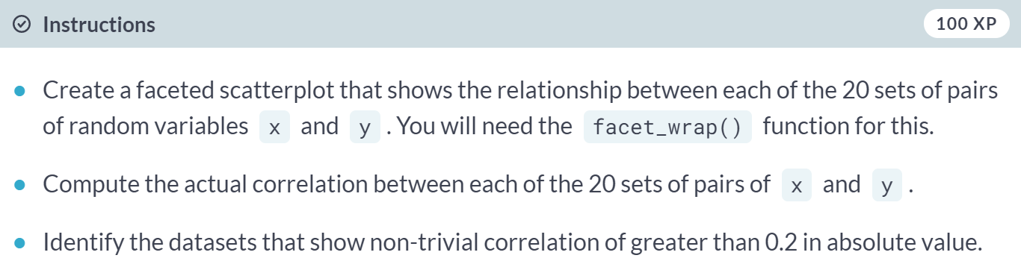

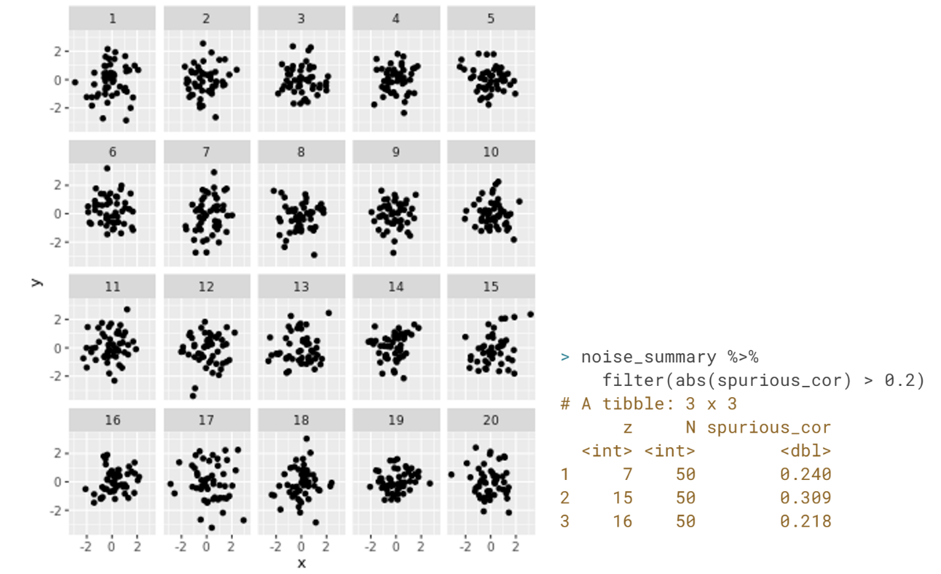

***Simple linear regression***With the notion of correlation under your belt, we'll now turn our attention to simple linear models in this chapter.



Let's build some intuition about what a regression line is.

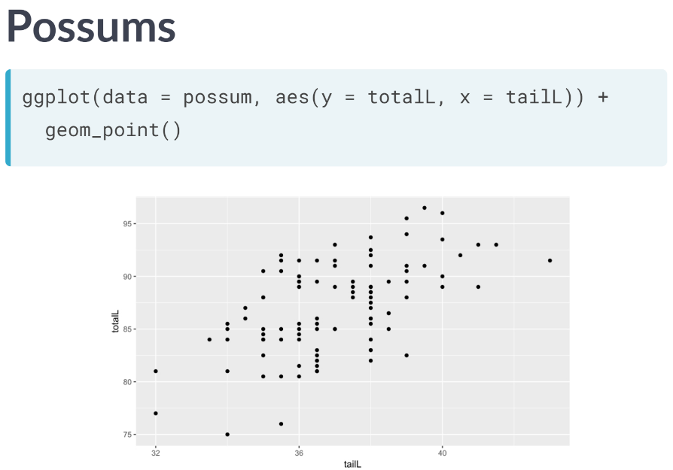  
In this scatterplot, we see the relationship between the total length of a possum and the corresponding length of its tail. Clearly, there is not a perfect relationship here: the total length of the possum varies even for possums with the same tail length. But we still have some intuitive desire to describe the relationship with a line.

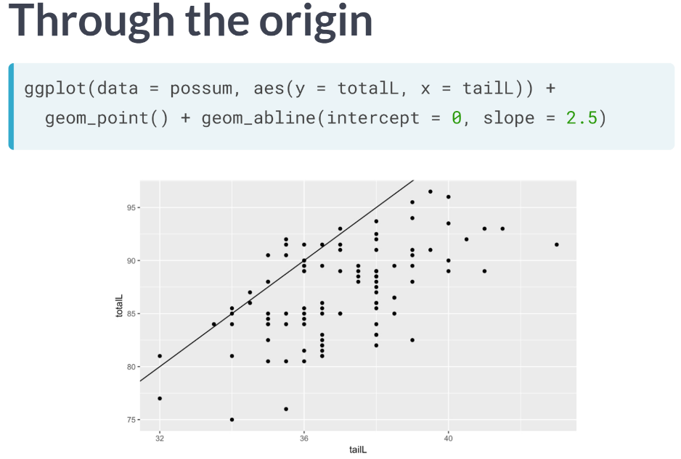  
This line goes through the origin, that is, the point where both x and y are equal to zero and has a slope of 2.5 centimeters per centimeter. In some sense, it does go through the points, but it doesn't capture the general trend as best we could gain.

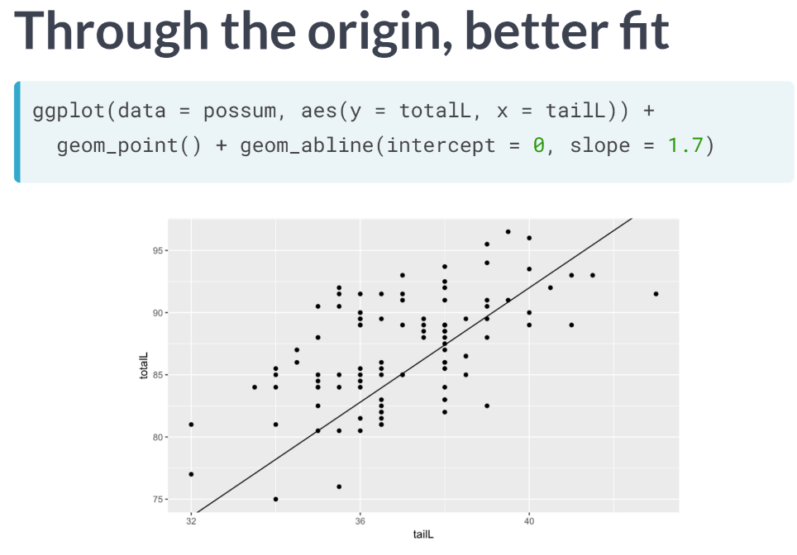  
This line also goes through origin but has a gentler slope. It seems like a better fit since it cuts through the points in a more central way.

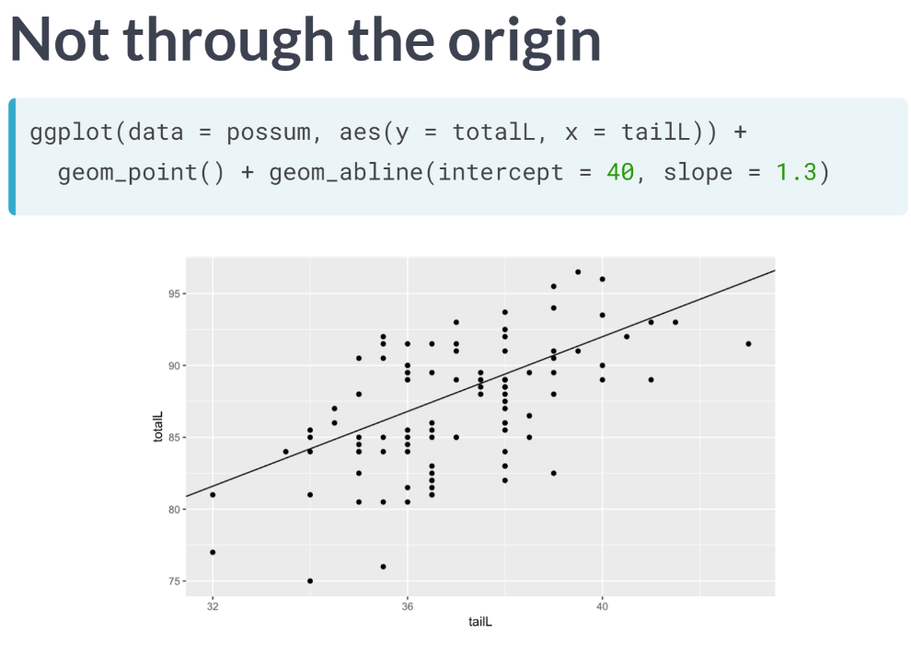  
But why should we force the line to go through the origin? Here's a line that has a y-intercept of 40 centimeters and an even gentler slope of 1.3 centimeters per centimeter. It seems like an even better fit still.

In order to find a best fit, there needs to be some criteria for judging which line fits better. In particular, we need a numerical measurement of how good the fit of each possible line is. In regression, we use the least squares criterion to determine the best fit line.

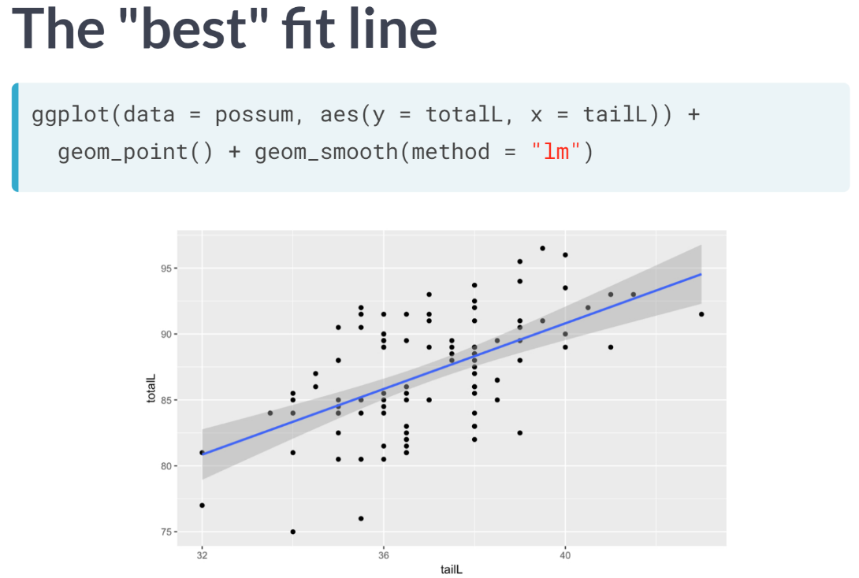  
Statisticians have proven that, apart from pathological examples, if we seek the line that tries to minimize the sum of the squared distances between the line and a set of data points, a unique line exists. That line is called the least squares regression line.

We can add the line to our plot using the ***geom_smooth()*** function and specifying the method argument to be *lm*, which stands for linear model. Note that by default, this will draw the regression line in blue with gray shading for the standard error associated with the line.

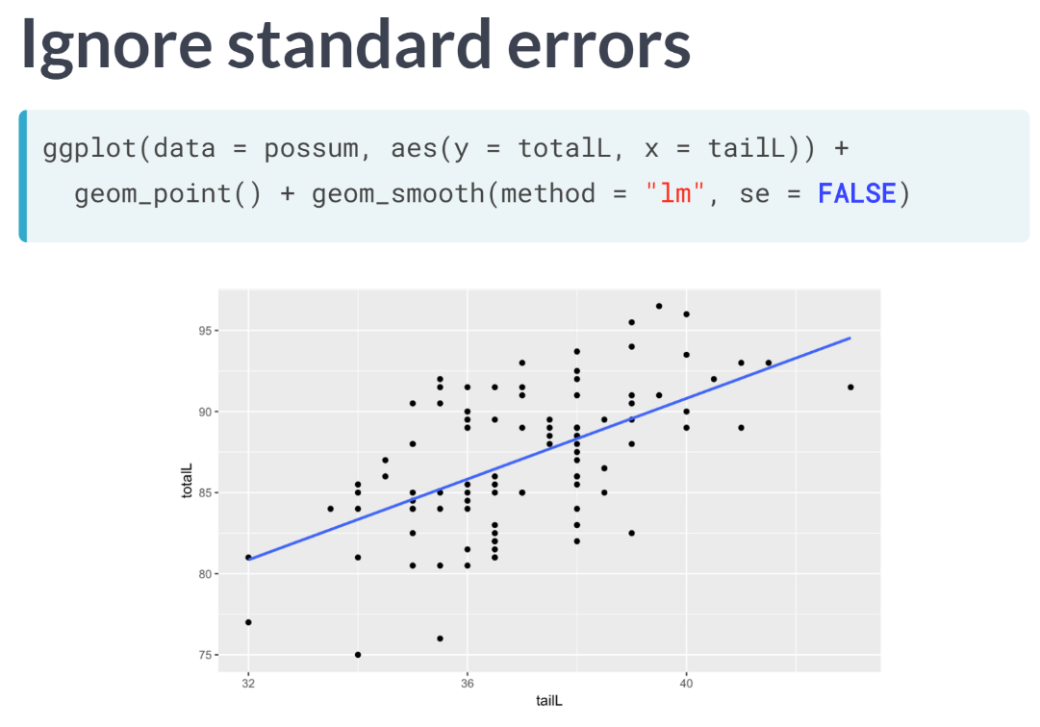  
But that needn't concern us just yet, so we can turn it off by setting the *se* argument to FALSE or to 0.

# The "best fit" line

The simple linear regression model for a numeric response as a function of a numeric explanatory variable can be visualized on the corresponding scatterplot by a straight line. This is a "best fit" line that cuts through the data in a way that minimizes the distance between the line and the data points.

We might consider linear regression to be a specific example of a larger class of smooth models. The geom_smooth() function allows you to draw such models over a scatterplot of the data itself. This technique is known as visualizing the model in the data space.

The method argument to geom_smooth() allows you to specify what class of smooth model you want to see. Since we are exploring linear models, we'll set this argument to the value "lm". Note that geom_smooth() also takes an se argument that controls the standard error, which we will ignore for now.

  
  
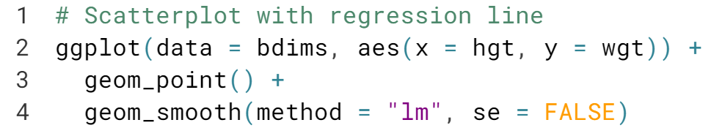  
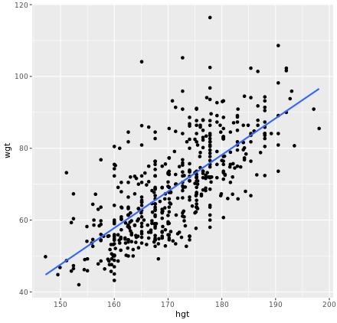

# Uniqueness of least squares regression line

The least squares criterion implies that the slope of the regression line is unique. In practice, the slope is computed by R. In this exercise, you will experiment with trying to find the optimal value for the regression slope for weight as a function of height in the bdims dataset via trial-and-error.

To help, we've built a custom function for you called add_line(), which takes a single argument: the proposed slope coefficient.

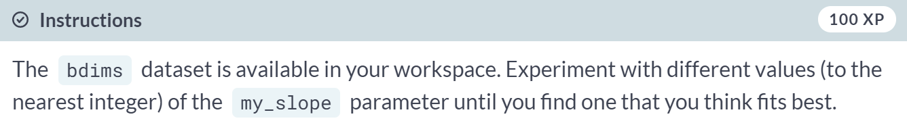

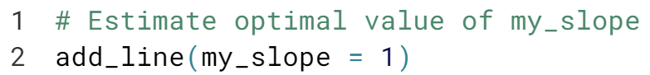

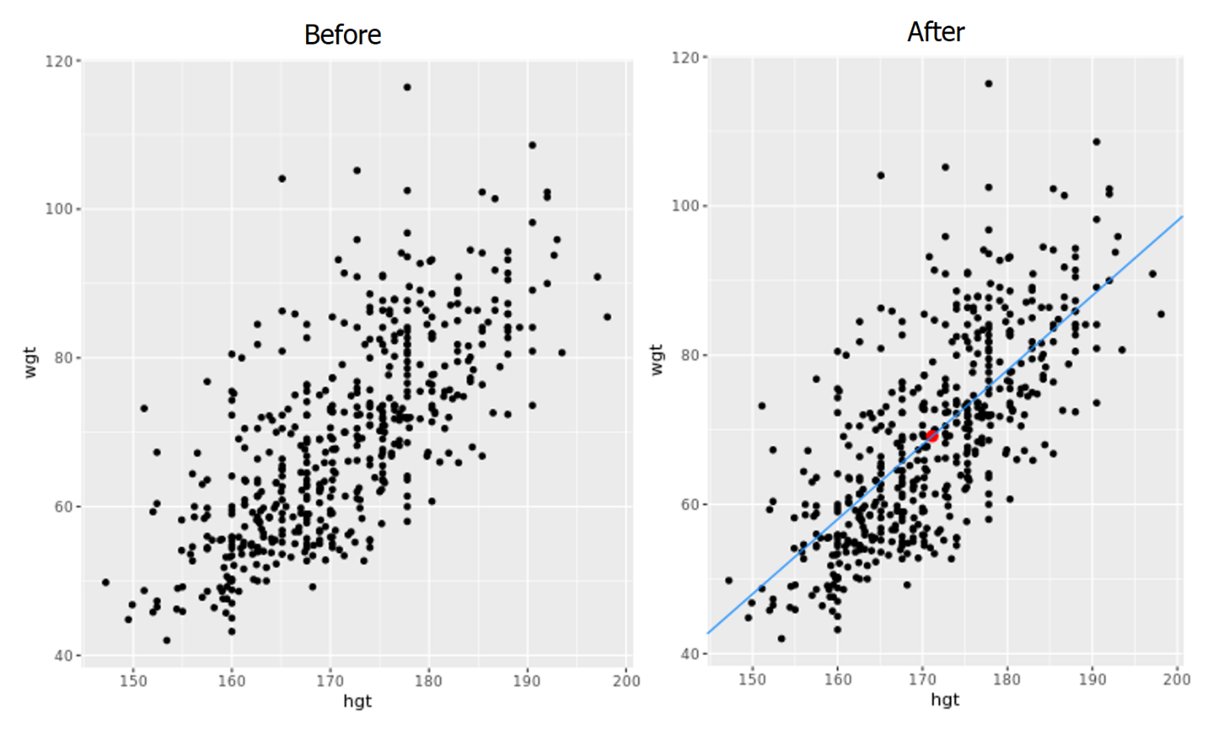



  
Models are ubiquitous in statistics. In many cases, we assume that the value of our response variable is some function of our explanatory variable plus some random noise. The latter term is important and, in a philosophical sense, is the signal of statistical thinking.

What we are saying here is that there is some mathematical function *f,* which can translate values of one variable into values of another, except that there is some randomness in the process. What often distinguishes statisticians from the other quantitative researchers is the way that we try to model that random noise.

  
For linear regression model, we simply assume that *f* takes the form of linear function. Thus, our model describes the value of the response variable in terms of an intercept and a slope.

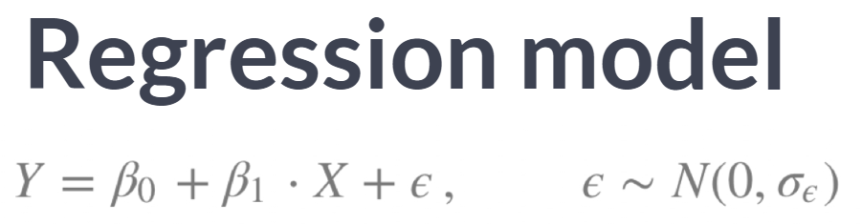

Mathematically, we usually call the intercept beta naught, and the slope beta one. The noise term is often denoted epsilon. In regression model, we specify that the distribution of the noise is normal, with mean 0 and a fixed standard deviation. Again, understanding the specification of this noise term is crucial to thinking like a statistician.

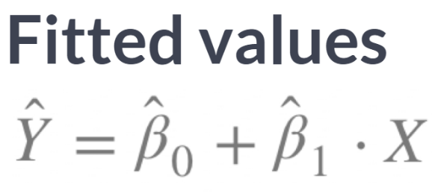  
The part of the function aside from the noise term consists of a linear function that produces the fitted values. These are usually denoted with Y hat. The difference between Y and Y hat is that Y is the actual observed value of the response, while Y hat is the expected values of the response based on the model.

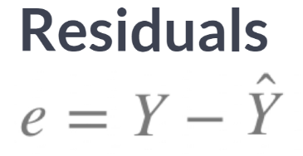  
The difference between those two quantities are called residuals. The order of the terms here matters, so that observations that exceed their expected value of the response variable will have positive residual, while those that don't reach their expected value will have negative residuals.

The residuals are the realization of the noise term. While epsilon and e play analogous roles in the regression equation, epsilon is an unknown, true quality, while e is a known, estimate of that quantity. While we won't delve into the specifics of the least squares fitting procedures, we will outline what it does.

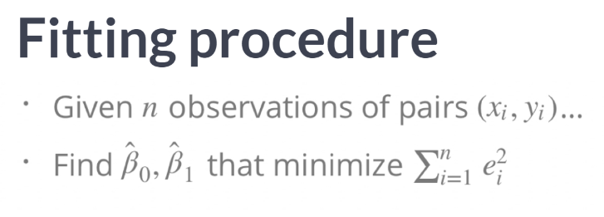  
Given *n* observations of *x* and *y* pairs, the procedure finds estimates for the intercept and slope that minimize the sum of the squared residuals. The estimated intercept and slope are usually denoted beta naught hat and beta one hat, respectively.

Note that here again, the hat indicates an estimated rather than a true quantity. Actually, computing the fitted coefficients is usually a messy business for which the computer is much better suited, so we won't discuss the details here.

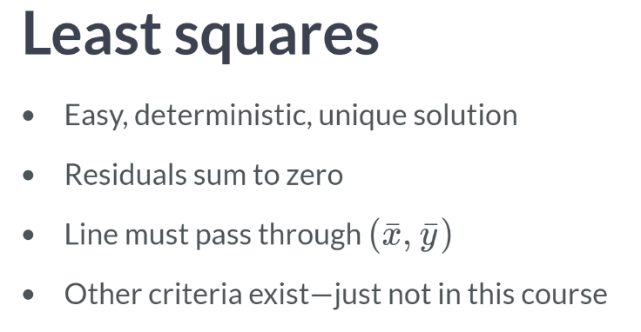  
You should know that the least squares fitting procedure is a well-understood, relatively simple, deterministic process that can be computed efficiently. It will always return a unique solution, except in rare, unrealistic cases. The residuals are guaranteed to sum to 0, and the point, $\overline{x}$, $\overline{y}$, is guaranteed to lie on the regression line.

Given your understanding of correlation, it should not surprise us to learn that regression slope and the correlation coefficient are closely related. In fact, they are proportioned to one another. You should also be aware that other criteria apart from the least square exist, but we won't discuss much about it in this course.

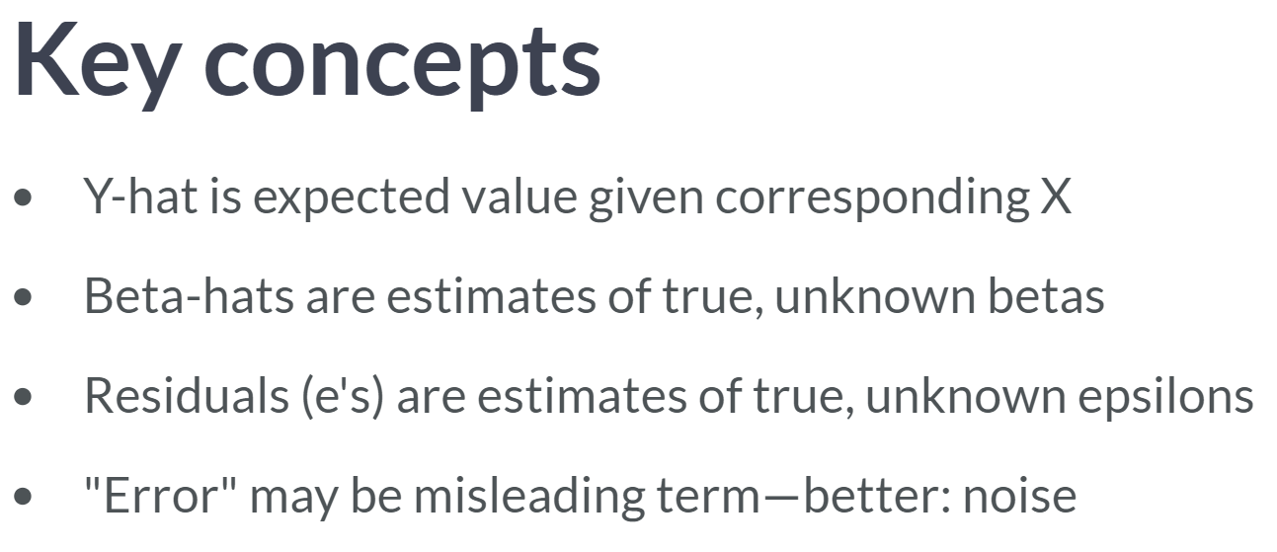  
It's worth reviewing some key concepts about regression models.

First, the fitted values, y hat, are the expected values given the corresponding value of *x*. It's not the case that *x* will always translate into $\hat{y}$; it's just that $\hat{y}$ is our best guess for the true value of *y* given what we know about *x*.

In the same way that the fitted intercept and slope are estimates of the true, unknown intercept and slope, the residuals are estimates of the true, unknown noise. Speaking of which, we may here these noise terms referred to as errors.

The term *"error"* is not necessarily indicating that something is wrong; it's just that physical process is subject to some variation.

# Regression model terminology

Consider a linear regression model of the form:  
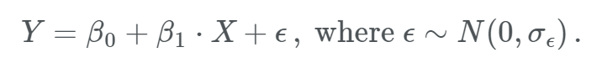

The slope coefficient is:

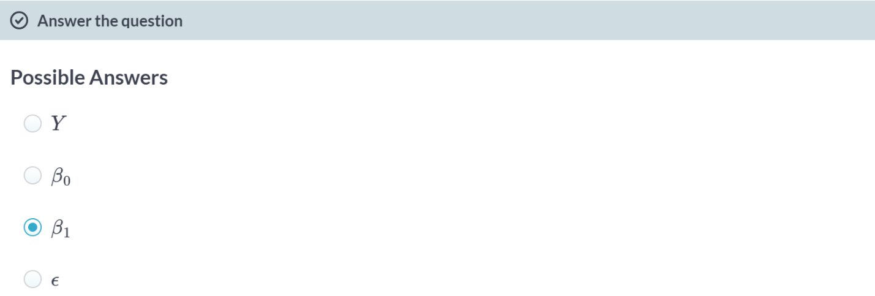

Y represents the response variable.

$β_{0}$ represents the y-intercept.

ϵ represents the disturbance term.

# Regression model output terminology

The fitted model for the poverty rate of U.S. counties as a function of high school graduation rate is:



In Hampshire County in western Massachusetts, the high school graduation rate is 92.4%. These two facts imply that the poverty rate in Hampshire County is ___.

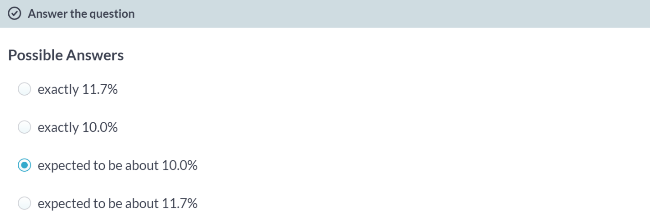

# Fitting a linear model "by hand"

Recall the simple linear regression model:

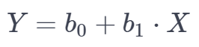

Two facts enable you to compute the slope $b_{1}$  and intercept $b_{0}$  of a simple linear regression model from some basic summary statistics.

First, the slope can be defined as:

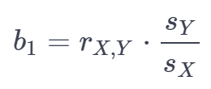

Where $r_{X,Y}$ represents the correlation (cor()) of *X* and *Y* and $s_{X}$  and $s_{Y}$  represent the standard deviation (sd()) of *X* and *Y*, respectively.

Second, the point ($\overline{x}, \overline{y}$) is always on the least squares regression line, where $\overline{x}$  and $\overline{y}$  denote the average of $x$  and $y$ , respectively.

The bdims_summary data frame contains all of the information you need to compute the slope and intercept of the least squares regression line for body weight *(Y)* as a function of height *(X)*. You might need to do some algebra to solve for !

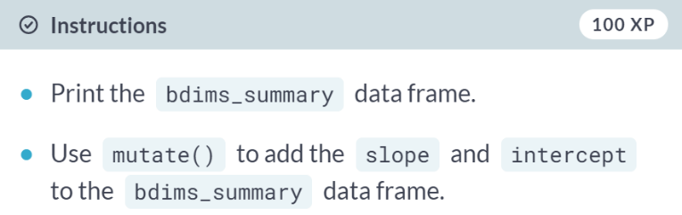

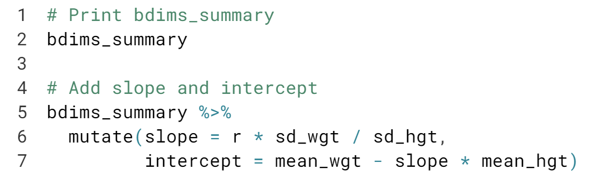  
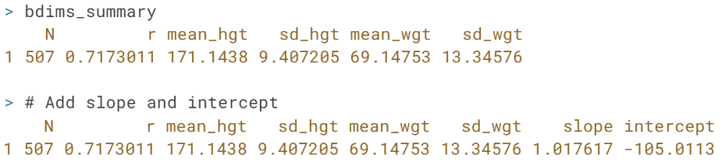





"Regression to the mean" is a distinct concept from "linear regression", which is the focus of this course. But "regression to the mean" is an important statistical concept in its own right, so we will explore it here so that we can appreciate the difference.

As always, it's best to start with a question: *do tall men tend to beget tall sons?* You might consider these questions in the context of professional basketball players.

For example, do you suspect children of seven-foot men to also be exceptionally tall? The answer turns out to be "yes, but not as tall as their fathers." This effect is what Galton deemed "regression to the mean".

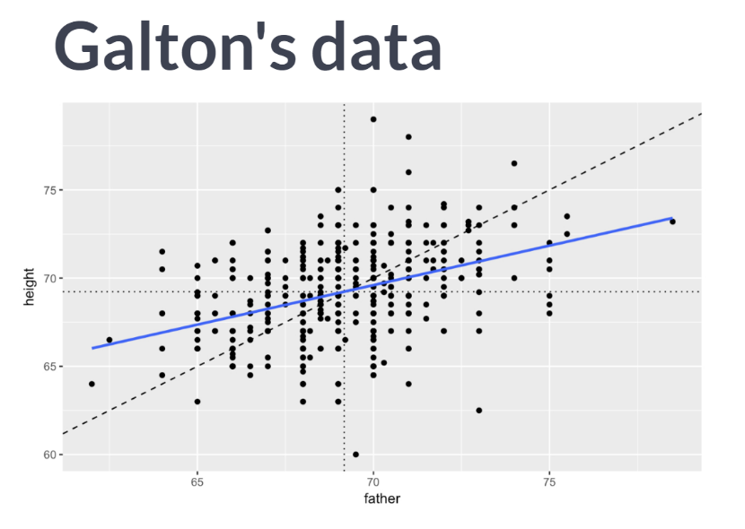  
In the plot, we see the relationship between the heights of a group of 465 men that Galton measured in the 1880s and their fathers. The height of the son is on the y-axis, while the height of the corresponding father is on the x-axis. The diagonal indicates sons who are as tall as their fathers.

The slope of the regression lines shown in blue is more gentle. This reflects the observation that while tall fathers are still likely to have tall sons, the sons aren't likely to be as tall as their fathers. Their height has been "regressed" towards the mean height.

It may be tempting to think that regression to the mean implies that men are getting shorter, but this isn't true. Even in this sample, the mean height of the sons was the same to the nearest tenth of an inch to those of the fathers.

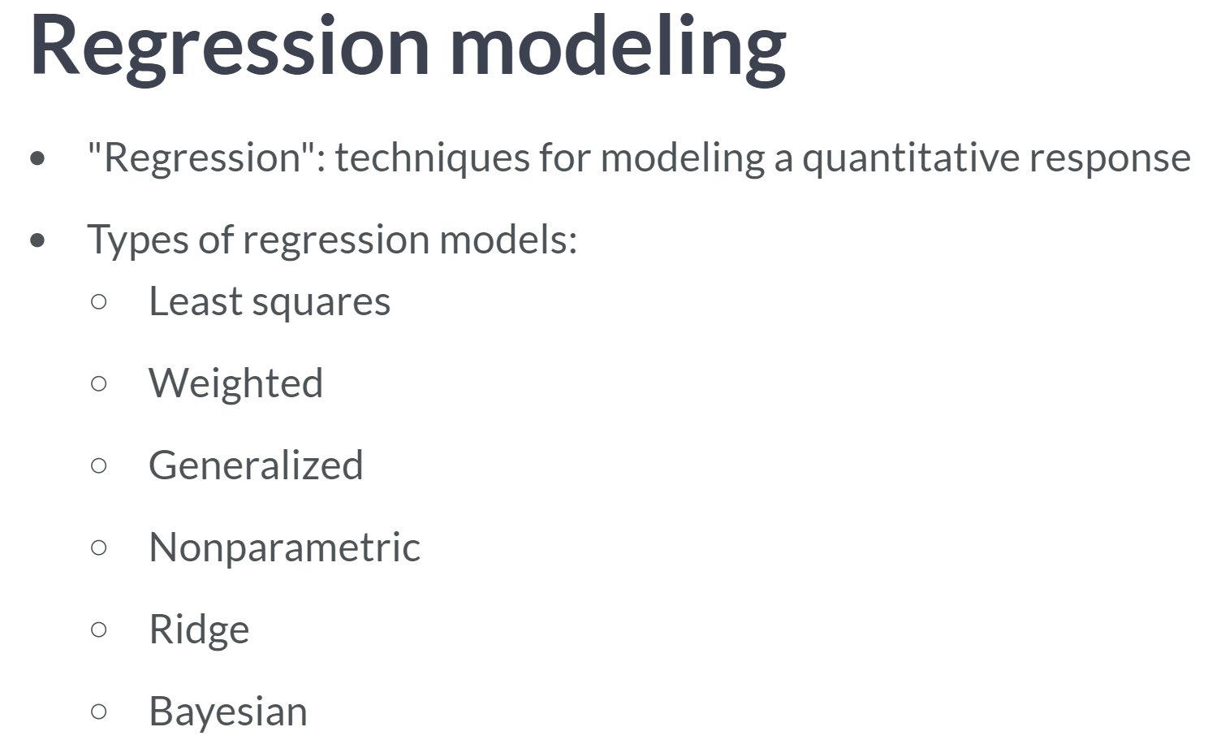

This course is about simple linear regression modeling.

Typically, regression models combine some explanatory variables into an estimate for a single, numerical response variable. We are pursuing least squares regression models, but there are many numbers of alternative regression model specifications.

Additionally, there’re models, like regression trees, that also estimate a single, numerical response, but do not use a linear framework as we do in this course.

# Regression to the mean

Regression to the mean is a concept attributed to Sir Francis Galton. The basic idea is that extreme random observations will tend to be less extreme upon a second trial. This is simply due to chance alone. While "regression to the mean" and "linear regression" are not the same thing, we will examine them together in this exercise.

One way to see the effects of regression to the mean is to compare the heights of parents to their children's heights. While it is true that tall mothers and fathers tend to have tall children, those children tend to be less tall than their parents, relative to average. That is, fathers who are 3 inches taller than the average father tend to have children who may be taller than average, but by less than 3 inches.

The Galton_men and Galton_women datasets contain data originally collected by Galton himself in the 1880s on the heights of men and women, respectively, along with their parents' heights.

Compare the slope of the regression line to the slope of the diagonal line. What does this tell you?

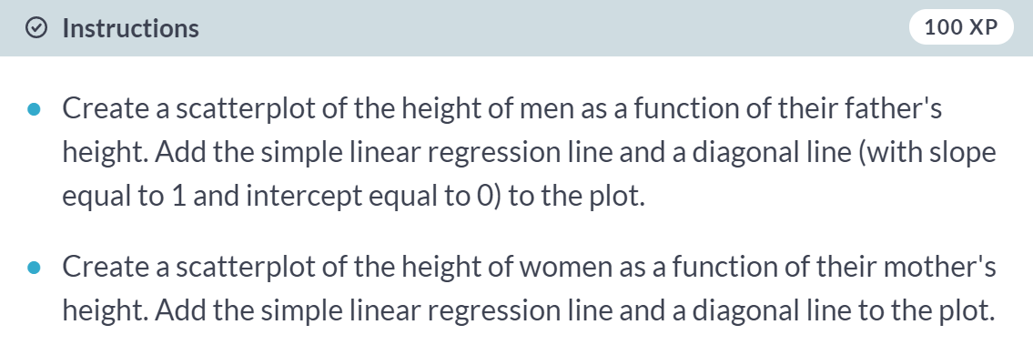

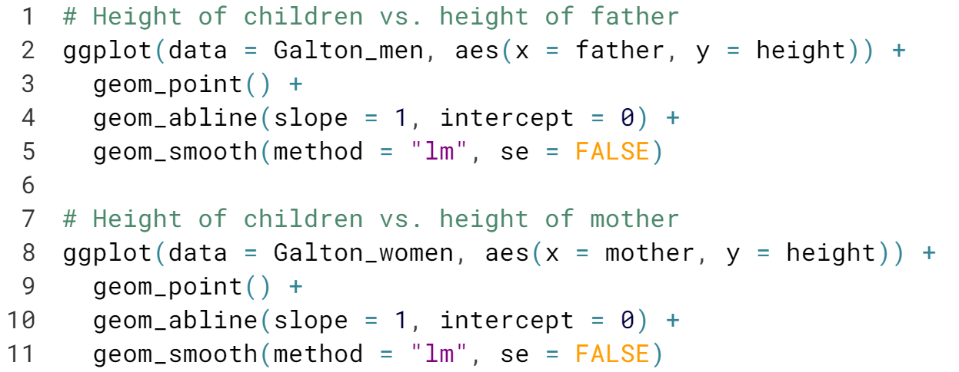  
(Graphs on the next page)

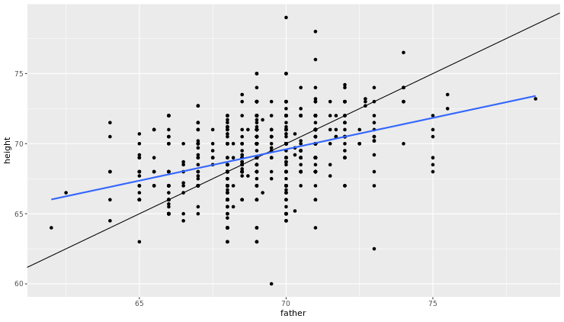

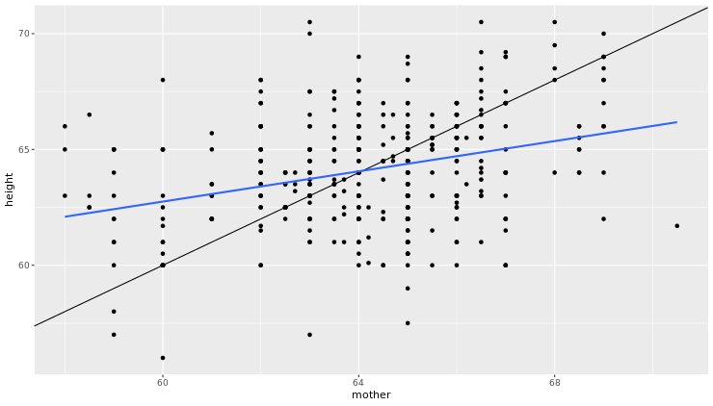  
Excellent! Because the slope of the regression line is smaller than 1 (the slope of the diagonal line) for both males and females, we can verify Sir Francis Galton's regression to the mean concept.

# "Regression" in the parlance of our time

In an opinion piece about nepotism [**published in The New York Times in 2015**](http://www.nytimes.com/2015/03/22/opinion/sunday/seth-stephens-davidowitz-just-how-nepotistic-are-we.html), economist Seth Stephens-Davidowitz wrote that:

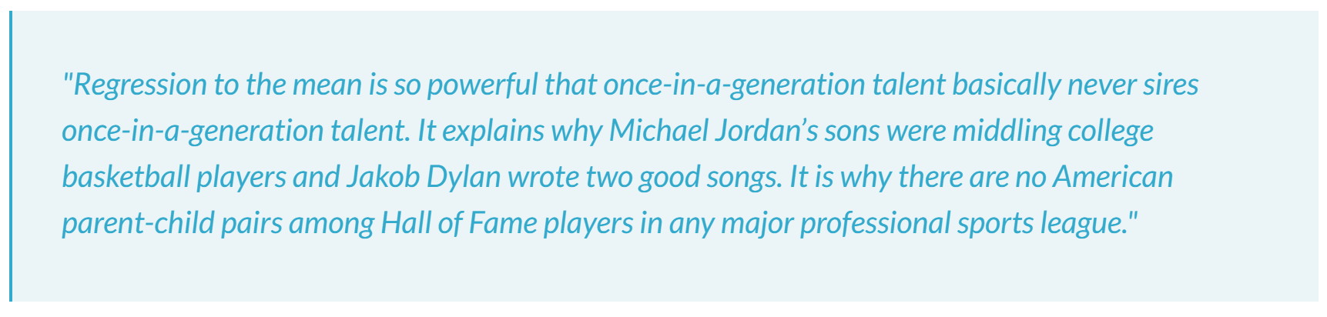

The author is arguing that...

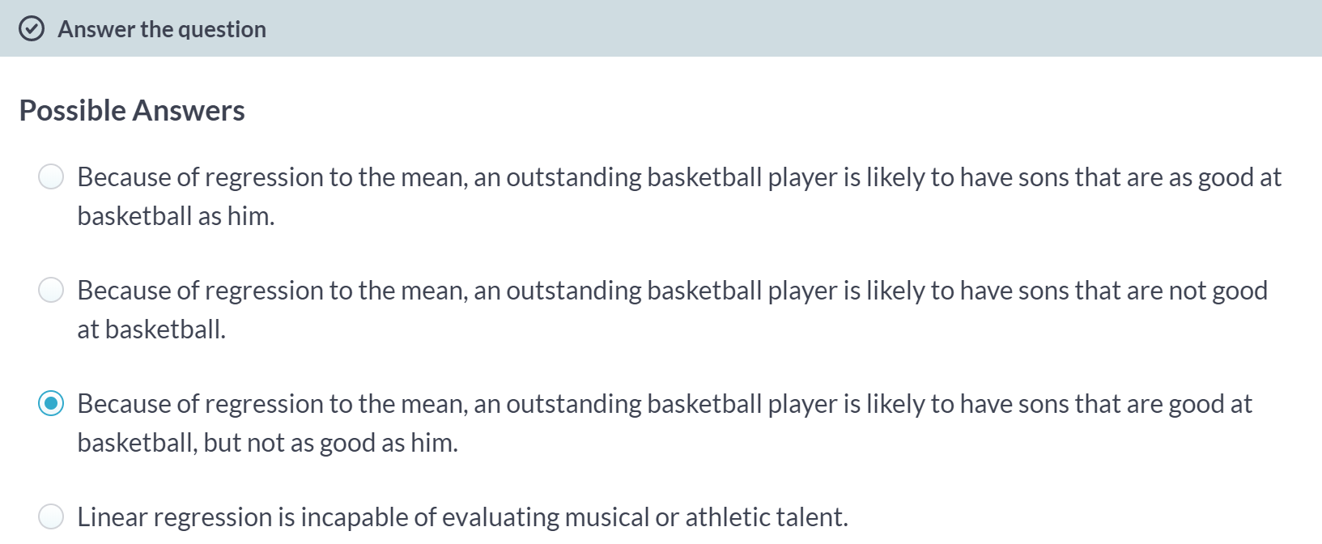

***Interpreting regression models***This chapter looks at how to interpret the coefficients in a regression model.



Interpreting the value of the coefficients is probably the most important thing we can do in a regression model.

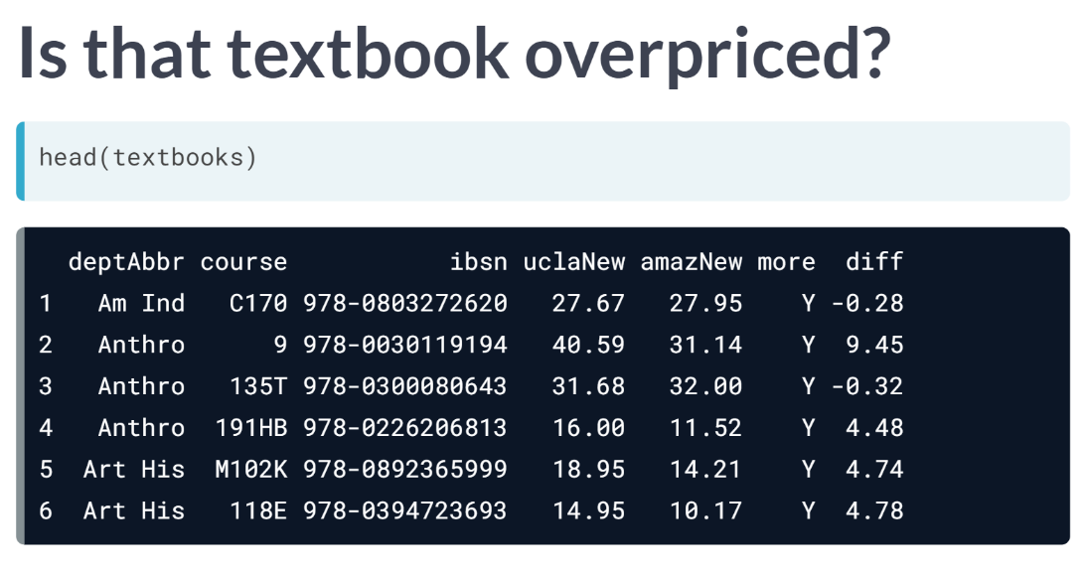  
Data were collected on 73 textbooks required for a few randomly selected courses at UCLA. For each textbook, we know the retail price at both the UCLA bookstore and on Amazon.com. We also know the dept and course number for each corresponding course and the ISBN of the book. What factors are associated with the price of each book at the UCLA bookstore? One might suppose that more advanced books cost more.

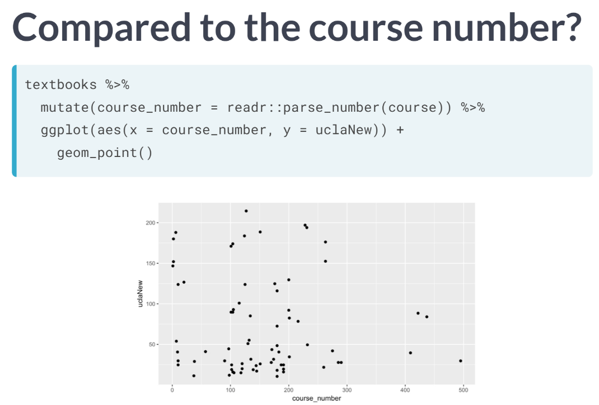  
Our best guess for the level of the course is to extract the course number. The scatter plot shows the relationship between the course number and the price of the book at the UCLA bookstore. This relationship is very weak, and if anything, it appears to be negative.

Instead, since Amazon.com provides a ready alternative for UCLA student, let's consider the relationship between the prices of these books at Amazon, relative to their price at the UCLA bookstore.

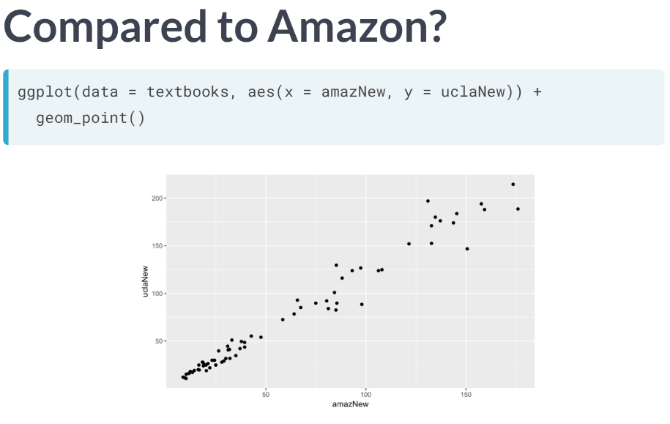  
Here we see clear evidence of a strong, positive, linear relationship. As noted previously, the regression line can be added to the plot with the ***geom_smooth()*** function. While this provides us with a way to visualize our model, it doesn't actually tell us what the fitted coefficients are.

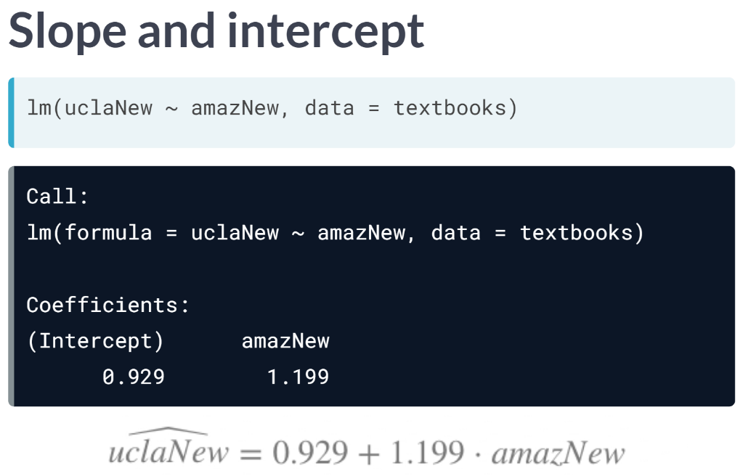  
To get those values, we'll use the *lm* command to actually fit the model. We specify two arguments to *lm*, a formula that indicates which variable is the response and which is the explanatory. And a data argument that identifies the data frame where those variables are located.

The output from *lm* reminds us how we called it and then gives us the fitted coefficients. The value of the intercept coefficient beta naught hat is 0.929 dollars, while the value of the slope coefficient beta one hat is one dollar and twenty cents.

What this says above is that for each additional dollar that Amazon changes for a book, the UCLA bookstore charges about 1 dollar and 20 cents. In effect, the prices at the UCLA bookstore are about 20 percent higher than those on Amazon. Generally, we are most interested in the slope coefficient, but occasionally the intercept coefficient is also interesting.

In this case, the intercept is not interesting: it merely tells us that we should expect a book that retails for 0 dollars on Amazon to cost about 93 cents at the UCLA bookstore. This, of course, is irrelevant.

Furthermore, since the least expensive book present in the dataset cost eight dollars and sixty cents, to discuss a book that was free on Amazon would be to extrapolate our findings to values outside the range of the data we collected. This is always dangerous.

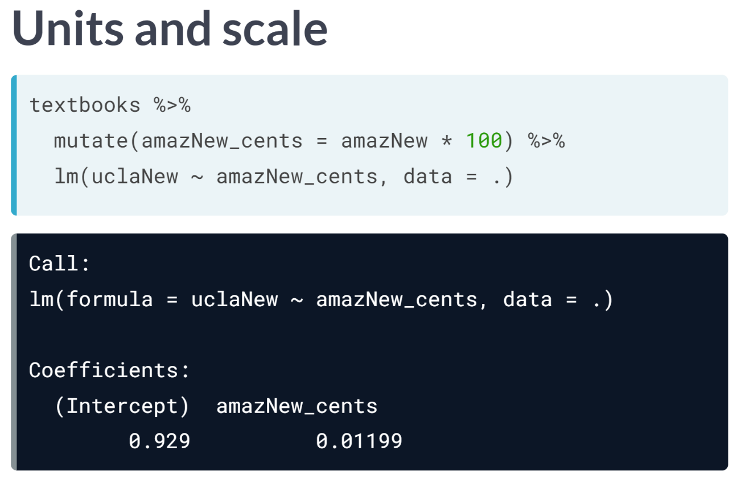

When interpreting slope coefficient, one must pay careful attention to units and scales. Note that the units of the slope coefficient are the units of the response variable per unit of the explanatory variable. In this case, the prices at both bookstores are in dollars, but that is easily changed.

Here, we create a new variable for the price at Amazon in cents and refit the model. Note that while the coefficient has changed, the underlying meaning hasn't. Here, we say that for each additional cent that a book costs on Amazon, the expected price at the UCLA bookstore increases by about 0.01199 dollars, or 1.2 cents. Thus, in both cases, the price of a book at the UCLA bookstore is about 20 percent higher than the corresponding price on Amazon.

# Interpretation of coefficients

Recall that the fitted model for the poverty rate of U.S. counties as a function of high school graduation rate is:



Which of the following is the correct interpretation of the slope coefficient?

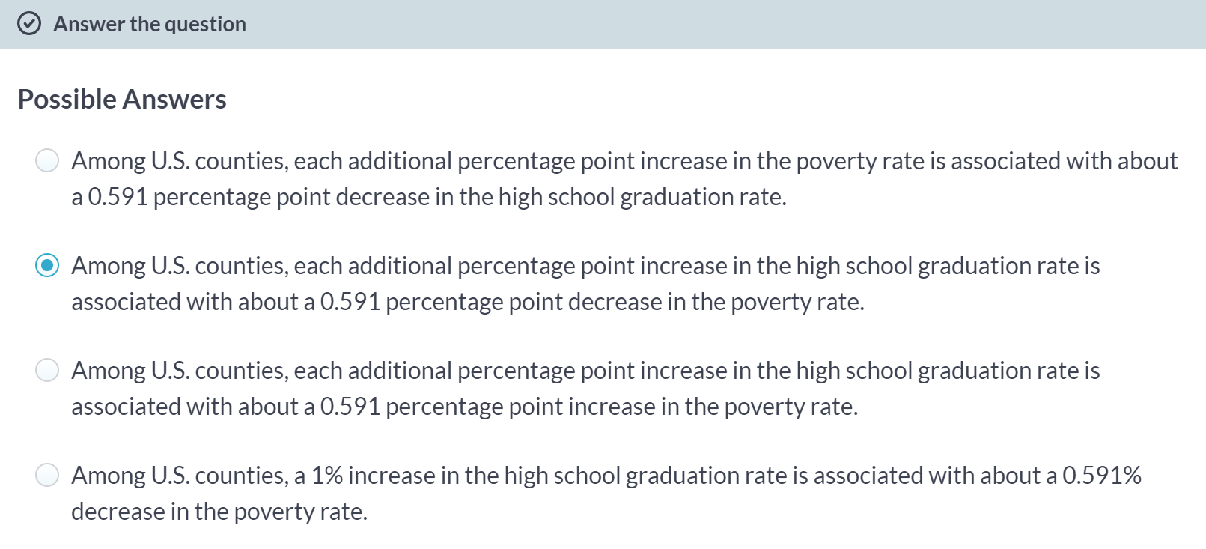

# Interpretation in context

A politician interpreting the relationship between poverty rates and high school graduation rates implores his constituents:

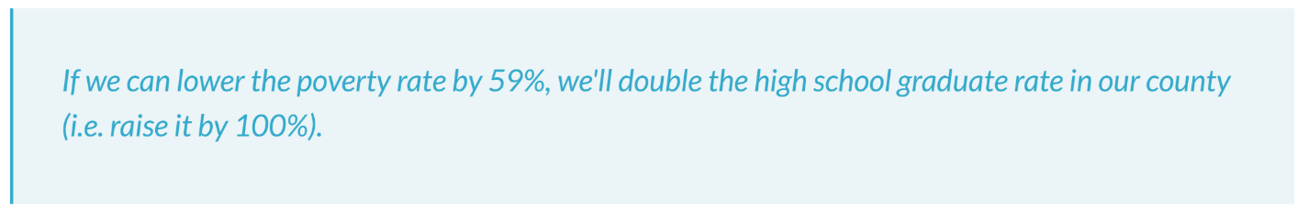

Which of the following mistakes in interpretation has the politician made?

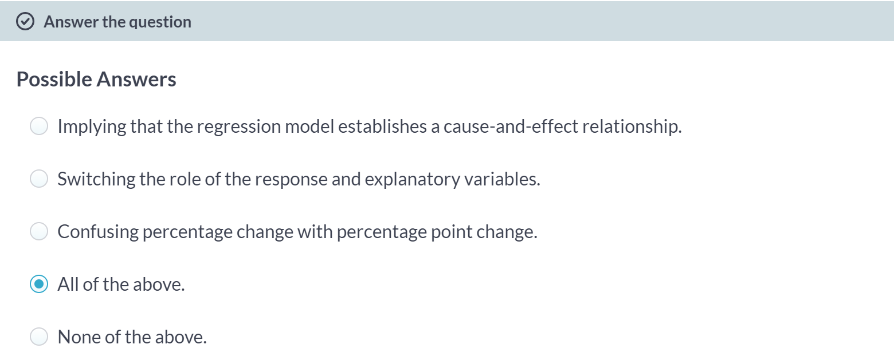

# Fitting simple linear models

While the geom_smooth(method = "lm") function is useful for drawing linear models on a scatterplot, it doesn't actually return the characteristics of the model. As suggested by that syntax, however, the function that creates linear models is lm(). This function generally takes two arguments:

* A formula that specifies the model
* A data argument for the data frame that contains the data you want to use to fit the model

The lm() function return a model object having class "lm". This object contains lots of information about your regression model, including the data used to fit the model, the specification of the model, the fitted values and residuals, etc.

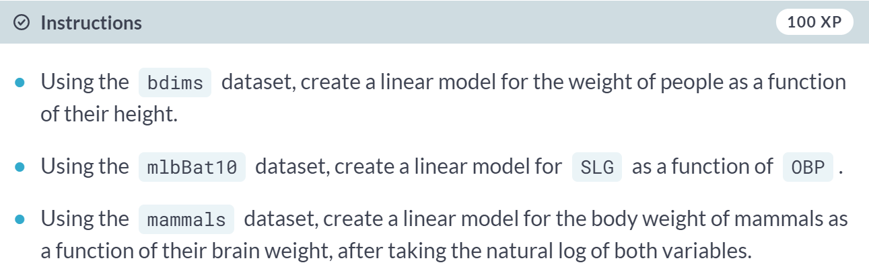

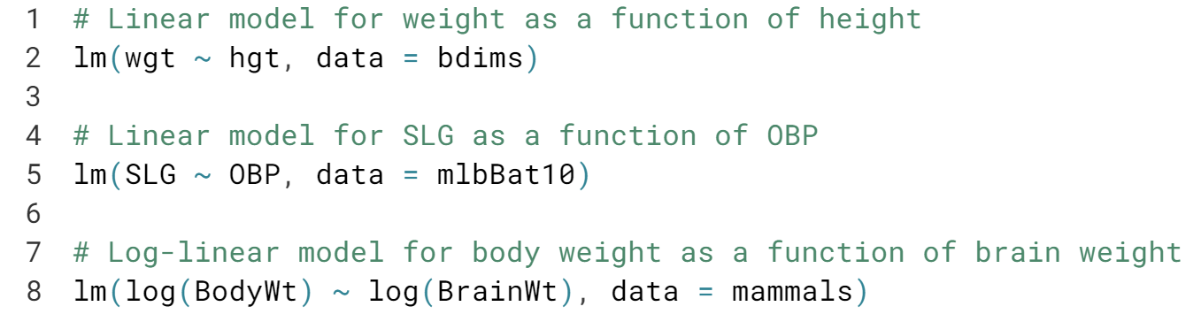

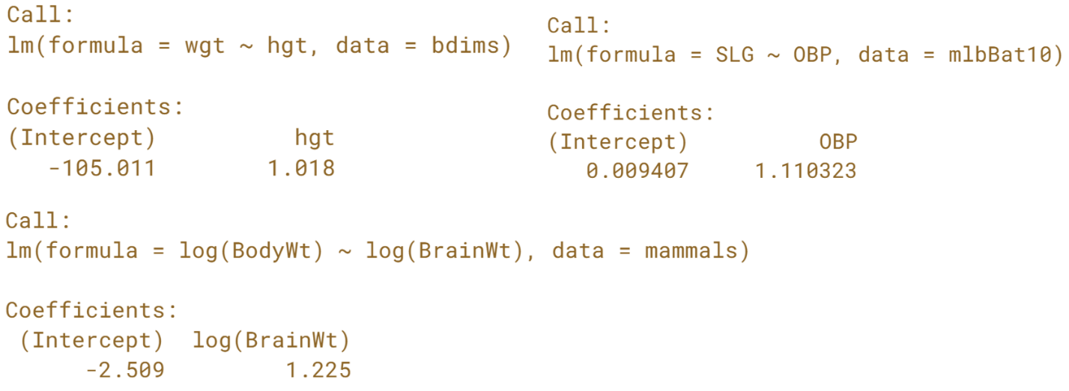

# Units and scale

In the previous examples, we fit two regression models:



and



Which of the following statements is **incorrect**?

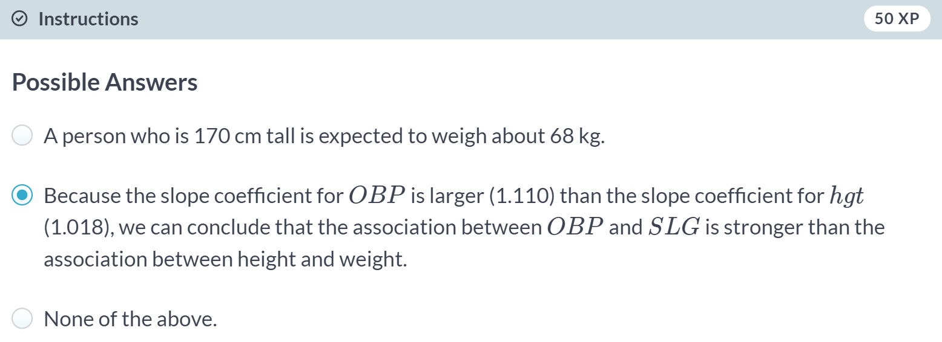

Right!



The output from *lm* is an object and there are a lot of useful things that we can do with that object.

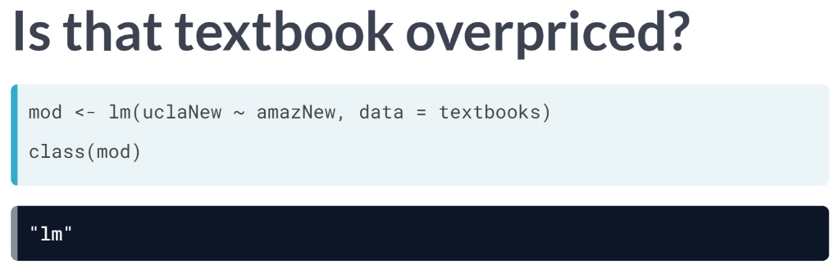

To get started, we need to store the output from *lm* as an object in our environment, in this case aptly named mod. Note that mod is of class *lm*.

This object contains all of the information needed to fit our regression model, including, by default, the relevant data and lots of other pieces of information that we can extract in various ways.

It's worth repeating that mod is an object of type *lm*. It's not a data frame, a function, a matrix, or a list.

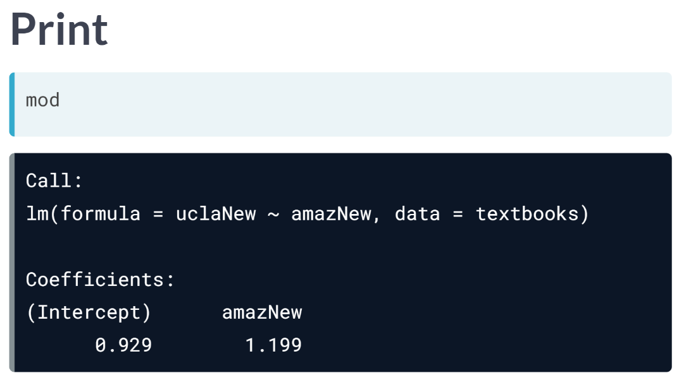  
By default, when you try to print an lm object, you see the call, as well as the fitted coefficients.

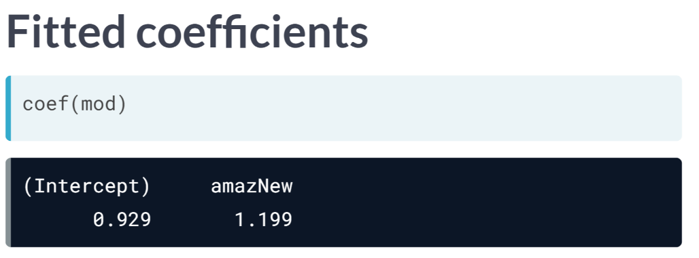  
You can also return just the fitted coefficients as a vector using the ***coef()*** function. For our purposes, these are the pieces of information that we are most interested in. In this course, we treat regression as a descriptive statistical technique thus explaining our focus on the coefficients. We will also learn about inference for regression in the later course.

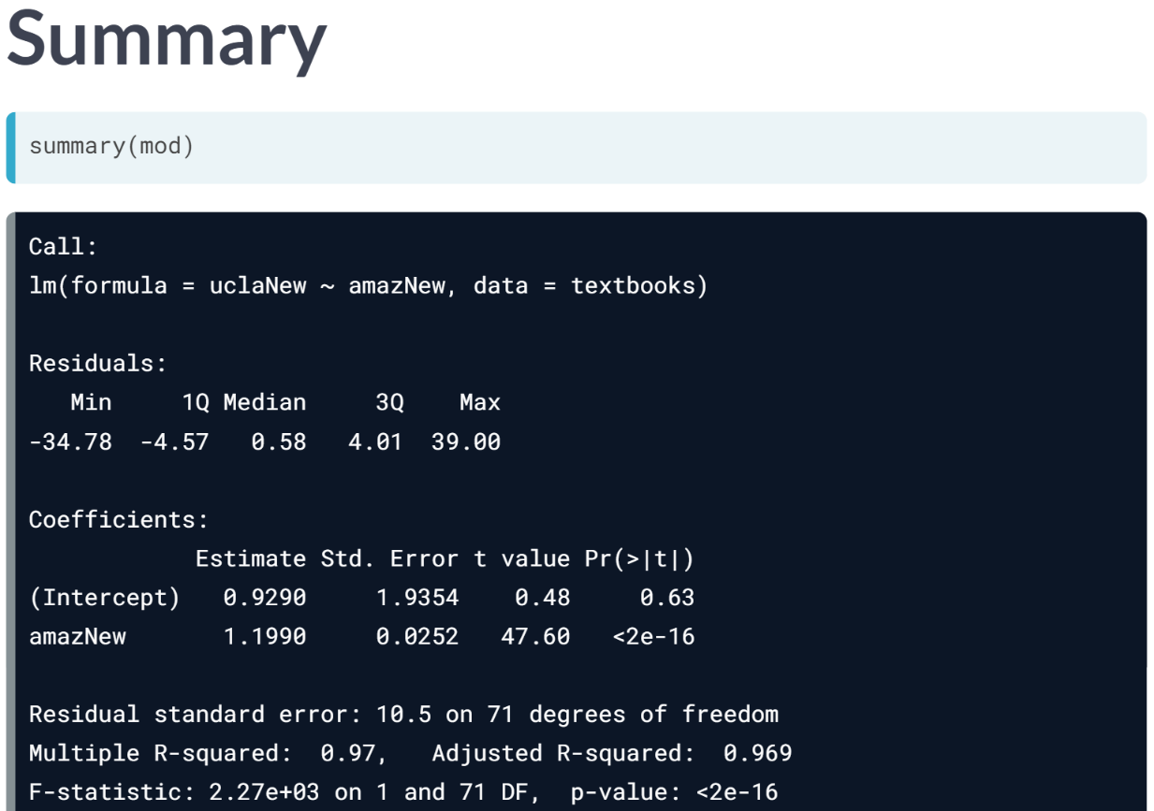  
The ***summary()*** function displays these. Since the object mod contains everything R knows about our model, we can ask R for the fitted values, using the ***fitted.values()*** function.

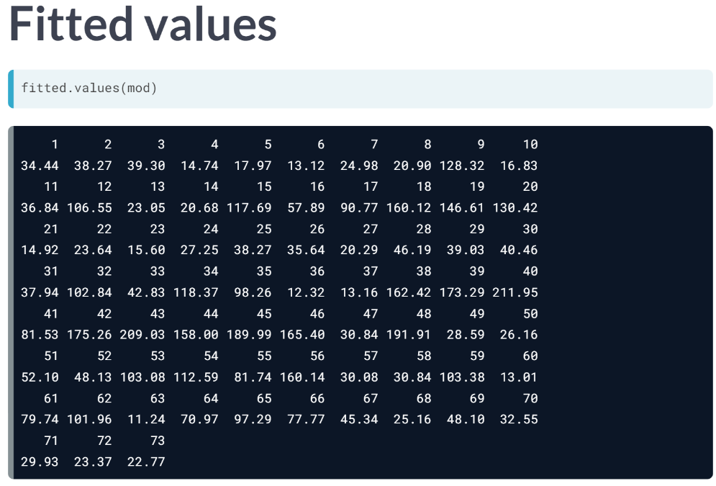  
This returns a vector containing the y hat values for each data point. In general, the length of the vector of fitted value is the same as the number of rows in the original data frame, since each observation corresponds to exactly one value of y hat.

However, if there were any observations with missing data, those will be automatically discarded by R when the model is fit, and thus, the length of the vector of the fitted values may not be a large as the number of rows in the original data frame.

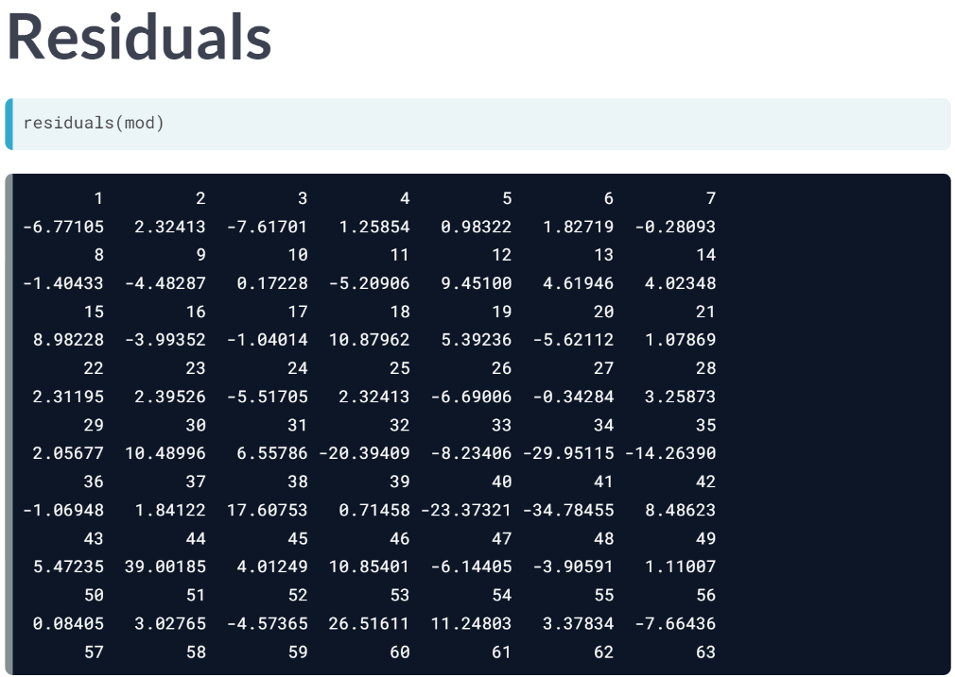  
Similarly, each fitted value generates a residual, which is a difference between actual observed value of the response variable and the expected value of the response according to the model. These residuals can be retrieved using ***residuals()*** function that returns the vector of residuals.

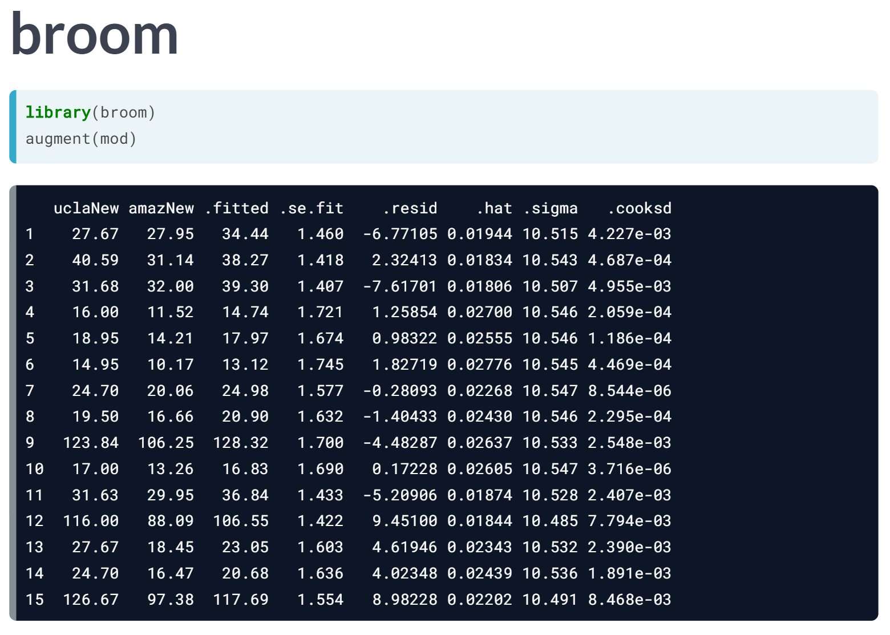

One of the packages in the tidyverse is called broom, since its goal is to help us tidy up a bit.

By loading up the broom package and then running the ***augment()*** function on our model object, we recover a data frame that contains our original response and explanatory variable, along with the fitted values, residuals, leverage scores, and several other pieces of information relevant to each observation.

Working with these tidy data frames can simplify some of the work we do with our models after they are fit.

# The lm summary output

An "lm" object contains a host of information about the regression model that you fit. There are various ways of extracting different pieces of information.

The coef() function displays only the values of the coefficients. Conversely, the summary() function displays not only that information, but a bunch of other information, including the associated standard error and p-value for each coefficient, the $R^{2}$ , adjusted $R^{2}$ , and the residual standard error.

The summary of an "lm" object in R is very similar to the output you would see in other statistical computing environments (e.g. Stata, SPSS, etc.)

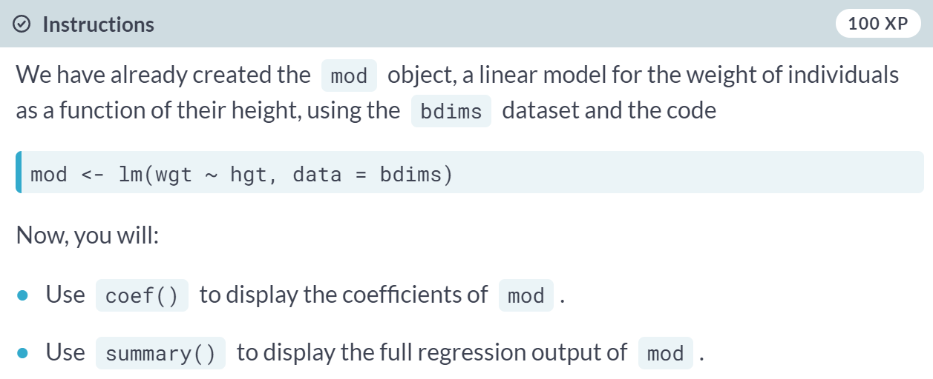

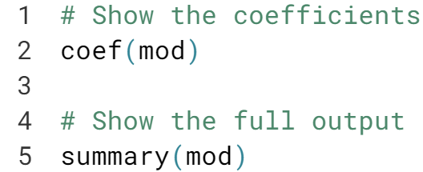

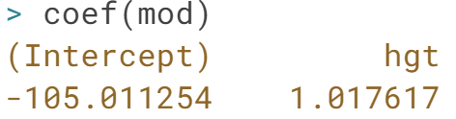  
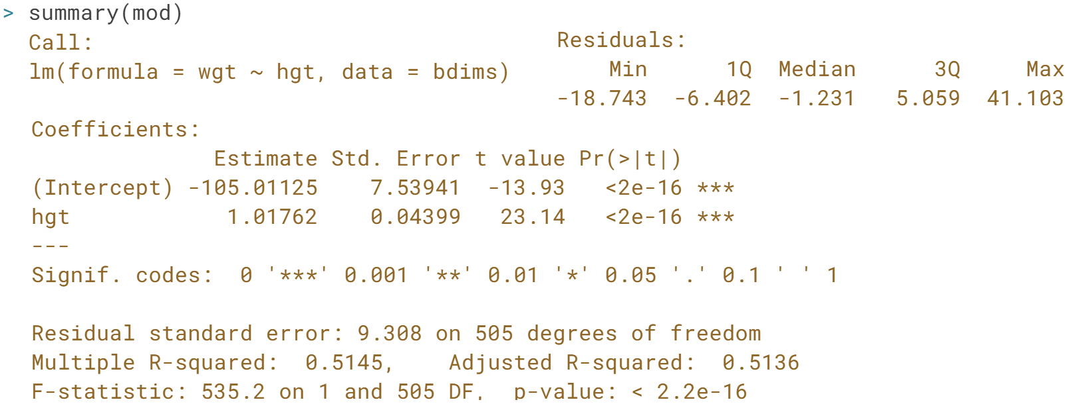

# Fitted values and residuals

Once you have fit a regression model, you are often interested in the fitted values (${\hat{y}}_{i}$) and the residuals ($e_{i}$), where $i$  indexes the observations. Recall that:

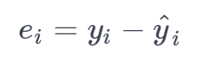

The least squares fitting procedure guarantees that the mean of the residuals is zero (n.b., numerical instability may result in the computed values not being exactly zero). At the same time, the mean of the fitted values must equal the mean of the response variable.

In this exercise, we will confirm these two mathematical facts by accessing the fitted values and residuals with the fitted.values() and residuals() functions, respectively, for the following model:



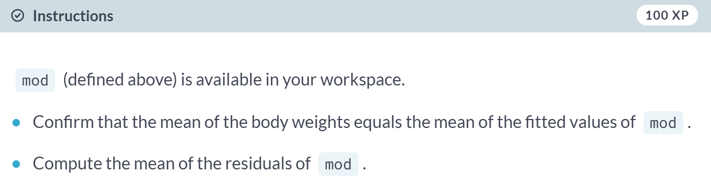

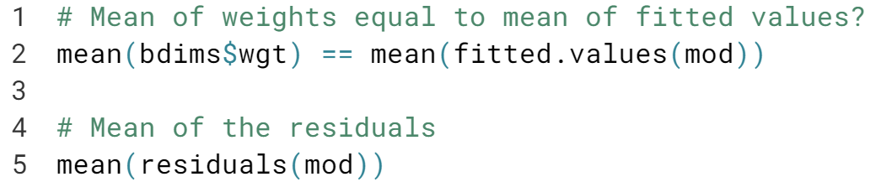  
  
  
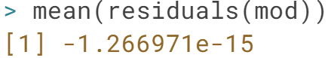

Great! We have verified both facts.

# Tidying your linear model

As you fit a regression model, there are some quantities (e.g. $R^{2}$ ) that apply to the model as a whole, while others apply to each observation (e.g. ${\hat{y}}_{i}$). If there are several of these per-observation quantities, it is sometimes convenient to attach them to the original data as new variables.

The augment() function from the broom package does exactly this. It takes a model object as an argument and returns a data frame that contains the data on which the model was fit, along with several quantities specific to the regression model, including the fitted values, residuals, leverage scores, and standardized residuals.



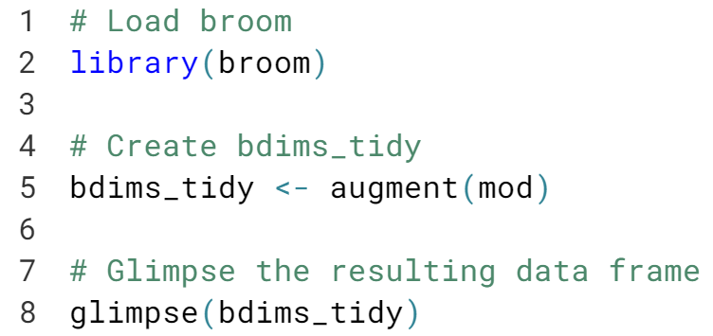  
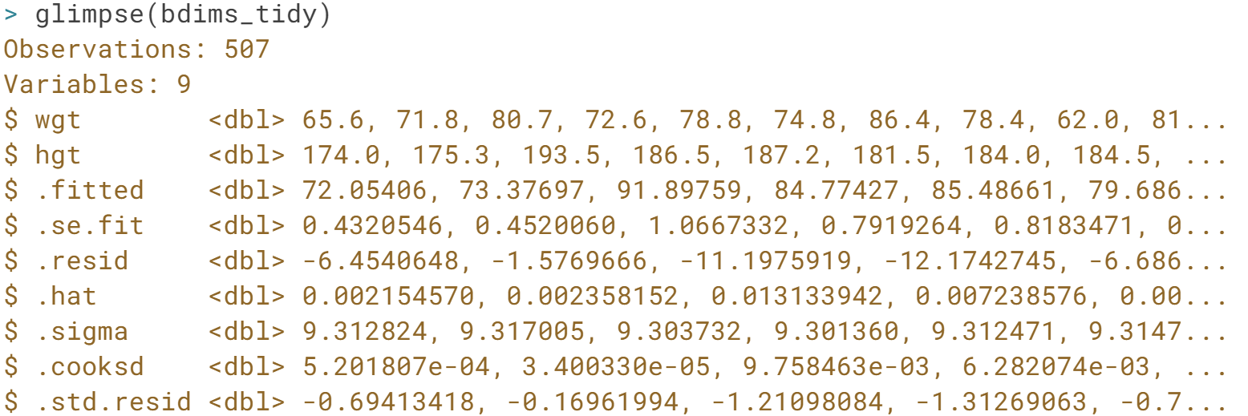



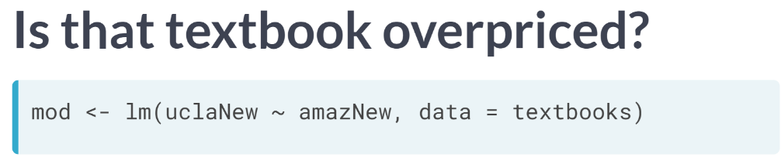

We fit the regression model suing the *lm* command, and stored the resulting model object.

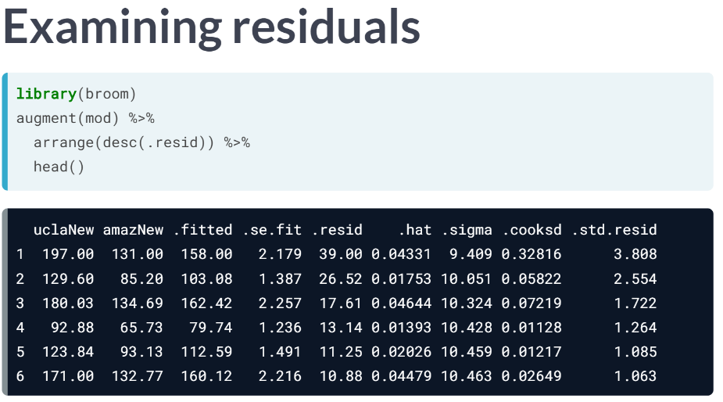

By examining the residuals, we can learn about whether particular textbooks appear to be under or overpriced. In this case, the most overpriced book cost $197 at the UCLA bookstore, but just $131 on Amazon, a markup of $66! The model predicts a cost of $158, resulting in a residual of $39.

  
This turns out to be the management textbook "Financial Statement Analysis and Security Valuation". I suppose this qualifies as irony. What about textbooks that aren't in our original dataset?

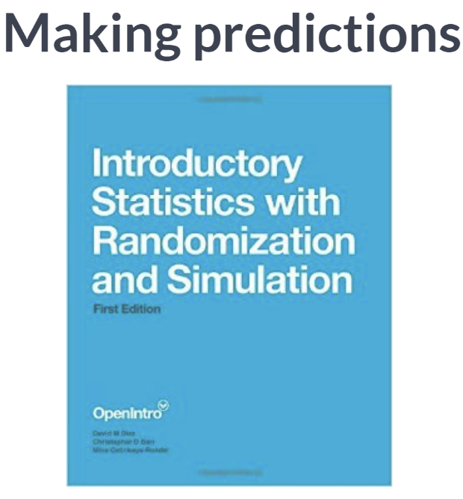   
Using our model to make predictions about new observation so-called "out-of-sample" observations is a powerful technique fundamental in machine learning. For example, the OpenIntro book "Introductory statistics with Randomization and Simulation" sells for eight dollars and forty-nine cents on Amazon. What would our model predict is the retail price at the UCLA store?

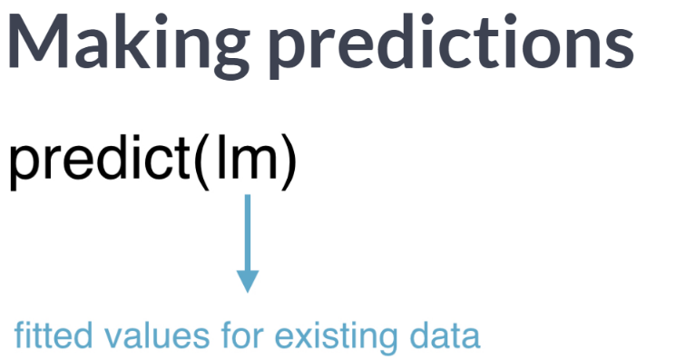  
The ***predict()*** function, when applied to an lm object, return the fitted values for the original observations by default.  
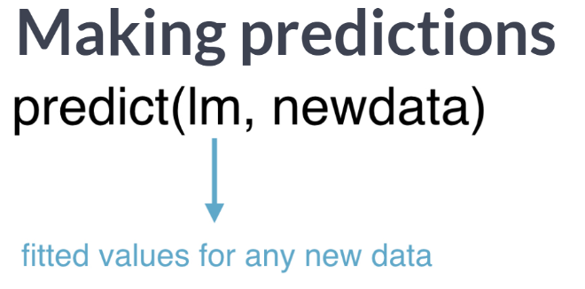  
However, if we specify the *newdata* argument, we can use the model to make the predictions about any observations we want. Note that the object passed to *newdata* must be a data frame with a variable with the same name as the explanatory variable used to fit the model. Note that the result is a vector of fitted values.

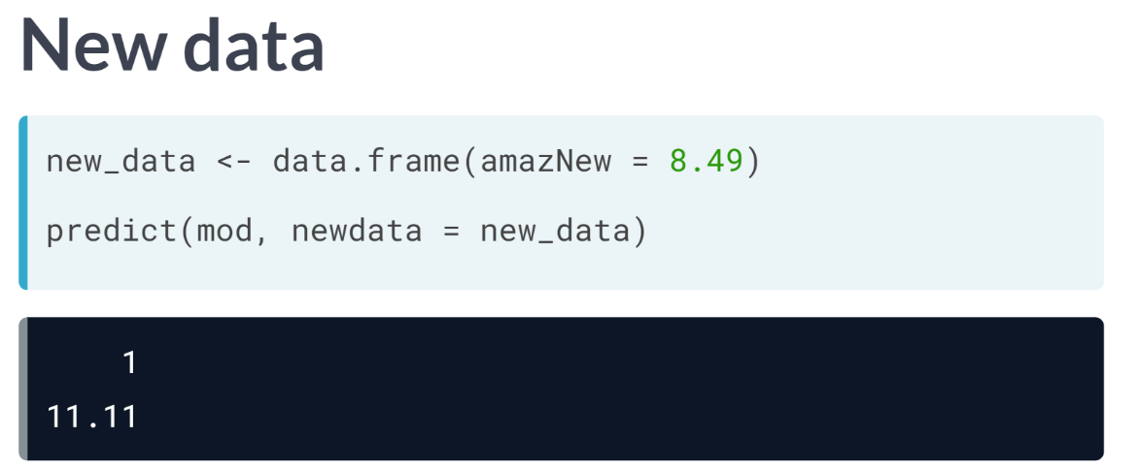  
Here, we create a simple data frame with one variable and one observation for the ISRS book. The model returns that the expected price at the UCLA bookstore is 11 dollars and 11 cents.

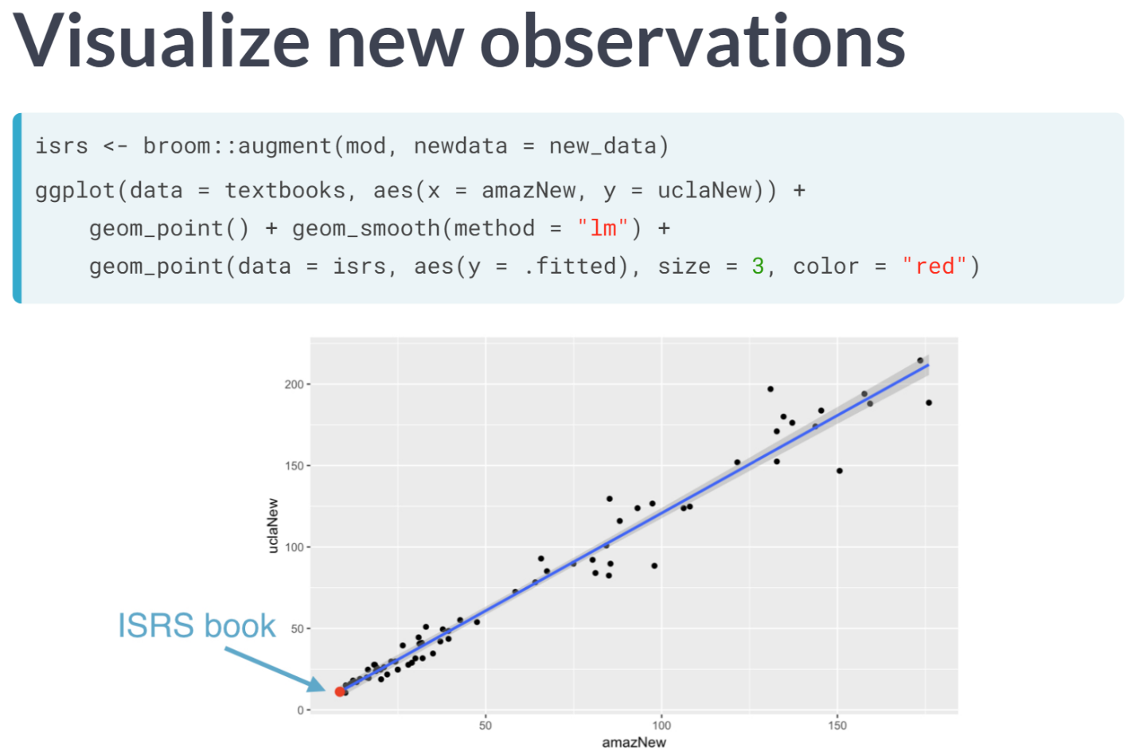  
Alternatively, the ***augment()*** function from broom will also take a newdata argument. However, this function will return a data frame. This is useful if we want to do a bit more with our predictions.

Here, we first use ***augment()*** to create a new data frame of predicted values and use ***geom_point()*** to put those observations on the scatter plot of the original data. Here the single observation for the ISRS book is shown in red dot.

# Making predictions

The fitted.values() function or the augment()-ed data frame provides us with the fitted values for the observations that were in the original data. However, once we have fit the model, we may want to compute expected values for observations that were **not** present in the data on which the model was fit. These types of predictions are called out-of-sample.

The ben data frame contains a height and weight observation for one person. The mod object contains the fitted model for weight as a function of height for the observations in the bdims dataset. We can use the predict() function to generate expected values for the weight of new individuals. We must pass the data frame of new observations through the newdata argument.

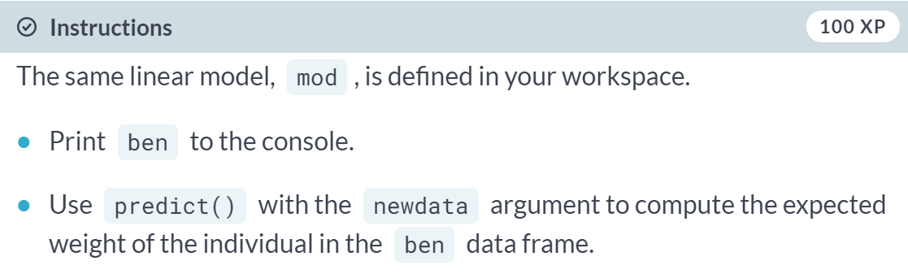

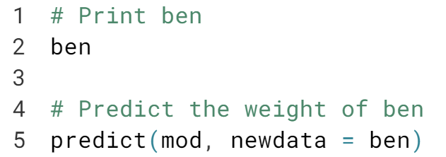

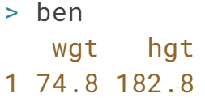

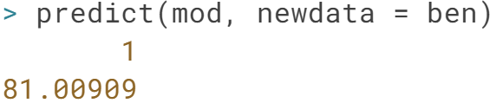

Great work! Note that the data frame *ben* has variables with the exact same names as those in the fitted model.

# Adding a regression line to a plot manually

The geom_smooth() function makes it easy to add a simple linear regression line to a scatterplot of the corresponding variables.

And in fact, there are more complicated regression models that can be visualized in the data space with geom_smooth(). However, there may still be times when we will want to add regression lines to our scatterplot manually.

To do this, we will use the geom_abline() function, which takes slope and intercept arguments. Naturally, we have to compute those values ahead of time, but we already saw how to do this (e.g. using coef())

The coefs data frame contains the model estimates retrieved from coef(). Passing this to geom_abline() as the data argument will enable you to draw a straight line on your scatterplot.



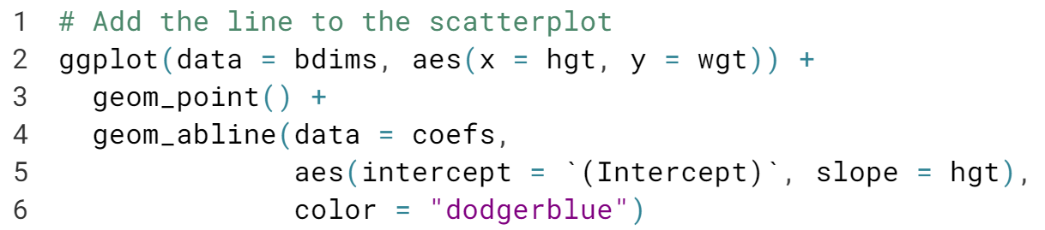  
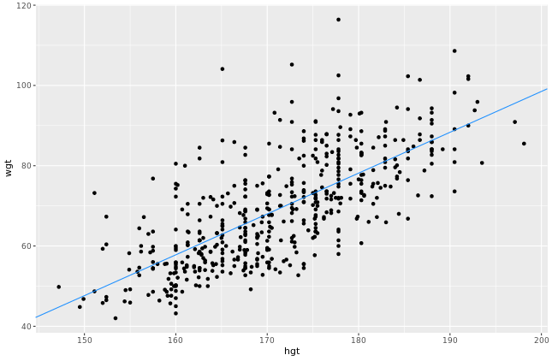

***Model Fit***In this final chapter, you'll learn how to assess the "fit" of a simple linear regression model.

******Let's evaluate how well the linear regression model works.

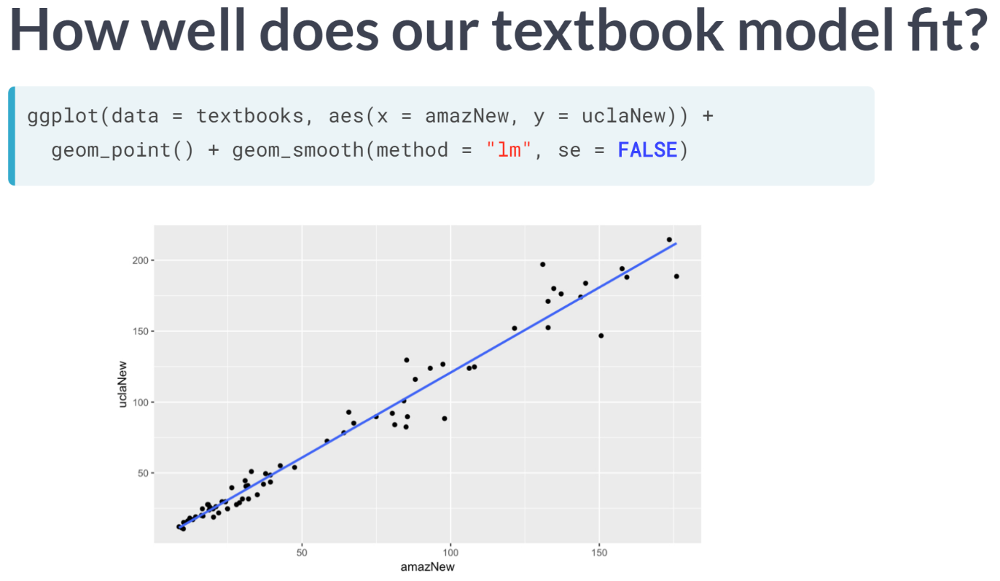  
In an intuitive sense, it seems clear that the regression line for the textbooks fits really well.  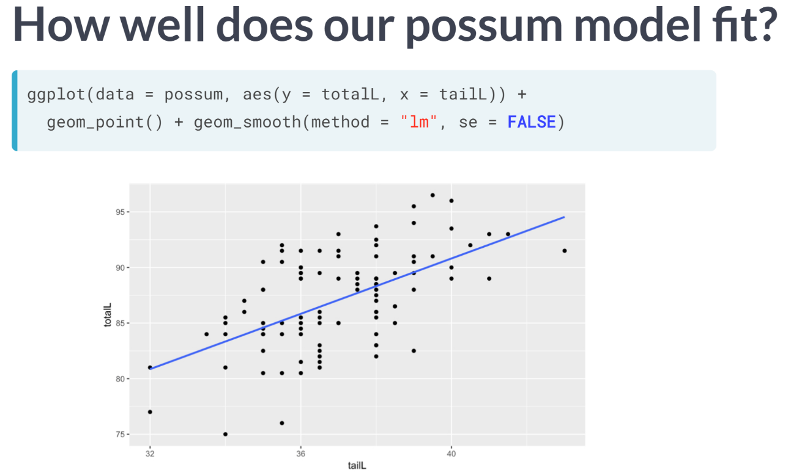  
At the same time, the regression line for the possums fit less well, but it still seems useful.

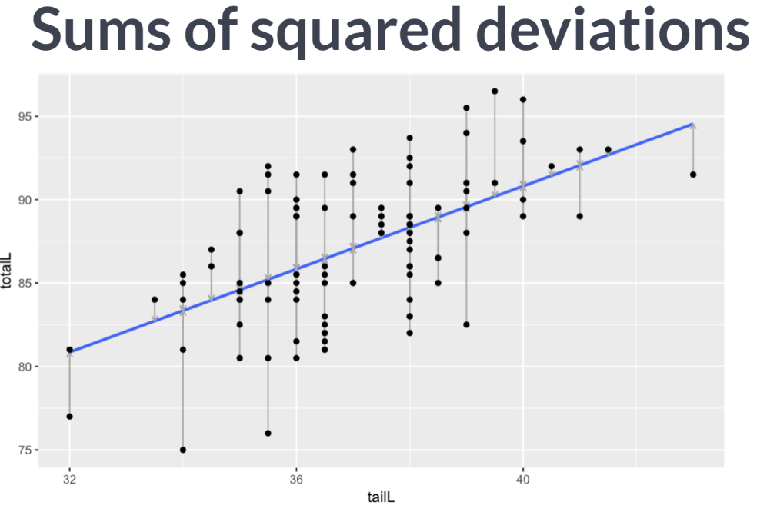Can we quantify our intuition about the quality of the model fit?

In fact, we can. Recall that we initially considered any number of lines. We settled on the unique regression line by applying the least squares criterion. That is, we found the line that minimizes the sum of the squared residuals.

For each observation, which is represented on the scatter point by a point, the residual is simply the vertical distance between that point and the line. Here, we have highlighted the possum residuals with grey arrows.

If we could find a line that made those gray arrows shorter, collectively and after squaring them, that would be our regression line. But there is no such line; this one is the best.

Note that we can't just minimize the sum of the residuals. That number is always zero, since the positive and negative residuals cancel each other out when added together.

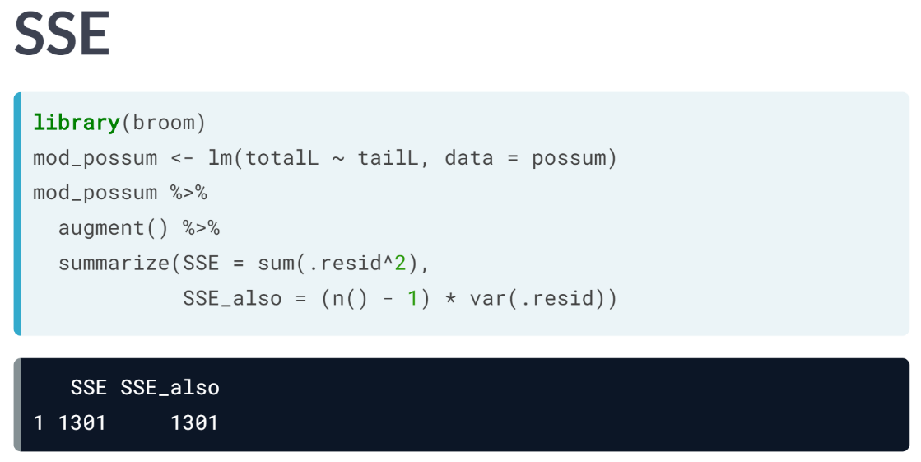  
The sum of the squares works well mathematically, but it also has the effect of penalizing large residuals disproportionately.

This is generally considered a useful property for statistical modeling, since we would usually prefer a model that missed often by a little bit, but never by a lot to a model that works well most of the time, but occasionally is way off.

Once again, there are situations when other criteria are used for fitting models, but we won't talk about it in this course. After using the augment function to tidy up our model, the sum of the squared residuals is easily computed using ***summarize()***.

By convention, we often call this quantity SSE, for sum of squared errors. It can also be computed as the variance of the residual’s times one fewer than the number of observations. The SSE is a single number that captures how much our model missed by. Unfortunately, it is difficult to interpret since the units have been squared.  
  
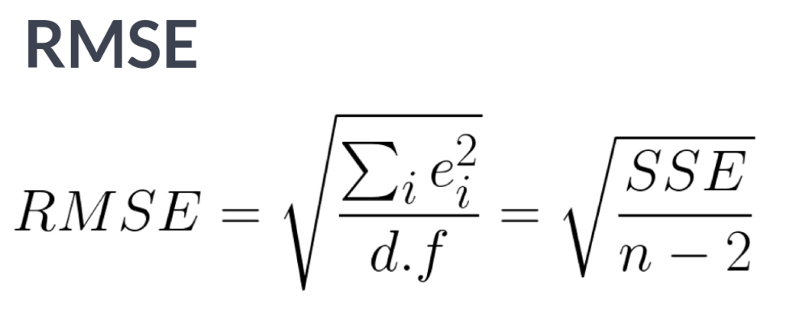  
Thus, another common way of thinking about the accuracy of a model is the root mean squared error (RMSE), which is essentially the standard deviation of the residuals.

Notice that instead of dividing by n here, we actually divide by the number of degrees of freedom, which in this case is n-2. The concept of degrees of freedom comes up in many contexts in statistics, but a detailed discussion is beyond the scope of this course.

The RMSE also generalizes to any kind model for a single numerical response, so it isn't specific to regression models.

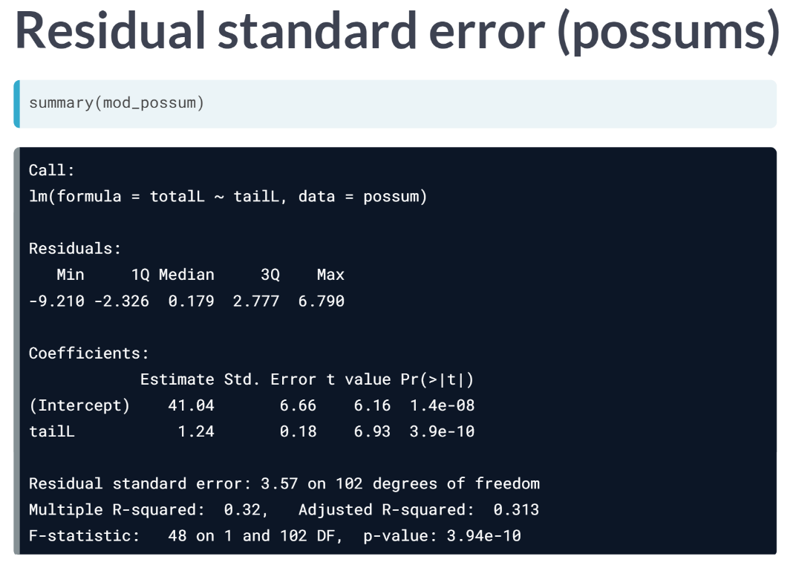  
When R displays the summary of a regression model, it displays the *"residual standard error"*. This is basically the RMSE.

Conveniently, the RMSE is in the units of the response, so this says that our model makes a predicted body length that is typically within about 3.57 centimeters of the truth. That seems useful since the possums in our dataset are between 75 and 96 centimeters.

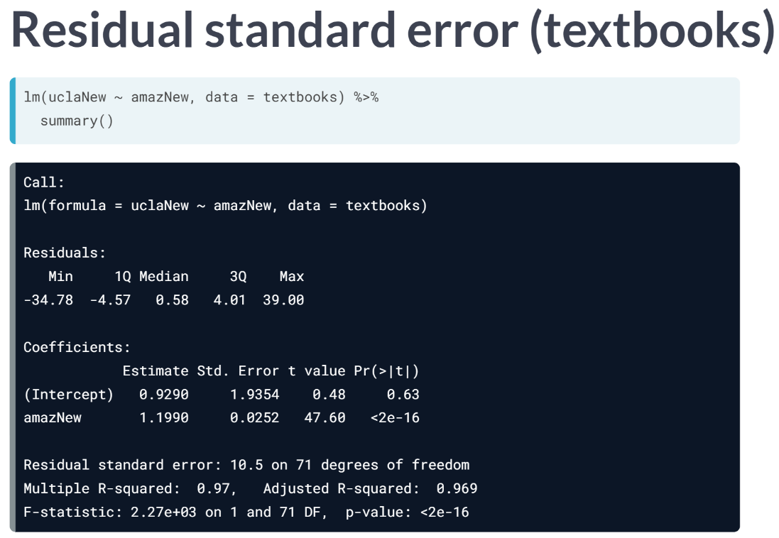  
For the textbooks, the residual standard error is $10.47. Somehow, this doesn't seem as useful and yet it seemed from the scatter plot that the fit of the textbook model was much better than the fit of the possum model. We will cover how we can reconcile these two notions.

# RMSE

The residual standard error reported for the regression model for poverty rate of U.S. counties in terms of high school graduation rate is 4.67. What does this mean?

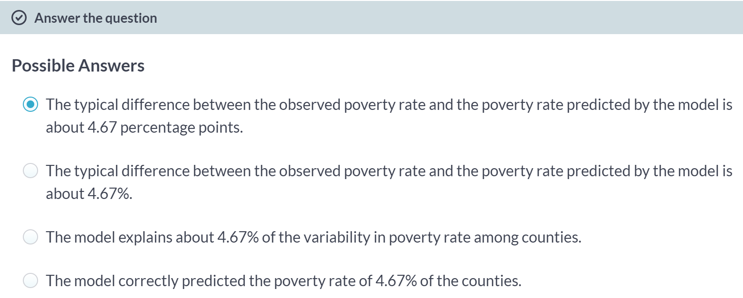

# Standard error of residuals

One way to assess strength of fit is to consider how far off the model is for a typical case. That is, for some observations, the fitted value will be very close to the actual value, while for others it will not. The magnitude of a typical residual can give us a sense of generally how close our estimates are.

However, recall that some of the residuals are positive, while others are negative. In fact, it is guaranteed by the least squares fitting procedure that the mean of the residuals is zero. Thus, it makes more sense to compute the square root of the mean squared residual, or root mean squared error ($RMSE$). R calls this quantity the residual standard error.

To make this estimate unbiased, you have to divide the sum of the squared residuals by the degrees of freedom in the model. Thus,

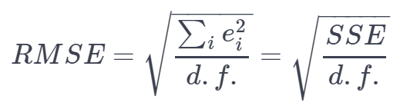

You can recover the residuals from mod with residuals(), and the degrees of freedom with df.residual().

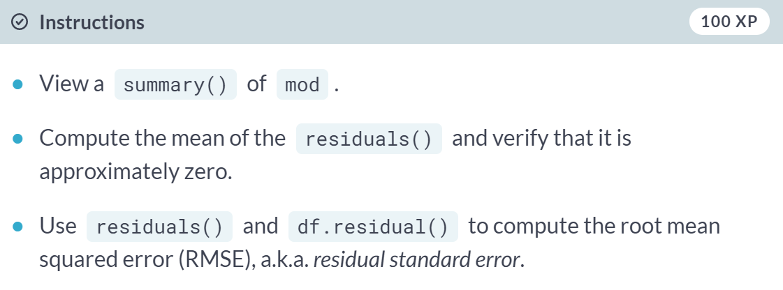  
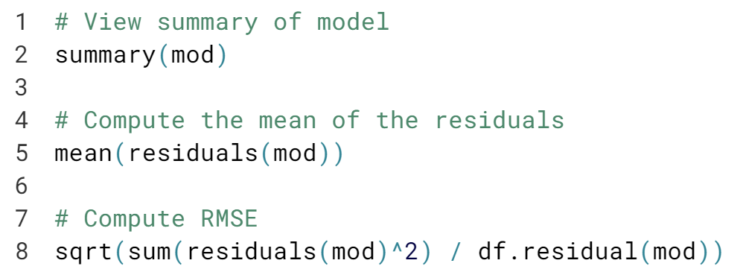

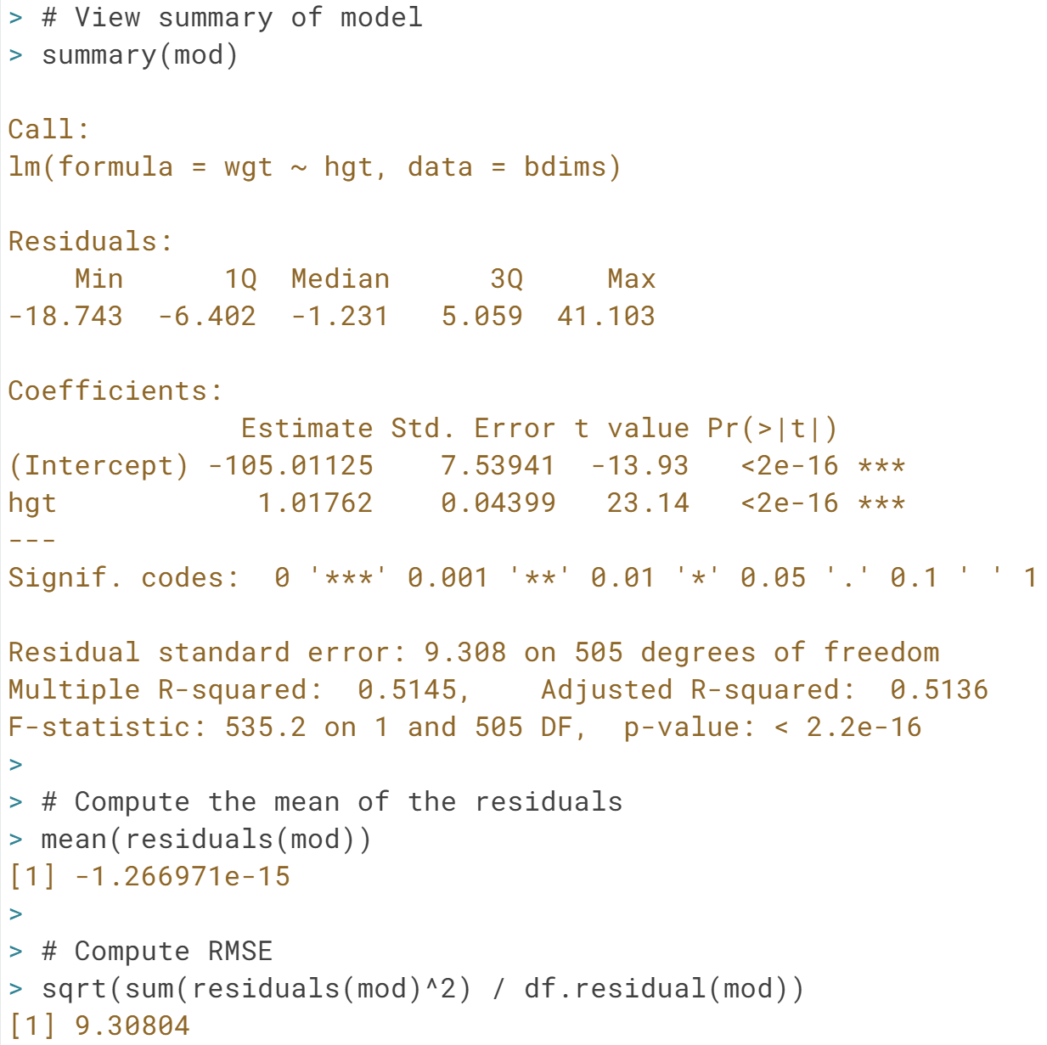



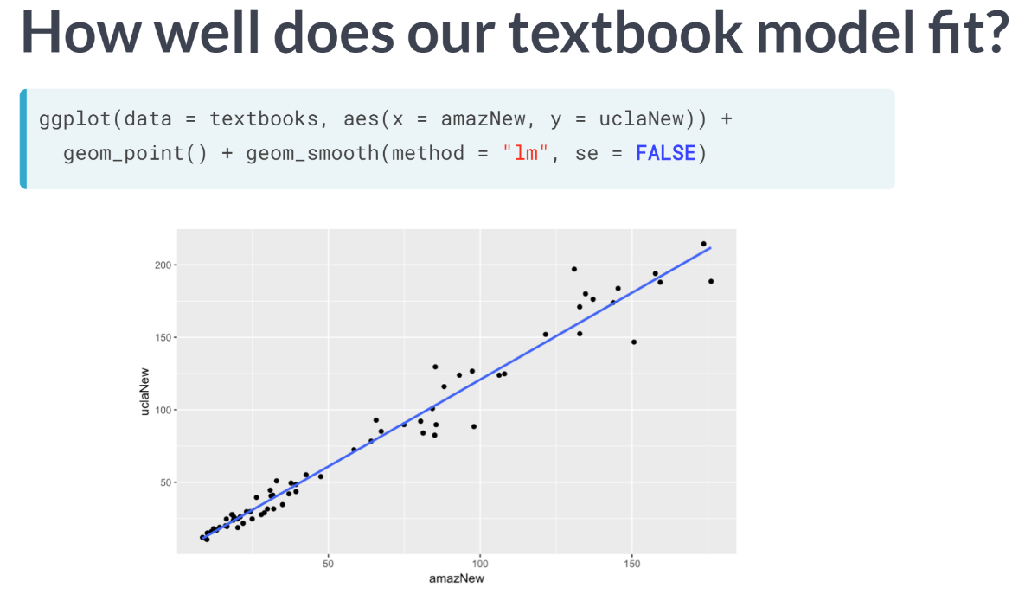

In the last lesson, we noted that although the textbook model seemed to fit the data really well, the residual standard error was more than $10.

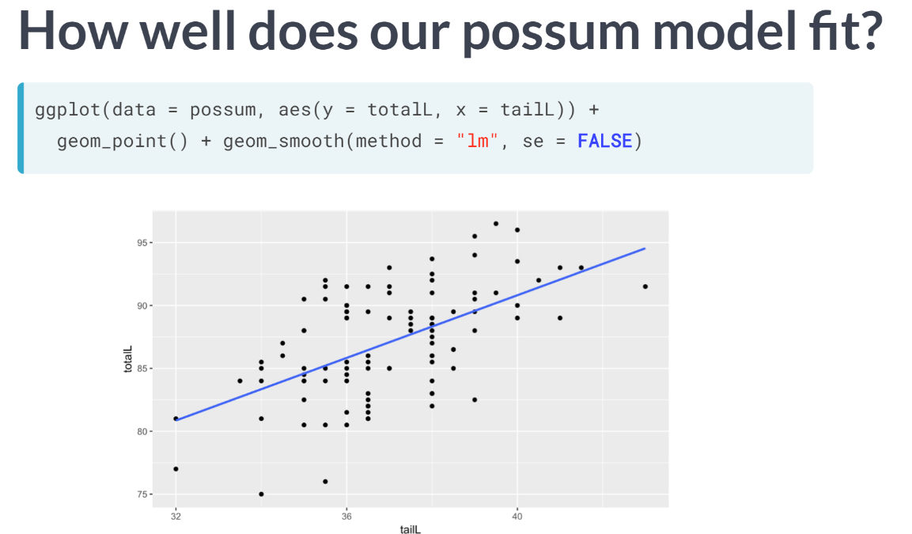  
On the other hand, the residual standard error for the possum model was about 3.5 centimeters, which seems like a high degree of accuracy for a model that does seem to be as tight of a fit. Moreover, it's hard to compare $10 to 3.5 centimeters.

Which is bigger? What would be nice is if we had a way to compare the quality of the fit that was unitless. To do so, it's helpful to think about a benchmark.

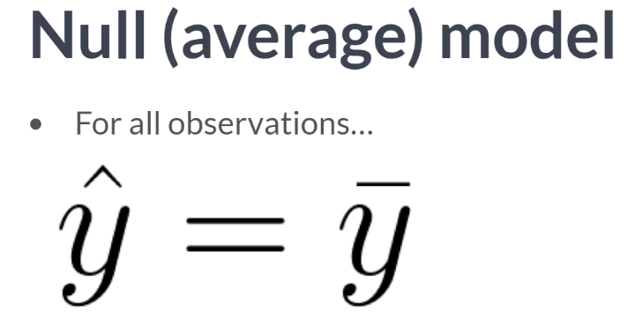

If you had to predict the body length of a possum and you didn't have any information about that particular possum, what would your prediction be? A sensible choice would be the average length of all possums.

And in fact, if you have to make the same prediction for every possum, the average is the best number you can pick. We can think about this as a model where y hat, the predicted value of y, is equal to y bar, the average value of y.

This model is often called the null model. This model makes sense to use as a benchmark, since it doesn't require any insight to make and yet there is no reasonable model that could be any worse.

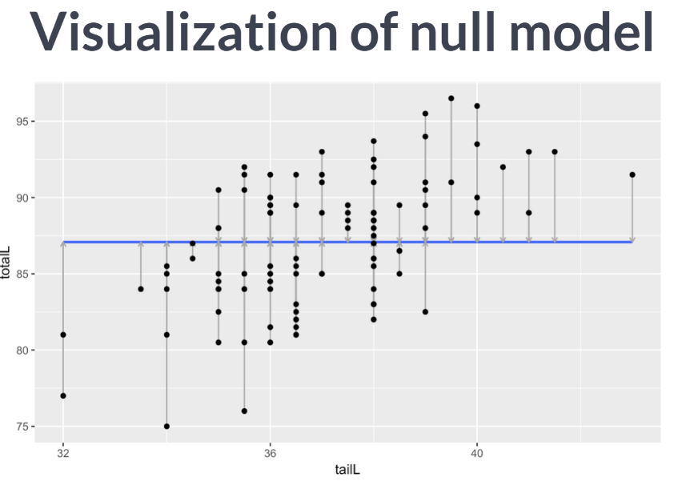  
It looks like this. We can fit the null model in R using *lm* but including only the constant 1 as our explanatory variable.

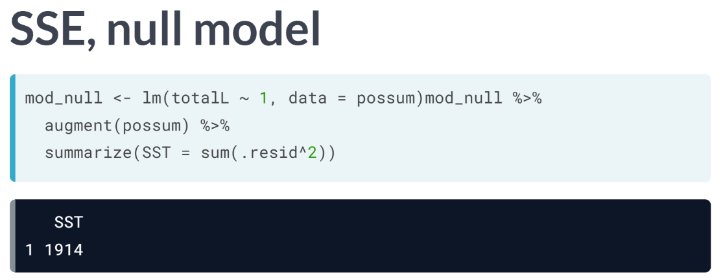

This results in an SSE value of 1914. Compare this number to the SSE for our possum model that uses tail length as an explanatory variable.

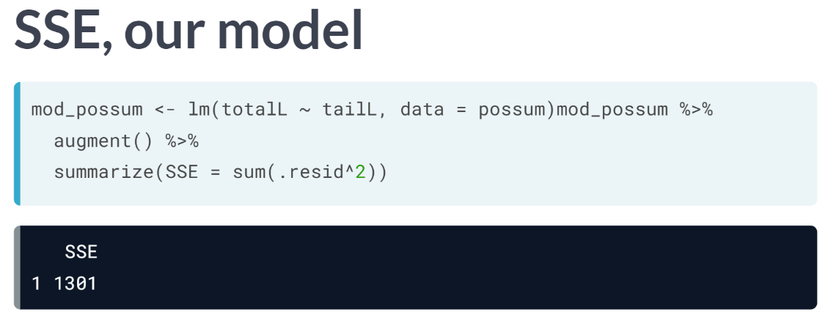  
The SSE in this case is 1301. The ratio of the SSE for our model to the SSE for the null model is a quantification of the variability explained by our model.

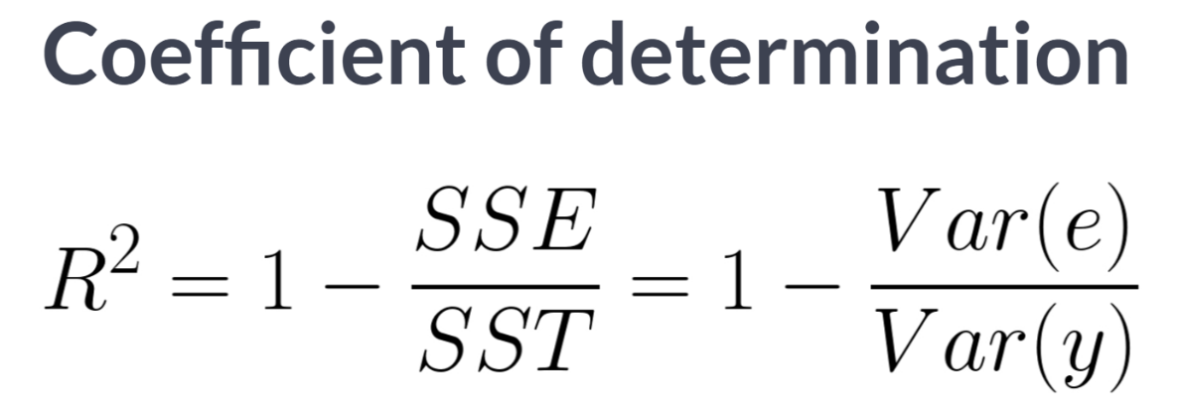  
More specifically, the SSE for the null model is often called SST, for the total sum of the squares. This is a measure of the variability in the response variable. By building a regression model, we hope to explain some of that variability.

The portion of the SST that isn't explained by our model is the SSE. These ideas are captured by this formula for the coefficient of determination, usually referred to as R squared. Due to this definition, we interpret R squared as the proportion of the variability in the response variable that is explained by our model.

It is most commonly cited measure of the quality of the fit of a regression model.

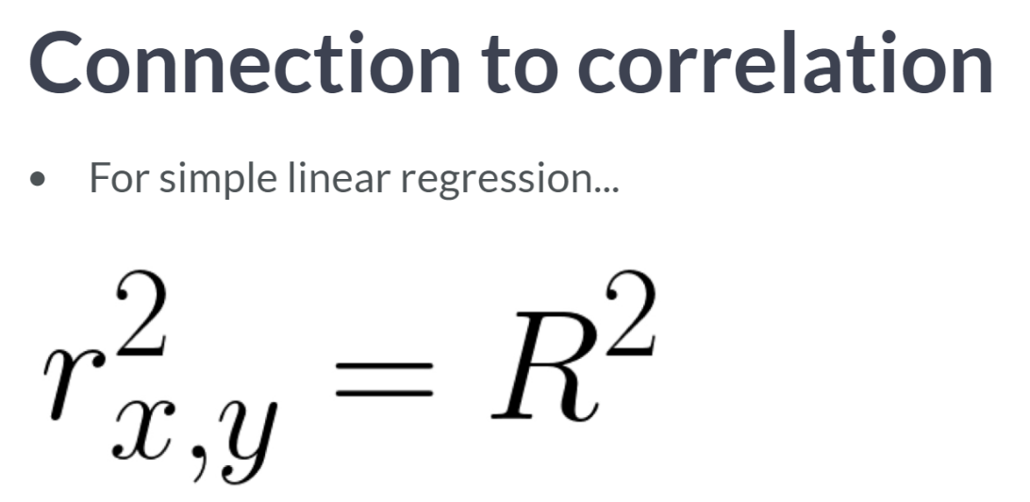  
We have already seen a connection between the value of the correlation between *x* and *y* and the slope of the regression line.

In fact, the value of the correlation coefficient is also closely related to the value of R squared. For least squares regression models with a single explanatory variable, the value of R squared is just the square of the correlation coefficient.  
  
**Why then, do we need both concepts?**

Correlation is strictly a bivariate quantity. It can only be between a single response and a single explanatory variable.

However, regression is a much more flexible modeling framework. Each regression model has its own value of R squared, but in future we will learn how such models can incorporate many explanatory variables, unlike correlation.

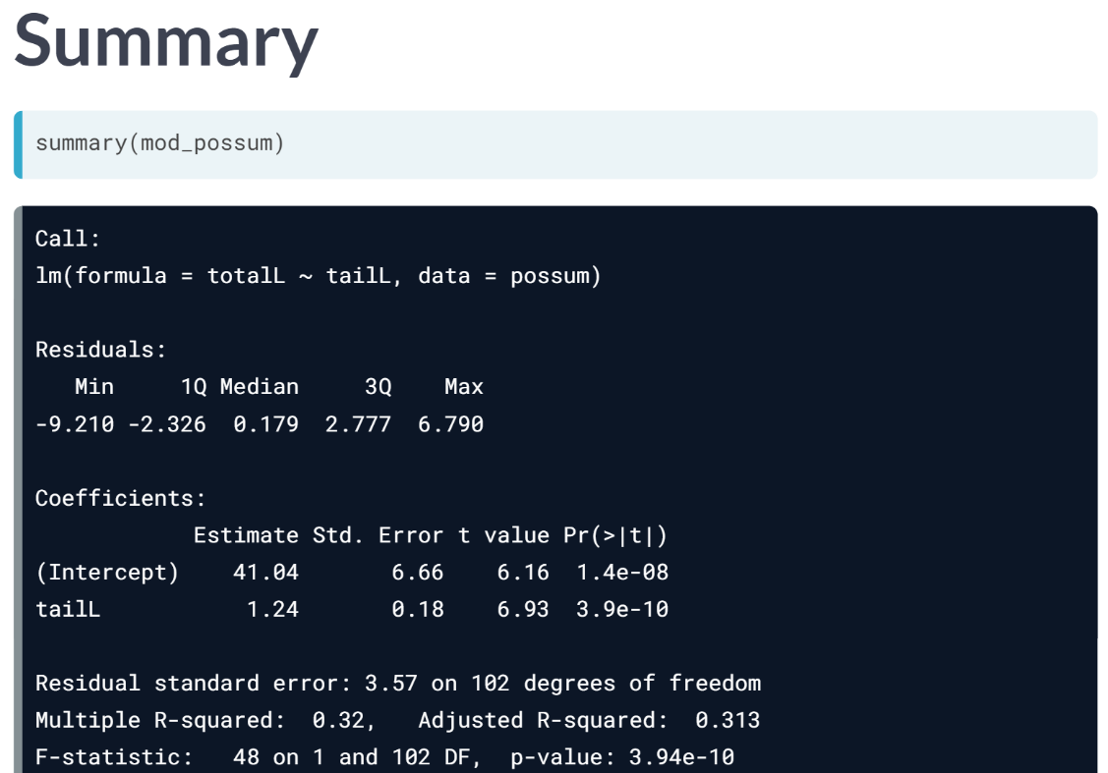

The easiest way to see the R squared value is to apply the summary function to our model object.

In this case, we see that our model based on tail length explains about 32 percent of the variability in body length of these possums.

While R squared is certainly a useful and ubiquitous measure of model fit, it is not the be-all-end-all of statistical modeling.

A high R square alone doesn't mean that you have a good model and low R square doesn't mean that you have a lousy model.

A model with a high R squared may be overfit or it may violate the conditions for inference that we will discuss in the future.

A model with a low R squared can still provide statistically significant insight into a complex problem.

# Assessing simple linear model fit

Recall that the coefficient of determination ($R^{2}$), can be computed as

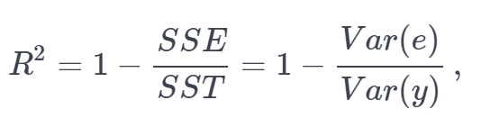

where $e$  is the vector of residuals and $y$  is the response variable. This gives us the interpretation of $R^{2}$  as the percentage of the variability in the response that is explained by the model, since the residuals are the part of that variability that remains unexplained by the model.

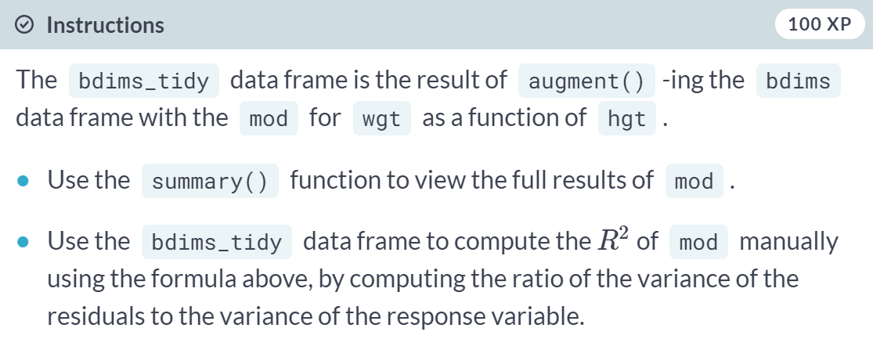  
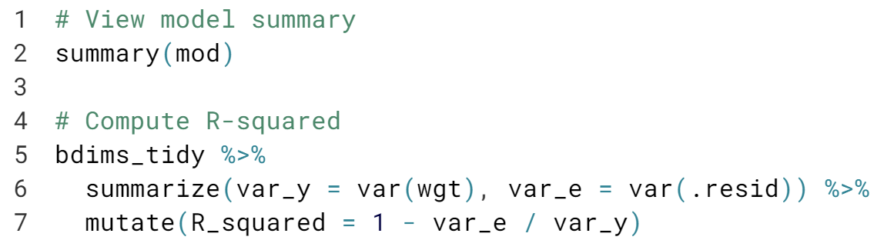  
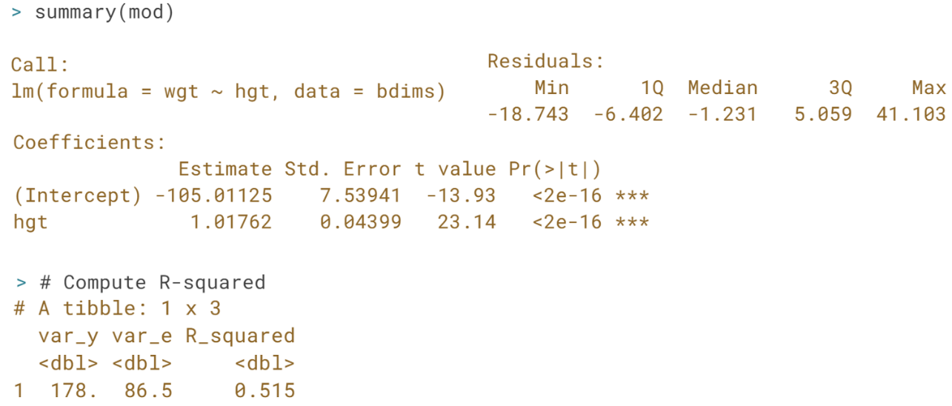  
*R_squared* value of 0.515 means that 51.5% of the variability in weight is explained by height.

# Interpretation of $R^{2}$

The $R^{2}$  reported for the regression model for poverty rate of U.S. counties in terms of high school graduation rate is 0.464.

lm(formula = poverty ~ hs_grad, data = countyComplete) %>%

summary()

How should this result be interpreted?

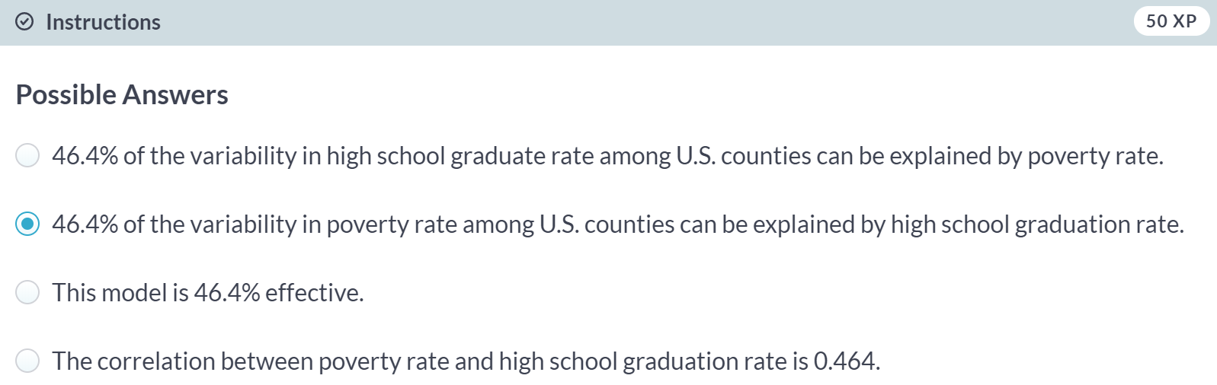

# Linear vs. average

The $R^{2}$  gives us a numerical measurement of the strength of fit relative to a null model based on the average of the response variable:

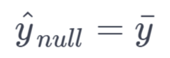

This model has an $R^{2}$  of zero because $SSE=SST$ . That is, since the fitted values $({\hat{y}}_{null})$ are all equal to the average ($\overline{y}$), the residual for each observation is the distance between that observation and the mean of the response. Since we can always fit the null model, it serves as a baseline against which all other models will be compared.

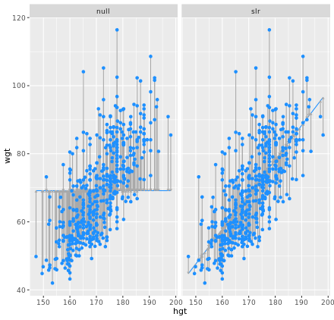

In the graphic, we visualize the residuals for the null model (mod_null at left) vs. the simple linear regression model (mod_hgt at right) with height as a single explanatory variable.

Try to convince yourself that, if you squared the lengths of the grey arrows on the left and summed them up, you would get a larger value than if you performed the same operation on the grey arrows on the right.

It may be useful to preview these augment()-ed data frames with glimpse():

glimpse(mod_null)

glimpse(mod_hgt)



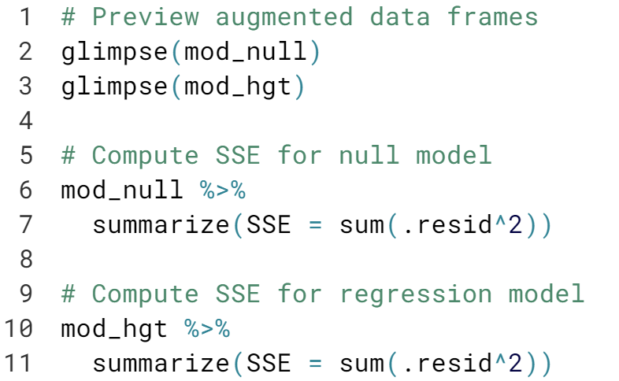

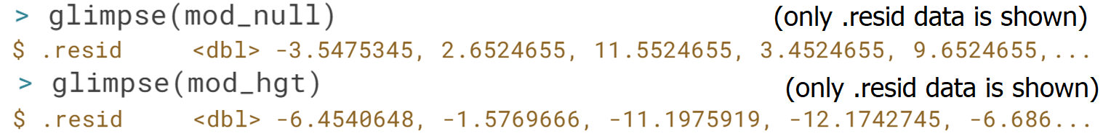

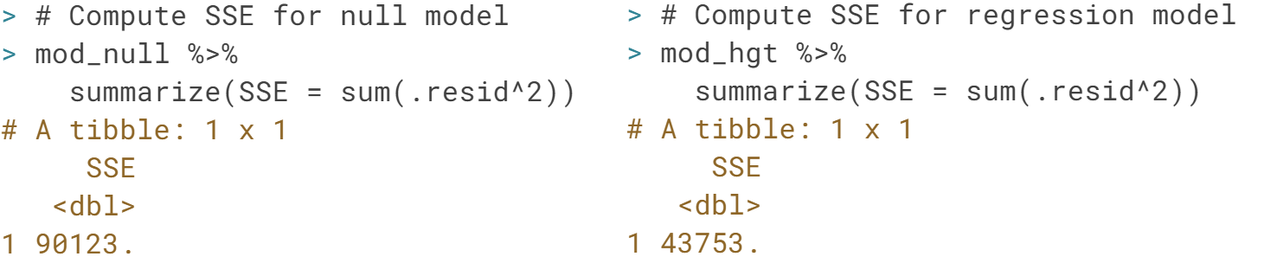



In previous discussion, we learned how to identify points that seem to be unusual. In this video, we will refine that understanding by introducing two related but distinct concepts: leverage and influence.

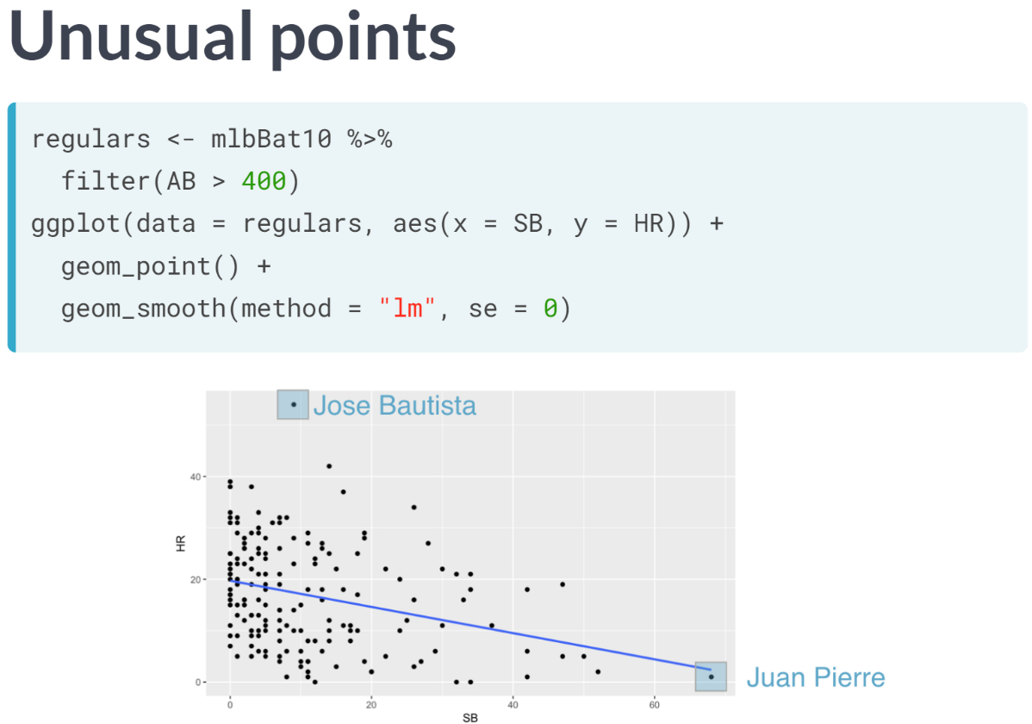

Recall this data we examined previously about MLB players during the 2010 season. We considered the relationship between the number of home run hit by each player and the corresponding number of bases that each player stole. The first statistic is a measurement of power, while the latter is a measurement of speed.

As these skills are considered complementary, it shouldn't be surprising that a simple linear regression model has a negative slope. In this case, we have fit the model to only those players with at least 400 at-bats, in a simple attempt to control for the confounding influence of playing time.

We noted previously that there were two potential outliers here: the point corresponding to the Jose Bautista in the upper left and the point belong to speedster Juan Pierre in the lower right.

Now we have a linear regression model, we want to think about how individual observations might affect the slope of the line.

Typically, the purpose of interpreting the slope coefficient is to learn about the overall relationship between the two variables, so it doesn't necessarily make sense if one or two individual observations have a disproportionate effect on that slope.

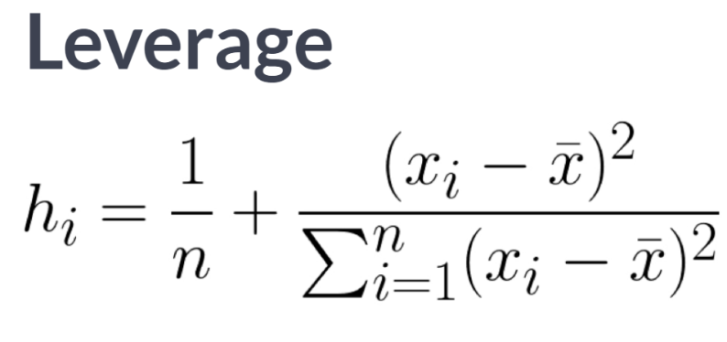  
The concepts of leverage and influence will help us quantify this intuition. Leverage has a precise mathematical definition that we can see here.

The specifics of the formula are not so important, but we should recognize that the leverage score *h sub i* for an observation is entirely a function of the distance between the value of the explanatory variable and mean of the explanatory variable.

This means that points that are close to the horizontal center of the scatter plot have low leverage, while points that are far from the horizontal center of the scatter plot have high leverage. The y-coordinate doesn't matter at all.

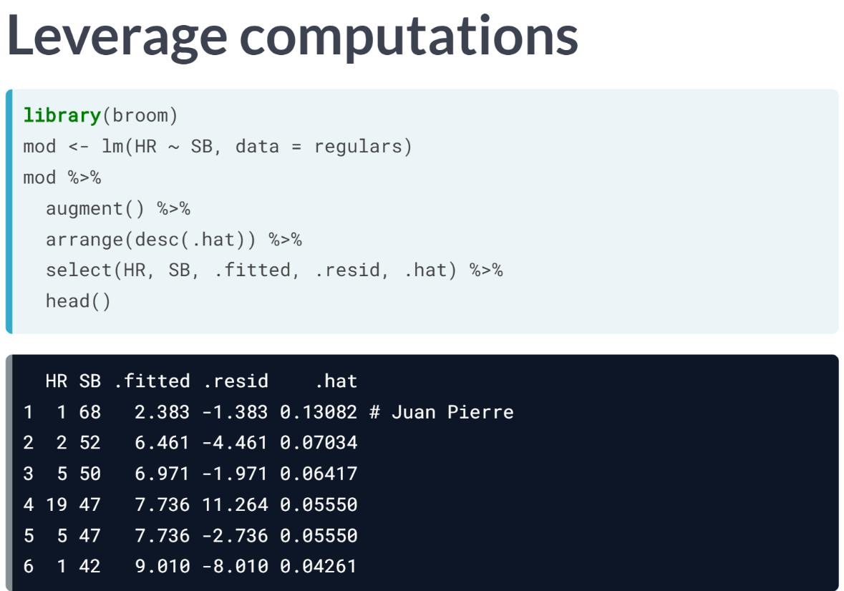  
It shouldn't be surprising then that the players with the largest leverage value is the aforementioned Juan Pierre. As you can see, the leverage scores can be retrieved using the ***augment()*** function and then examining the hat variable.

For the side note, this name comes from the historical convention of computing leverage from the "hat" matrix. Note that the leverage score based only upon stolen bases. In this case, Pierre's leverage score is nearly twice as large as that of the next player.

Observations of high leverage, by virtue of their extreme values of the explanatory variable, may or may not have a considerable effect on the slope of the regression line. An observation that does have such an effect is called influential.

In our case, the regression line is very close to the point corresponding to Juan Pierre anyway. So, even though this is a high leverage observation, it is not considered influential.

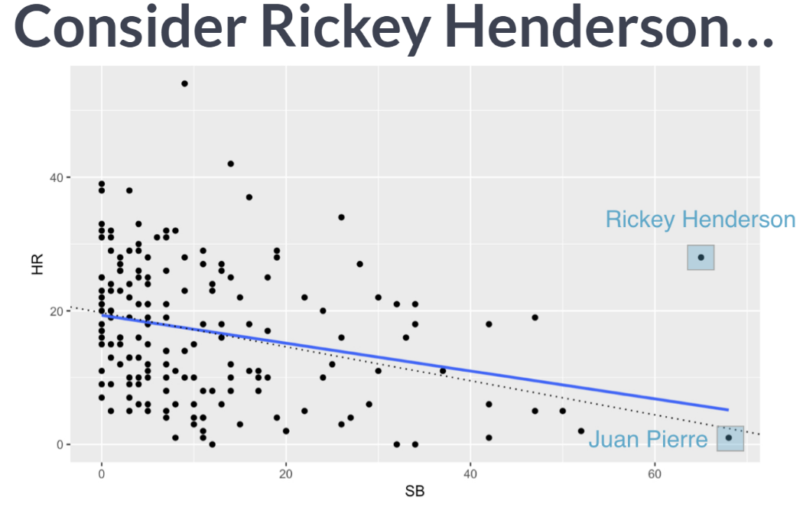  
However, suppose that there was a player with a similar number of stolen bases, but a decent number of home runs as well. In fact, Hall of Famer Rickey Henderson was such a player and in his high-career season, he stole 65 bases while hitting 28 home runs. Let's add this observation to our plot.

Notice how the new regression line pulls upward ever so slightly from the previous dotted regression line after adding Rickey's data. Thus, this is a direct result of Henderson's influence. Because this is a point of high leverage, it has the ability to pull the slope of the regression line up.

But unlike the point corresponding to Pierre, the point corresponding to Henderson also has a large residual and the combination of high leverage and large residual determine influence.

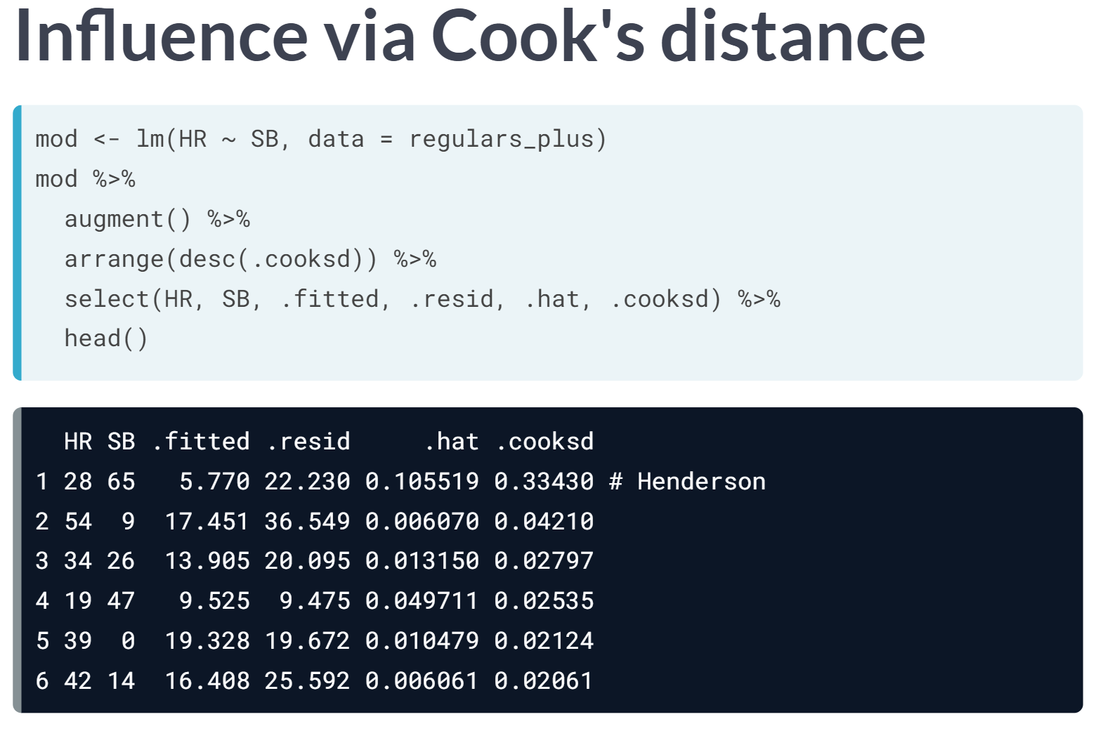

In fact, a measurement known as Cook's distance combines these two quantities to measure influence. These figures are also reported by ***augment()***.

We note here that the observation corresponding to Henderson has a large residual, high leverage, and by far the largest value of Cook's distance.

# Leverage

The leverage of an observation in a regression model is defined entirely in terms of the distance of that observation from the mean of the explanatory variable. That is, observations close to the mean of the explanatory variable have low leverage, while observations far from the mean of the explanatory variable have high leverage. Points of high leverage may or may not be influential.

The augment() function from the broom package will add the leverage scores (.hat) to a model data frame.

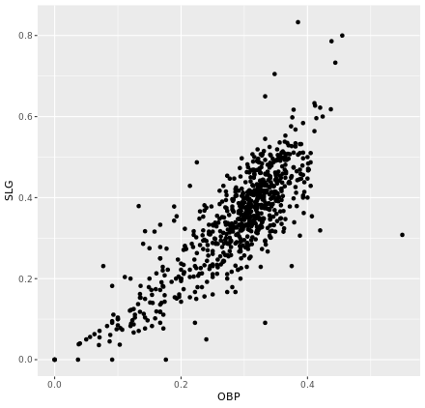

  
  
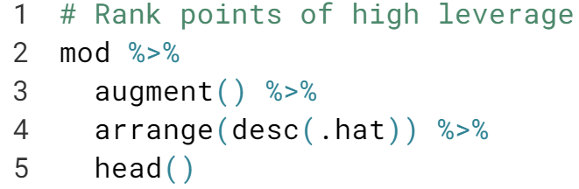  
  
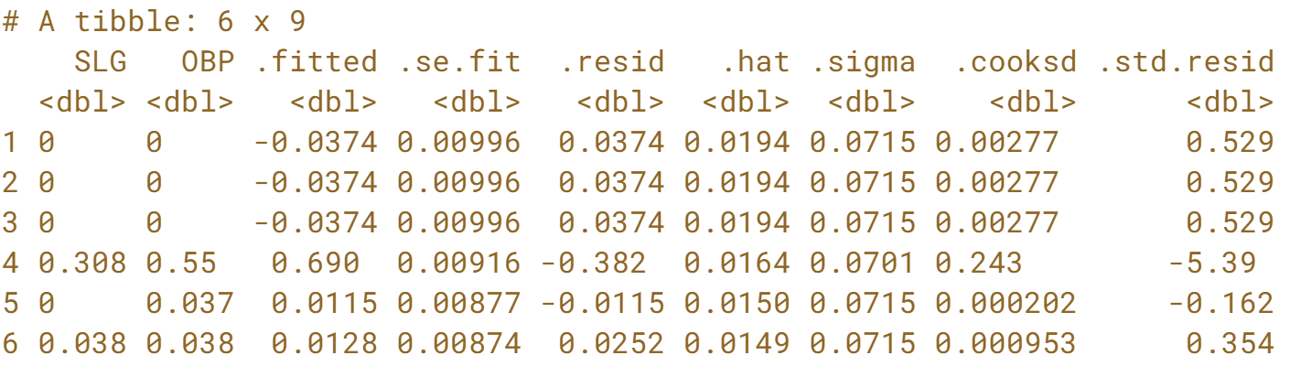

# Influence

As noted previously, observations of high leverage may or may not be influential. The influence of an observation depends not only on its leverage, but also on the magnitude of its residual. Recall that while leverage only considers the explanatory variable ($x$), the residual depends on the response variable ($y$) and the fitted value ($\hat{y}$).

Influential points are likely to have high leverage and deviate from the general relationship between the two variables. We measure influence using Cook's distance, which incorporates both the leverage and residual of each observation.

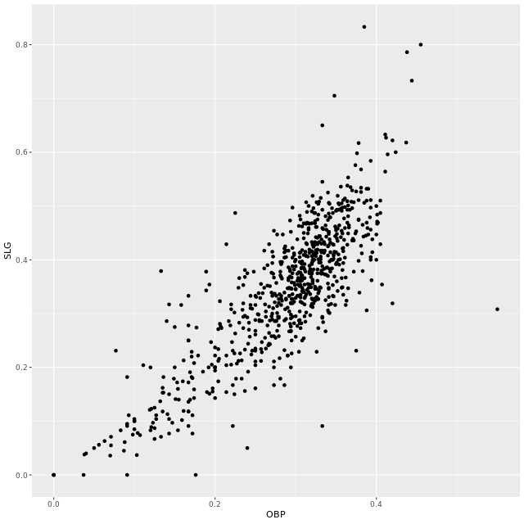

  
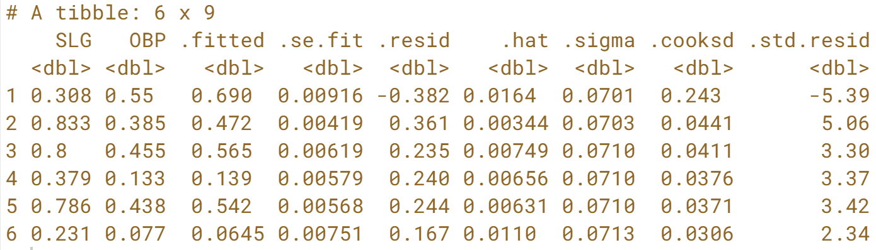



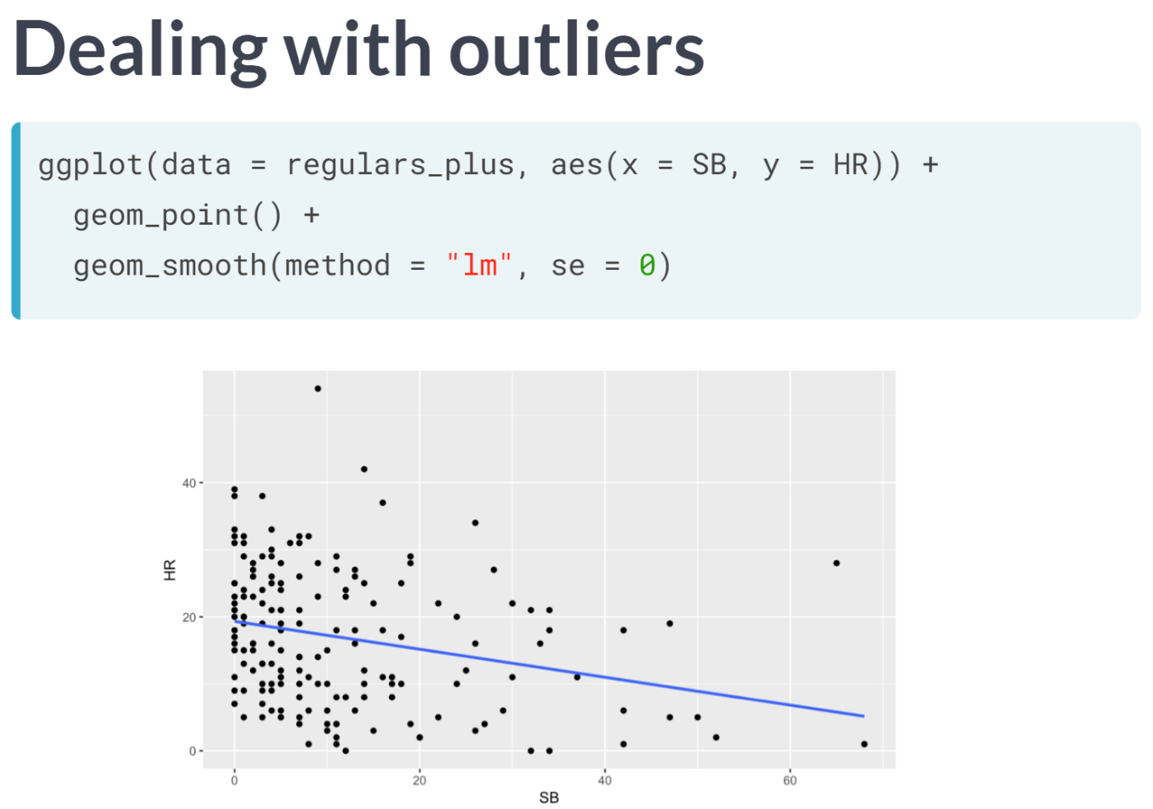  
Suppose we have determined that an influential observation is affecting the slope of our regression line in a way that undermines the scientific merit of our model. What can we do about it?

The short answer is that there isn't much we can do about it other than removing the outliers. As the statistical modeler, this is a decision we can make, but it's crucial that we understand the ramifications of this decision and act in good scientific faith.

The long answer is that there are more sophisticated statistical techniques that can help us deal with the troublesome impact of outliers.

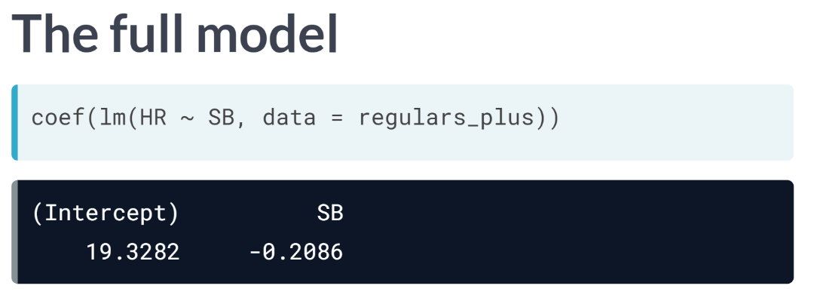  
In the full model of all the regular players from 2010 and Rickey Henderson from 1990, the slope of the regression line was -.21 home runs per stolen base. In other words, players who steal five extra bases hit about one fewer home run, on average.

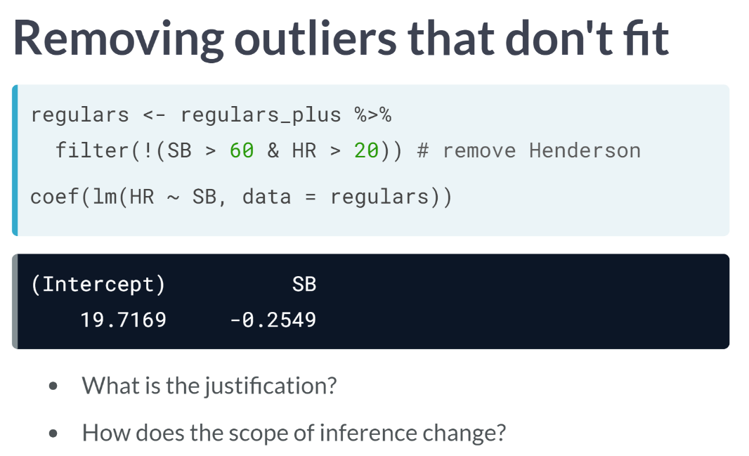  
Now in this case, there is an easy argument that Rickey Henderson doesn't fit with the rest of these data. It's a bit of a contrived argument, since we added him previously for effect, but nonetheless there are good reasons to assert that Henderson doesn't belong. If we remove him, note how the slope of the regression line decreases.

Now it's only four extra stolen bases that are associated with hitting one fewer home run. Anytime you are removing outlier, justification should be asked. "Because it improves my result" isn't a good justification.

Indeed, conscious ignorance of valid data isn't intellectually honest and has been the cause of more than a few retractions of previously published scientific papers.

Be skeptical. The burden of proof is on you to make a strong argument as to why data should be omitted. Second, you must consider how this changes the scope of inference. If you are studying countries, are you omitting only the poorest countries? If so, then your results no longer apply to all counties, just non-poor countries.

Misunderstanding how the scope of inference changes can be a fatal flaw in our analysis.

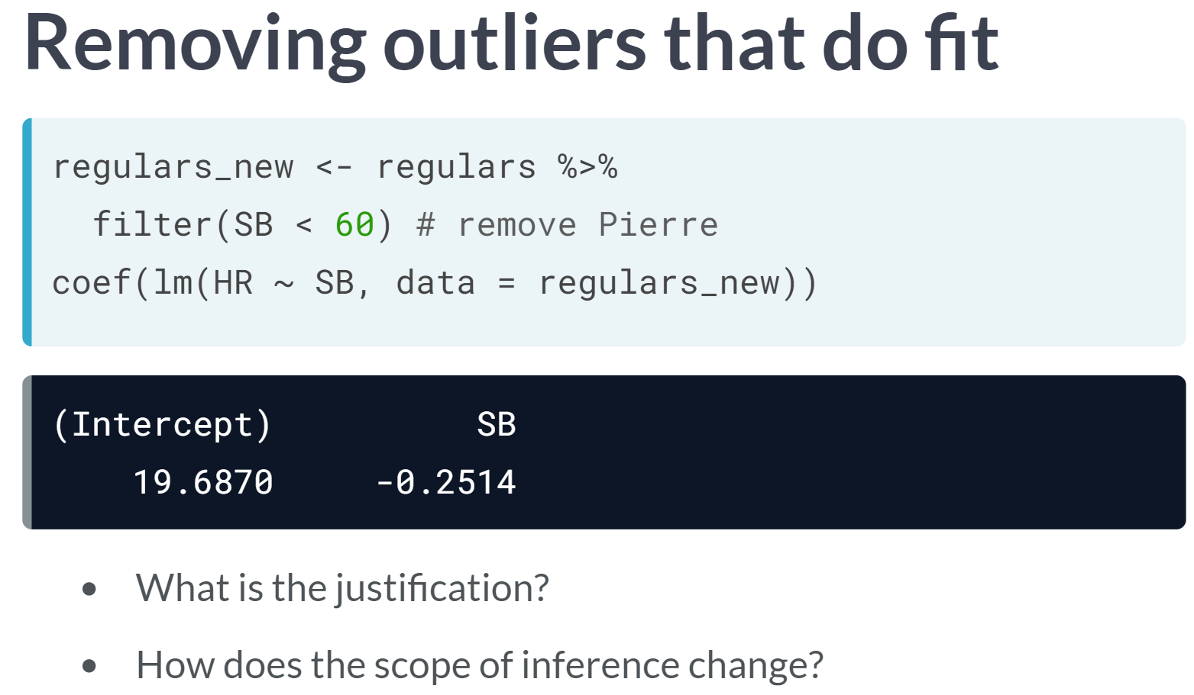

With Henderson out of the way, consider removing Juan Pierre as well. Here, there really aren't good arguments as to why this should be done. First, the point isn't influential, so whether we include it or not, it won't affect the result much.

More importantly, because Pierre was just a regular MLB player in 2010, there's no reason to think that he somehow doesn't belong to the larger group of players. What is so special about Juan Pierre that would lead us to exclude him?

If, hypothetically, he was a pitcher, or he was 60 years old, or he only had one arm, then you could try and make that case. But there is nothing like that going on here, and so we have no scientific reason to exclude him.

# Removing outliers

Observations can be outliers for a number of different reasons. Statisticians must always be careful—and more importantly, transparent—when dealing with outliers. Sometimes, a better model fit can be achieved by simply removing outliers and re-fitting the model. However, one must have strong justification for doing this. A desire to have a higher $R^{2}$  is not a good enough reason!

In the mlbBat10 data, the outlier with an OBP of 0.550 is [**Bobby Scales**](https://en.wikipedia.org/wiki/Bobby_Scales), an infielder who had four hits in 13 at-bats for the Chicago Cubs. Scales also walked seven times, resulting in his unusually high OBP. The justification for removing Scales here is weak. While his performance was unusual, there is nothing to suggest that it is not a valid data point, nor is there a good reason to think that somehow, we will learn more about Major League Baseball players by excluding him.

Nevertheless, we can demonstrate how removing him will affect our model.

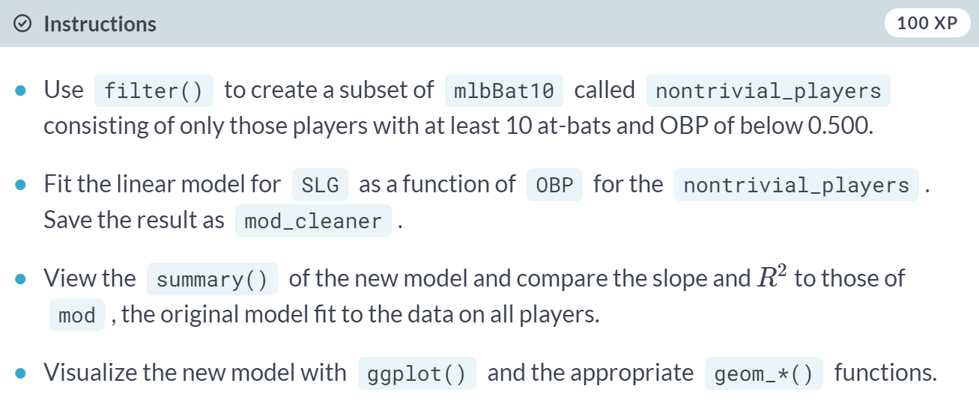  
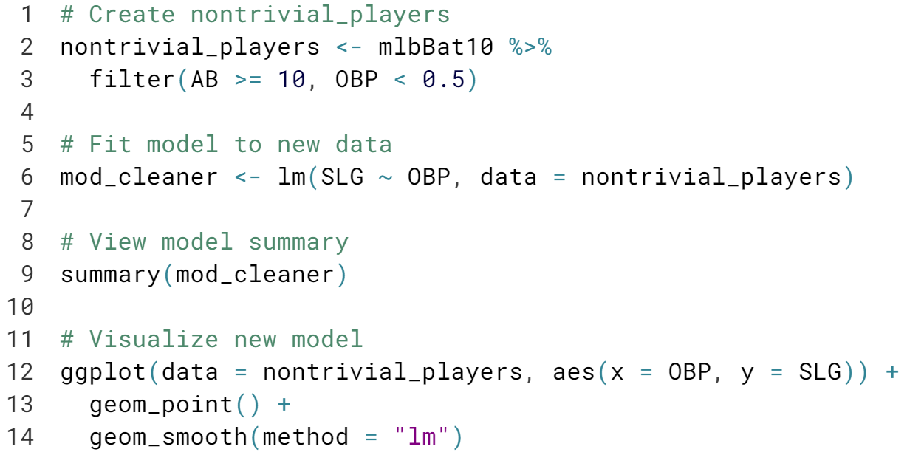

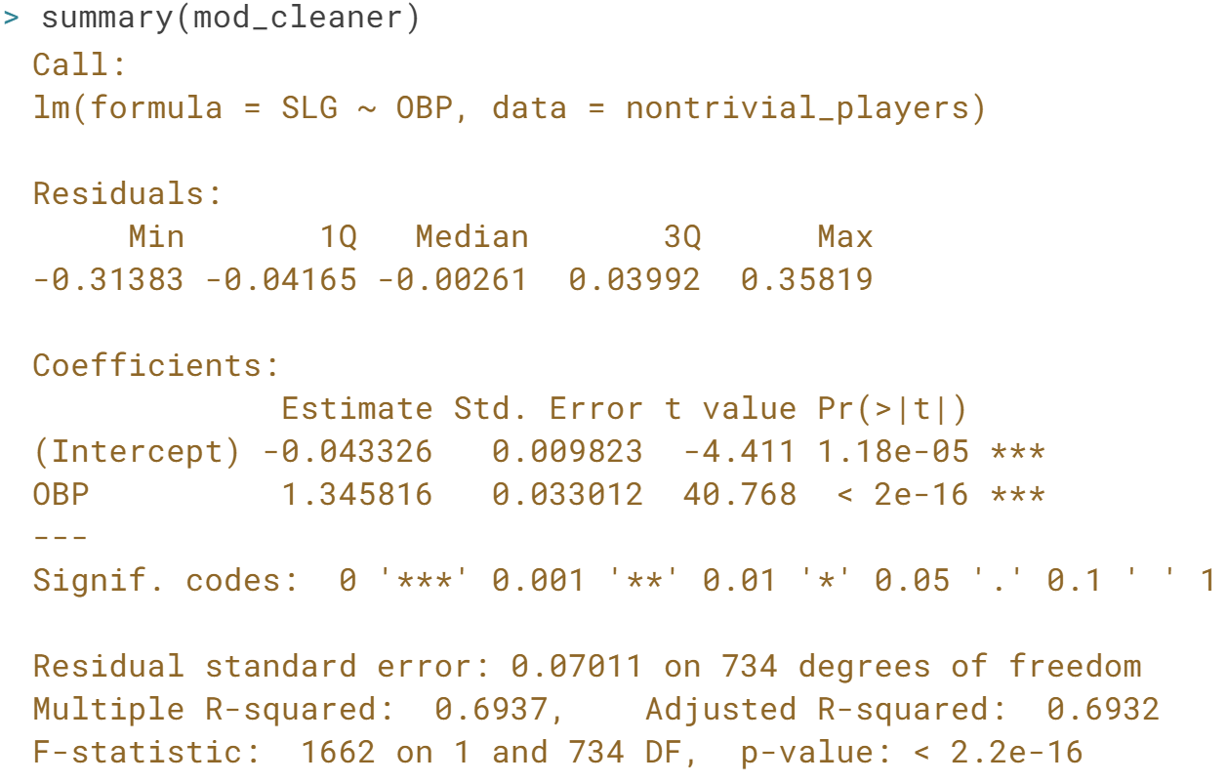

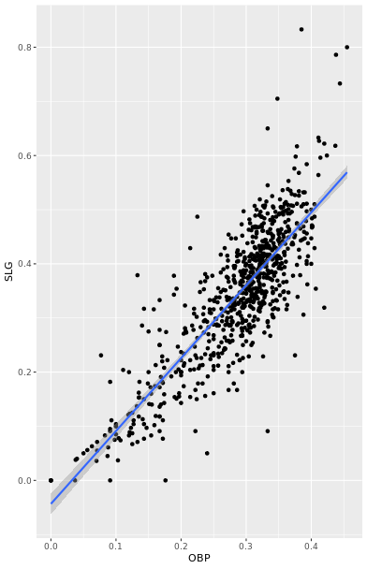

# High leverage points

Not all points of high leverage are influential. While the high leverage observation corresponding to Bobby Scales in the previous exercise is influential, the three observations for players with OBP and SLG values of 0 are not influential.

This is because they happen to lie right near the regression anyway. Thus, while their extremely low OBP gives them the power to exert influence over the slope of the regression line, their low SLG prevents them from using it.

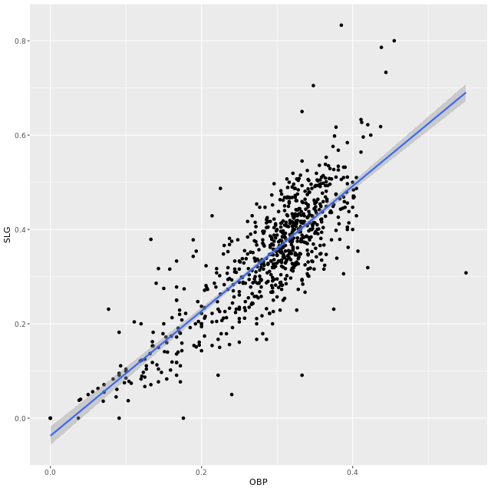

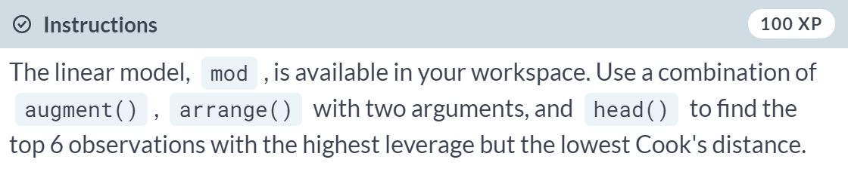

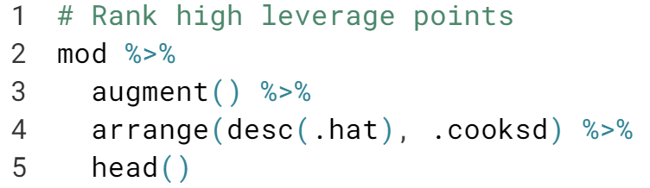  
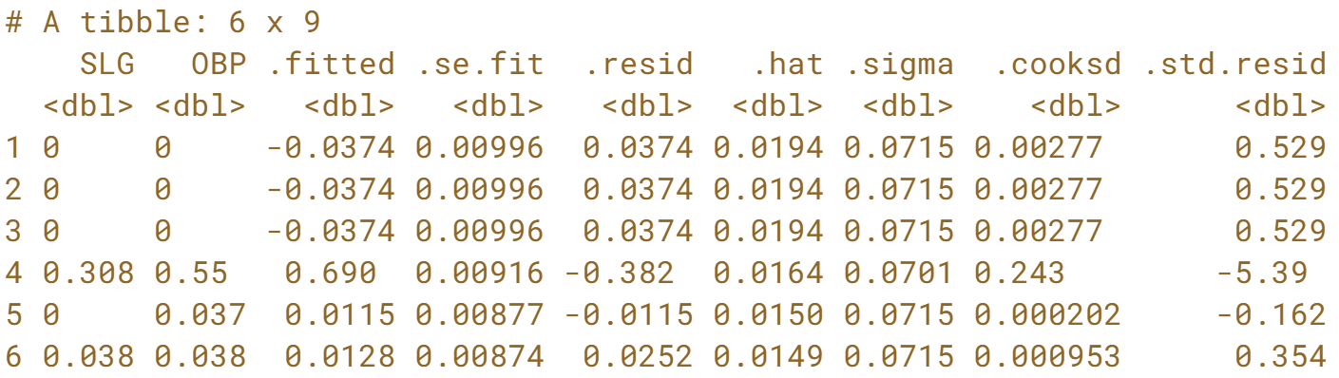



This course was about analyzing the relationship between two numeric variables. We learned a variable of technique for doing this.

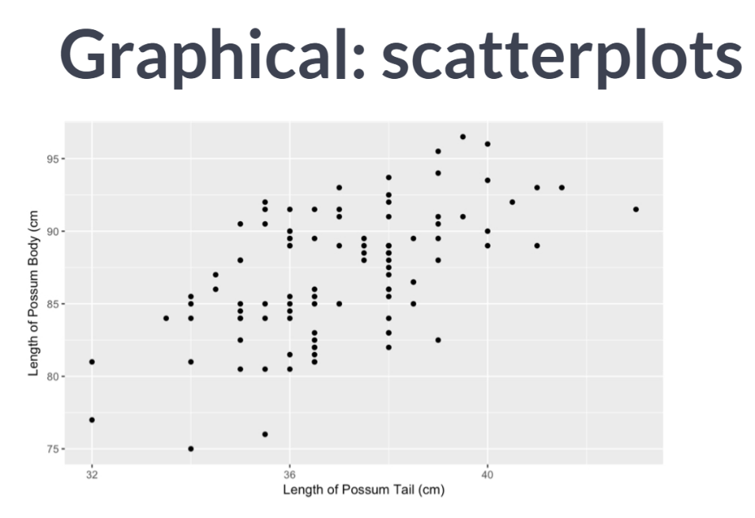  
First, we explored how powerful scatter plots can be in revealing bivariate relationships in an intuitive, graphical form. We built a framework for describing what we see in those scatter plots and practiced implementing that framework on real data.

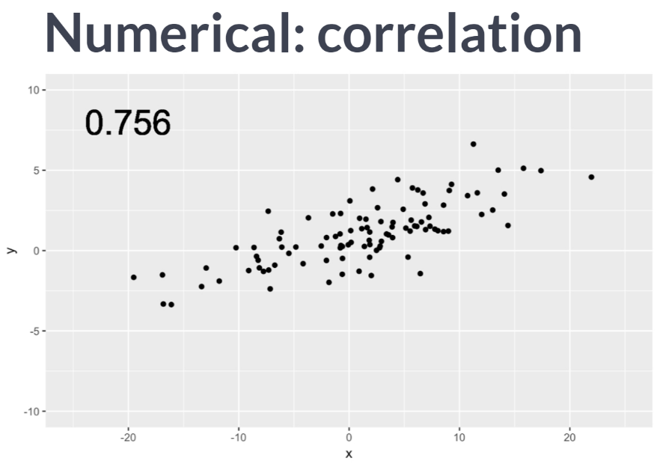

Second, we learned about correlation, a simple way to quantify the strength of the linear relationship between two variables using a single number. We emphasized the value of such measurements, illustrated how their careless application can lead to erroneous result.

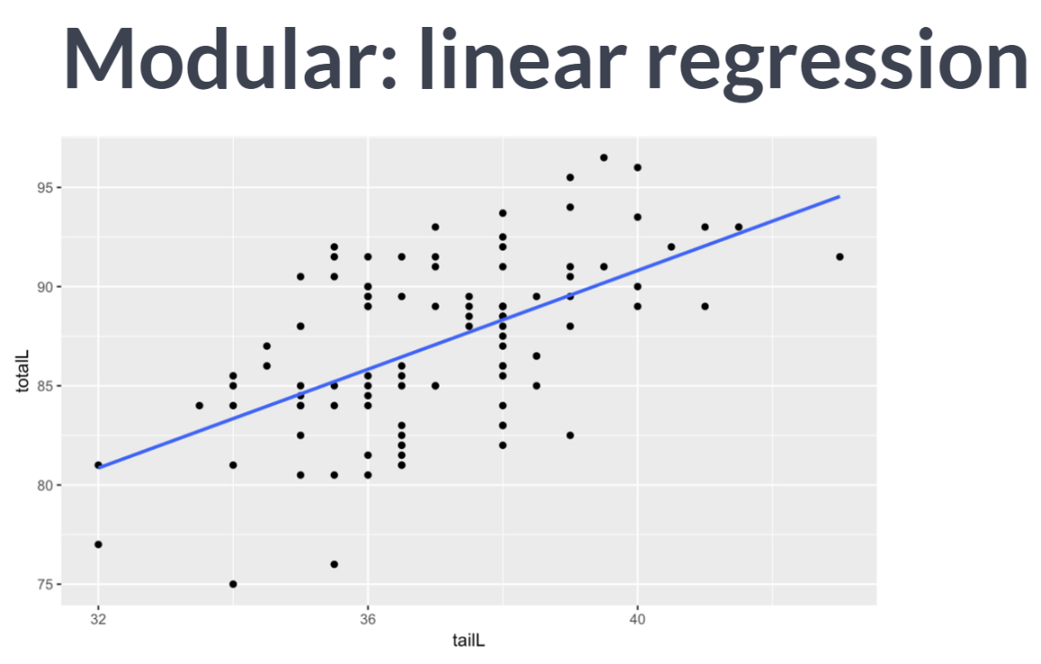  
Third, we learned about linear regression, a relatively simple but a powerful technique for modeling a response variable in terms of a single explanatory variable. We built our intuition about how these models work and identified some of their key properties.

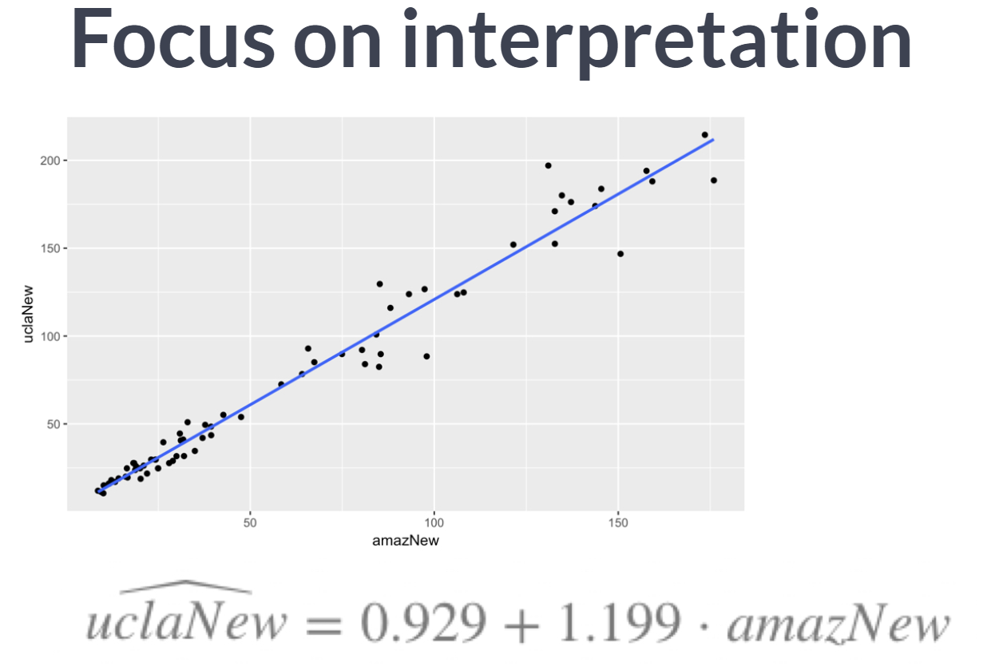

Fourth, we focused carefully on how to interpret the coefficient of regression models and how those interpretation can bring real insight into complex problems.

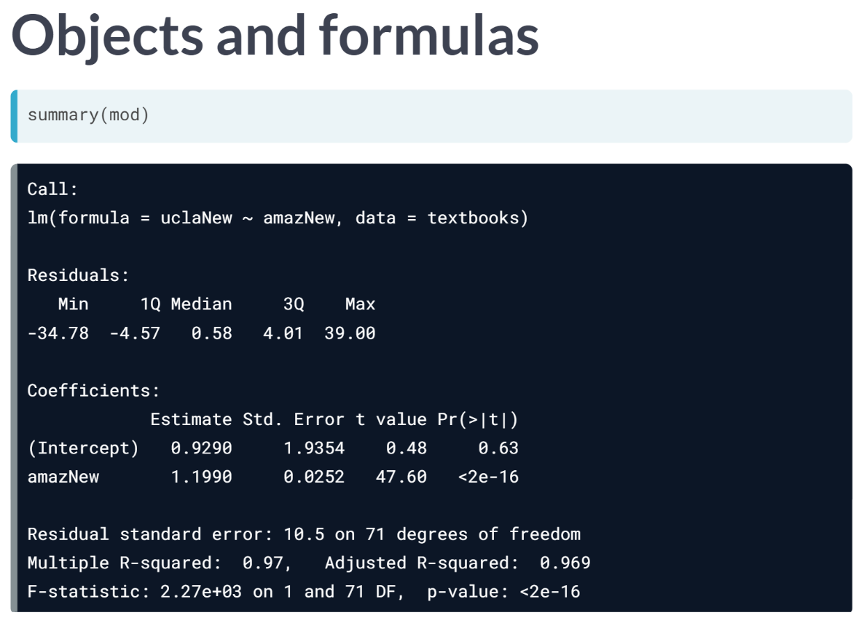  
We also developed a foundational understanding of how to build these models in R and how to work with them afterwards.

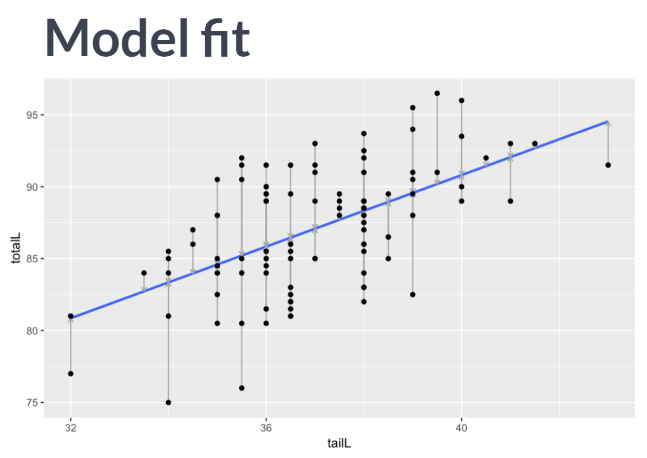  
Finally, we introduced the notion of model fit and developed tools for helping us reason about the quality of our models and how much we can learn from them.